**DATA SPECIALIZATION**

***Unit 6: Statistical Inference***

# Introduction

**Link**: <https://www.coursera.org>

**Overview**: About this course: Statistical inference is the process of drawing conclusions about populations or scientific truths from data. There are many modes of performing inference including statistical modeling, data oriented strategies and explicit use of designs and randomization in analyses. Furthermore, there are broad theories (frequentists, Bayesian, likelihood, design based, …) and numerous complexities (missing data, observed and unobserved confounding, biases) for performing inference. A practitioner can often be left in a debilitating maze of techniques, philosophies and nuance. This course presents the fundamentals of inference in a practical approach for getting things done. After taking this course, students will understand the broad directions of statistical inference and use this information for making informed choices in analyzing data.

**Objective**: Ask the right questions, manipulate data sets, and create visualizations to communicate results.

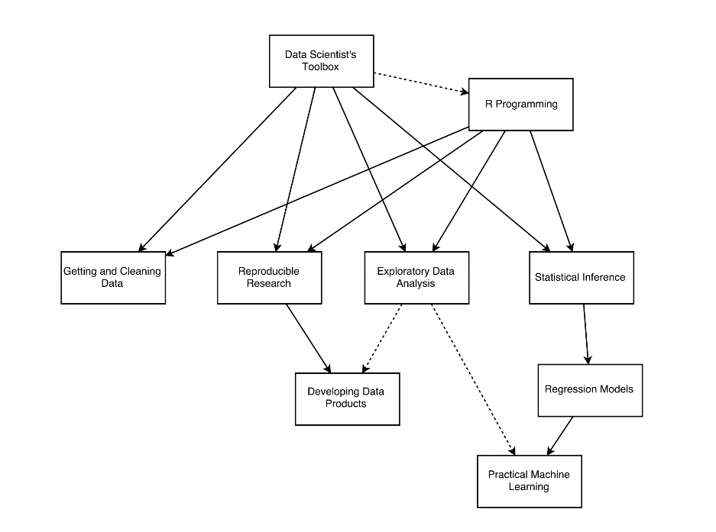This Specialization covers the concepts and tools you'll need throughout the entire data science pipeline, from asking the right kinds of questions to making inferences and publishing results. In the final Capstone Project, you’ll apply the skills learned by building a data product using real-world data. At completion, students will have a portfolio demonstrating their mastery of the material.

**Who:**

Jeff Leek – professor JHU School of Public Health. Statistics of genetic data.

* <http://biostat.jhsph.edu/~jleek/>, <http://simplystatistics.org/>, <https://github.com/jtleek>

Roger Peng

* <http://www.biostat.jhsph.edu/~rpeng/>, http://simplystatistics.org/

Brian Caffo – statistics to analyze brain image data.

* [www.bcaffo.com](http://www.bcaffo.com), <https://githup.com/bcaffo>

**Plagiarism**

Johns Hopkins University defines plagiarism as "...taking for one's own use the words, ideas, concepts or data of another without proper attribution. Plagiarism includes both direct use or paraphrasing of the words, thoughts, or concepts of another without proper attribution." We take plagiarism very seriously, as does Johns Hopkins University.

We recognize that many students may not have a clear understanding of what plagiarism is or why it is wrong. Please see the JHU referencing guide for more information on plagiarism.

It is critically important that you give people/sources credit when you use their words or ideas. If you do not give proper credit -- particularly when quoting directly from a source -- you violate the trust of your fellow students.

The Coursera Honor code includes an explicit statement about plagiarism:

I will register for only one account. My answers to homework, quizzes and exams will be my own work (except for assignments that explicitly permit collaboration). I will not make solutions to homework, quizzes or exams available to anyone else. This includes both solutions written by me, as well as any official solutions provided by the course staff. I will not engage in any other activities that will dishonestly improve my results or dishonestly improve/hurt the results of others.

**Reporting plagiarism on course projects**

One of the criteria in the project rubric focuses on plagiarism. Keep in mind that some components of the projects will be very similar across terms and so answers that appear similar may be honest coincidences. However, we would appreciate if you do a basic check for obvious plagiarism and report it during your peer assessment phase. It is currently very difficult to prove or disprove a charge of plagiarism in the MOOC peer assessment setting. We are not in a position to evaluate whether or not a submission actually constitutes plagiarism, and we will not be able to entertain appeals or to alter any grades that have been assigned through the peer evaluation system. But if you take the time to report suspected plagiarism, this will help us to understand the extent of the problem and work with Coursera to address critical issues with the current system.

# Statistical Inference

Started: June 6, 2016

Ends: July 10, 2016

Statistical inference is the process of drawing conclusions about populations or scientific truths from data. There are many modes of performing inference including statistical modeling, data oriented strategies and explicit use of designs and randomization in analyses. Furthermore, there are broad theories (frequentists, Bayesian, likelihood, design based, …) & numerous complexities (missing data, observed and unobserved confounding, biases) for performing inference. A practitioner can often be left in a debilitating maze of techniques, philosophies and nuance. This course presents the fundamentals of inference in a practical approach for getting things done. After taking this course, students will understand the broad directions of statistical inference and use this information for making informed choices in analyzing data.

## Week 1: Probability & Expected Values

Module 1: Introduction

### Introductory video

* ***Statistical inference***: generate conclusions about a population from a noisy sample.
  + Only formal system of inference we have.
  + See often in “predictive models/analysis”
* Ex. find areas of brain associated with finger tapping
* Ex. political elections (sample of likely voters)
* Ex. weather forecasts – probability of rain (sample of recent and climatic whether observations)
* Inferential Paradigms
  + ***Frequentists*** -
  + ***Bayesians*** –
  + Many shades of gray
* This class will go with the FREQUENTIST paradigm – most likely used in practice.
* Other problems:
  + Does smoking cause cancer?
  + Does an ad campaign cause and increase in web traffic?
  + Does a new treatment really reduce cancer progression?
* 4 quizzes and 1 project
* homework problems for practice before each quiz.

### Welcome to Statistical Inference

I'm glad that you decided to take Statistical Inference, part of the Data Science Specialization from Johns Hopkins Biostatistics! This course presents the fundamentals of statistical inference that you will need throughout the rest of the Data Science track. We believe that the key word in Data Science is "science".

This Specialization is focused on providing you with three things:

1. ***an introduction to the key ideas behind working with data in a scientific way that will produce new and reproducible insight,***
2. ***an introduction to the tools that will allow you to execute on a data analytic strategy, from raw data in a database to a completed report with interactive graphics, and***
3. ***on giving you plenty of hands-on practice so you can learn the techniques for yourself.***

This course represents the most fundamental and foundational component of the series. Using only a bare minimum of mathematics, we attempt to give students the fundamentals of using statistics to draw inferences about populations. We are excited about the opportunity to attempt to scale Data Science education. We intend for the courses to be self-contained, fast-paced, and interactive.

### Some introductory comments

A couple of first week housekeeping items. First, make sure that you've had R Programming and the Data Scientist's Toolbox before taking this class. At a minimum you must know: very basic git and basic R.

An important aspect of this class is to peruse the materials in the github repository. All of the most up to date material can be found here

<https://github.com/bcaffo/courses/tree/master/06_StatisticalInference>

You should clone this repository as your first step in this class and make sure to fetch updates periodically. (Please send pull requests too!) It is one of the most essential components of the Specialization that you start to use Git frequently. We're practicing what we preach as well by using the tools in the series to create the series, especially git.

You can clone the whole repo with (http)

git clone https://github.com/bcaffo/courses.git

or (ssh)

git clone git@github.com:bcaffo/courses.git

The lectures are in the index.Rmd lecture files. In Data Products, we'll cover how to create these sorts of slides. However, for the time being, you should be able to open them in R Studio and look at their contents. You will see all of the R code to recreate the lectures. Going through the R code is the best way to familiarize yourself with the lecture materials.

If you'd prefer to watch the videos on YouTube, the current version of the class is here: <https://www.youtube.com/playlist?list=PLpl-gQkQivXiBmGyzLrUjzsblmQsLtkzJ>

If you'd like to keep up with the instructors, I'm @bcaffo on twitter, Roger is @rdpeng and Jeff is @jtleek. The Department of Biostat here is @jhubiostat.

### Pre-Course Survey

Done

### Syllabus

**Course Title:** Statistical Inference

Course Instructor(s): The primary instructor of this class is Brian Caffo. Brian is a professor at Johns Hopkins Biostatistics and co-directs the SMART working group. This class is co-taught by Roger Peng and Jeff Leek. In addition, Sean Kross and Nick Carchedi have been helping greatly.

**Course Description**

In this class students will learn the fundamentals of statistical inference. Students will receive a broad overview of the goals, assumptions and modes of performing statistical inference. Students will be able to perform inferential tasks in highly targeted settings and will be able to use the skills developed as a roadmap for more complex inferential challenges.

Course Content: The course is taught via 13 lectures

* Introduction
* Probability
* Conditional Probability
* Expectations
* Variance
* Common Distributions
* Asymptotics
* T confidence intervals
* Hypothesis testing
* P-values
* Power
* Multiple Testing
* Resampling

**YouTube Videos**. If you'd prefer to watch the videos on YouTube, you can do that here:

<https://www.youtube.com/playlist?list=PLpl-gQkQivXiBmGyzLrUjzsblmQsLtkzJ>

**Course Book**

There's now a (sort of) book for the class. It's a different sort of book published on LeanPub. If you purchase the book on LeanPub, you'll get all editions in the future for free. You pick the price on the site. You can get it here:

<https://leanpub.com/LittleInferenceBook>

However, you can also just read a web page rendering of the book here: <https://leanpub.com/LittleInferenceBook/read>

In addition, the book is on github if you want to render it yourself using pandoc <https://github.com/bcaffo/LittleInferenceBook>

**Github repository**

The most up to date information on the course lecture notes will always be in the Github repository

(<https://github.com/DataScienceSpecialization/courses/tree/master/06_StatisticalInference> )

Please issue pull requests so that we may improve the materials. Notice that Brian's forked github repo is sometimes out of sync with the Data Science Specialization repo managed by the other instructors. Make sure to check in Brian's master repo for the most up to date material.

If you would just like the full set of lecture pdfs, grab them here

If you would just like the full set of Rmd files for the lecture code, get it here.

**Quizzes**

There are four quizzes.

You must earn a grade of at least 80% to pass a quiz.

You may attempt each quiz up to 3 times in 8 hours.

The score from your most successful attempt will count toward your final grade.

The quizzes will cover the material from that week. The quizzes don't always exactly correspond to the material for that week. However, the material is always covered before the quiz is due. Here's the rough makeup

Quiz 1 covers lectures 1 - 4

Quiz 2 covers lectures 5 - 7

Quiz 3 covers lectures 8 - 10

Quiz 4 covers lectures 8 - 13

Thus, Quiz 3 and 4 cover a lot of overlapping material.

**Course Project**

The Course Project is an opportunity to demonstrate the skills you have learned during the course. It is graded through peer assessment.

**Grading policy**

You must score at least 80% on all assignments (Quizzes & Project) to pass the course. Your final grade will be calculated as follows:

Quiz 1 = 15%

Quiz 2 = 15%

Quiz 3 = 15%

Quiz 4 = 15%

Course project = 40%

**Homework**

There is some optional homework that can be accessed here. More information can be found in the navbar homework tab. These exercises are optional and perhaps a little more difficult than the quizzes. They also may not exactly correspond to the quiz and lecture schedules.

**Differences of opinion**

Keep in mind that currently data analysis is as much art as it is science - so we may have a difference of opinion - and that is ok! Please refrain from angry, sarcastic, or abusive comments on the message boards. Our goal is to create a supportive community that helps the learning of all students, from the most advanced to those who are just seeing this material for the first time.

**Plagiarism**

Johns Hopkins University defines plagiarism as "...taking for one's own use the words, ideas, concepts or data of another without proper attribution. Plagiarism includes both direct use or paraphrasing of the words, thoughts, or concepts of another without proper attribution." We take plagiarism very seriously, as does Johns Hopkins University.

We recognize that many students may not have a clear understanding of what plagiarism is or why it is wrong. Please see the following guide for more information on plagiarism:

<http://www.jhsph.edu/academics/degree-programs/master-of-public-health/current-students/JHSPH-StudentReferencing_handbook.pdf>

It is critically important that you give people/sources credit when you use their words or ideas. If you do not give proper credit -- particularly when quoting directly from a source -- you violate the trust of your fellow students.

The Coursera Honor code includes an explicit statement about plagiarism:

I will register for only one account. My answers to homework, quizzes and exams will be my own work (except for assignments that explicitly permit collaboration). I will not make solutions to homework, quizzes or exams available to anyone else. This includes both solutions written by me, as well as any official solutions provided by the course staff. I will not engage in any other activities that will dishonestly improve my results or dishonestly improve/hurt the results of others.

**Reporting plagiarism on course projects**

One of the criteria in the project rubric focuses on plagiarism. Keep in mind that some components of the projects will be very similar across terms and so answers that appear similar may be honest coincidences. However, we would appreciate if you do a basic check for obvious plagiarism and report it during your peer assessment phase.

It is currently very difficult to prove or disprove a charge of plagiarism in the MOOC peer assessment setting. We are not in a position to evaluate whether or not a submission actually constitutes plagiarism, and we will not be able to entertain appeals or to alter any grades that have been assigned through the peer evaluation system.

But if you take the time to report suspected plagiarism, this will help us to understand the extent of the problem and work with Coursera to address critical issues with the current system.

### Course Book: Statistical Inference for Data Science

Got it!

### Data Science Specialization Community Site

Here: <http://datasciencespecialization.github.io/>

* examples of student created content

### Homework Problems

In the book, there are homework problems fairly similar to the quiz questions.

If you can do them, you should be in very good shape for the quizzes. The homework assignments in this course are optional. They won't count toward your final grade, but they are a good opportunity to practice the skills covered in the course. There are worked out solutions on youtube (linked to from the book).

Use arrow keys or PageUp/PageDown keys to navigate through the homework slides. These are ordered in an odd way, as the class has been restructured. So, it's probably best to just do them through the book.

Here's all four homeworks as interactive web pages (though remember, it's probably better to just keep up with them from the book):

<http://bcaffo.github.io/courses/06_StatisticalInference/homework/hw1.html#1>

<http://bcaffo.github.io/courses/06_StatisticalInference/homework/hw2.html#1>

<http://bcaffo.github.io/courses/06_StatisticalInference/homework/hw3.html#1>

<http://bcaffo.github.io/courses/06_StatisticalInference/homework/hw4.html#1>

## Module 2: Probability

Probability

In this module we discuss probability, the foundation of statistical analysis. Probability assigns a number between 0 and 1 to events to give a sense of the "chance" of the event. Probability has become our default model for apparently random phenomena. Our eventual goal is to use probability models, our formal mechanism for connecting our data to a population. However, before we get to probability models, we need to understand the basics of probability calculus. The next few lectures cover these basics.

### 02 01 - Introduction to probability

* In depth discussion on youtube link see Mathematical Biostatistics
* Random experiment has a probability measure is a population quantity that summarizes the randomness
  + (this is an intrinsic characteristic of population)
* ***Kolmorgrov*** – probability of two independent
* Rules:
  + probability that nothing occurs is 0
  + probability of occur is 1
  + probability of something is 1 minus the probability that opposite occurs
  + probability of a least one of two (or more) things that can not simultaneously occur (mutually exclusive) is the sum of their respective probabilities
  + if an event A implies occurrence of event B, then probability of A occurring is less than the probability that B occurs, probability of B is strictly greater than A
  + For any two events the probability that at least one occurs is the sum of their probabilities minus their intersection

### 02 02 - Probability mass functions

* Probability calculus is useful for understanding rules that probabilities must follow
* Need ways to model and think about probabilities for numeric outcomes of experiments (or sims)
* Densities and mass functions for random variables are best starting point
  + Bell curve is most famous example of a density
  + densities are population quantities and ***not statements about the data***
* We use models to estimate properties of the population
* Random variable: numerical outcome of an experiment
  + ***Discrete*** – countable, assign probability to all possible values
  + ***Continuous*** – any value in a continuum, assign probability to the ranges they can take
  + flip of coin – discrete with two levels
  + roll of die – discrete with N-sided die
  + web site traffic (no real upper bound) – likely Poisson distribution
  + BMI of an individual four years after the baseline measure = continuous
  + Hypertension status of a subject randomly drawn from population
* ***PMF – Probability Mass Function*** – evaluated at a value corresponds to the probability that a random variable takes that value. Associated with Discrete random variables.
* To be a valid ***pmf*** a function ***p*** must satisfy:
  + it must always be larger or equal to 0
  + the sum of possible values that the random variable can take has to add up to 1
  + binomial – coin flip
  + Poisson – counts, arrivals
* Bernoulli distribution (binomial)
  + unfair coin with probability Theta

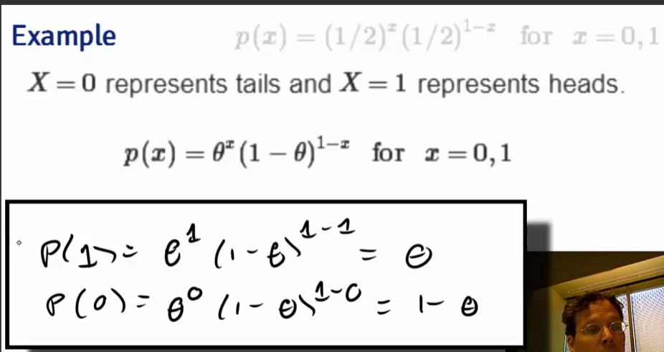

### 02 03 - Probability density functions

* ***Probability Density Function – pdf*** – function associated with continuous random variable
* To be a valid pdf, function must satisfy:
  + It must be larger than or equal to zero everywhere
  + The total area under it must be one
* Areas under pdfs correspond to probabilities for that random variable
* Ex. IQ is normal distribution with mean =100, sd = 15
* Normal distributions are often difficult to work with – need specific methods
* Triangle distribution is easier to work with
  + ***Beta distribution*** – triangle distribution
  + pbeta( ) in R # probability from beta density
* ***Cummulative Distribution Function (CDF***) – cumulative distribution function of random variable X, returns the probability that the random variable is less than or equal to the value x
  + pbeta() returns the CDF value

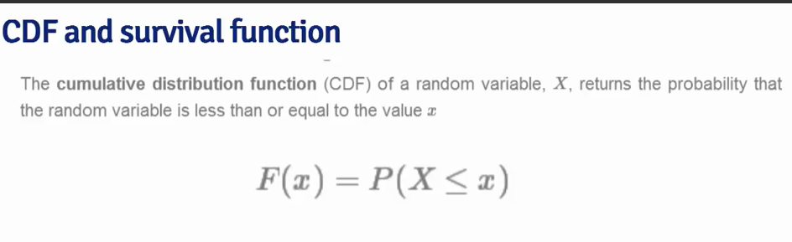

* ***Survival Function*** – survival function of a random variable X is defined as the probability that the random variable is greater than the value x

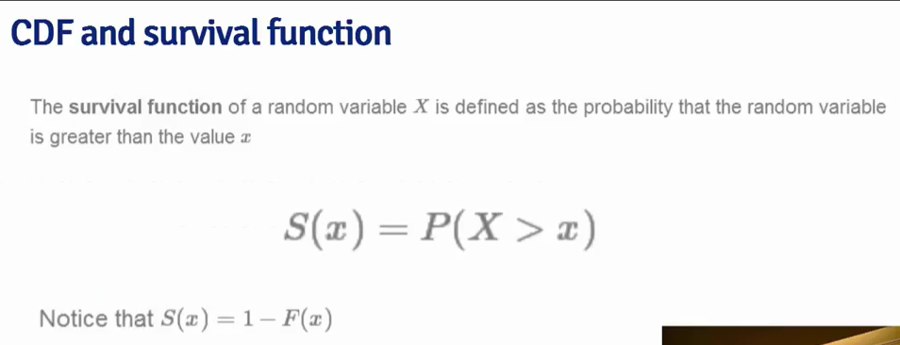

* R function

pbeta( c( 0.4, 0,5, 0.6), 2, 1 )

* ***Quantiles*** – sample quantiles (95th percentile on exam, 95% scored worse, and 5% better)
  + - formed from an ordered list of exam scores
    - This is a Sample Quantile
  + 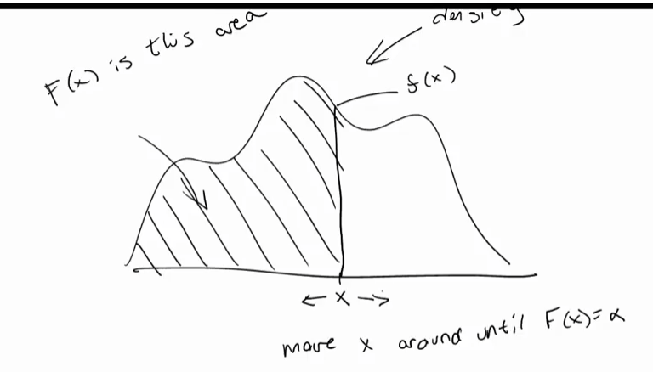**Population Quantile** – using the density function, find the value of x that gives the same F(x) probability that the quantile exists the same. Ex. find x such that F(x) area is same as 95% probability below x.

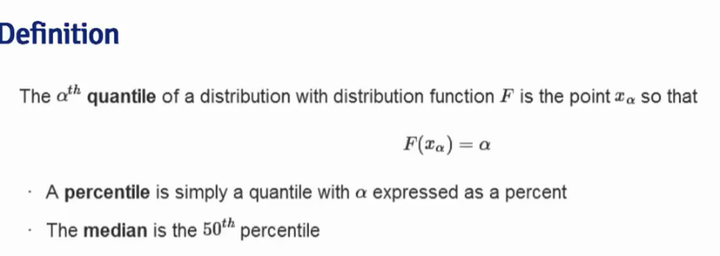

* Example: how many phone calls get answered on any given day?
  + beta distribution (triangle)
  + Means: on about 50% of days, 70% or fewer calls get answered and on 50% of days, 70% or more of phone calls get answered.

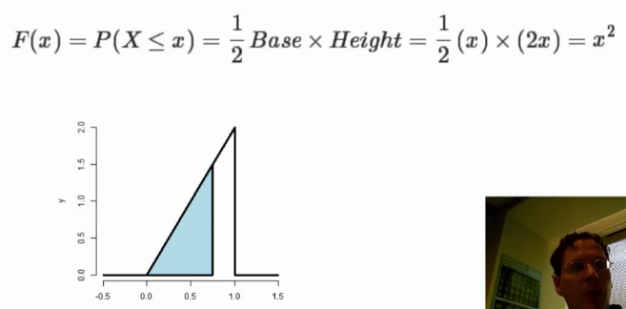

* R function to get quantiles from a density is use the ‘q’ form instead of the probability ‘p’ form:

qbeta ( 0.5, 2, 1 )

* **Summary**
  + medians – sample quantity calculation doesn’t require an integration (you have the counts and values for the SAMPLE of the population)
    - sample = virtual/simulation, population = reality
    - there is uncertainty in making estimates of population/reality from a sample/simulation
  + population quantities – the population median is different concept than a sample median
    - this is where the functions with integration exist (formal definitions)
  + A probability model connects the data (sample) to the population (reality) using assumptions
    - KNOW WHAT THESE ARE!!!
  + population median is an **estimand**, a sample median is the **estimator**
    - making good/accurate assumptions can lead to an estimator that gets close to estimand
  + Formal process of statistical inference – link a sample to a population
    - justify making estimates of the population from the sample

## Module 3: Conditional Probability

### Conditional probability

Conditional probability is a very intuitive idea, "What is the probability given partial information about what has occurred?". The probability of getting hit by lightning is small. However, it's much larger for people playing outside in open fields during a lightning storm! In these lectures we go over the formal rules of conditional probability.

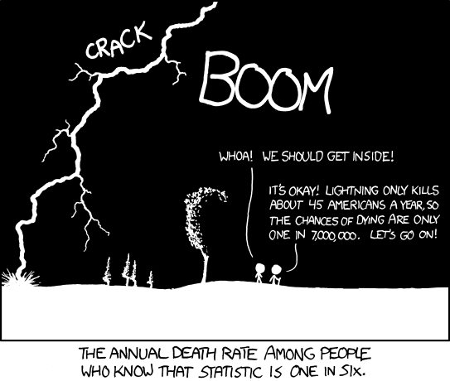

<https://xkcd.com/795/>

### 03 01 - Conditional Probability

* lighting strike comic – the character didn’t condition the probability based on what they KNOW
* extra information may change your assumptions – and therefore you should change the estimator
* Conditional Probability – defined: let B be an event so that P(B) > 0, then:

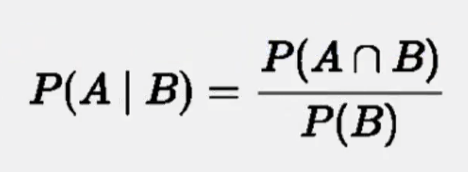

For statistically independent events, then the prior event gives no new information toward estimate for next event

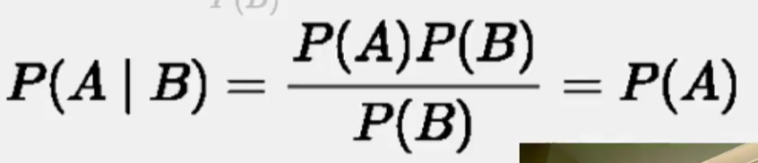

### 03 02 Bayes' rule

* Presbyterian Minister, posthumously published
* Can estimate probability of B given A with additional information.

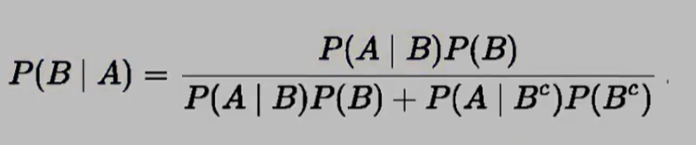

* Useful for diagnostic testing
  + Desire a high sensitivity and high specificity
* ***Sensitivity*** = probability of a positive test result given that subject does truly have condition
* ***Specificity*** = probability of a negative test result given that subject does not truly have condition

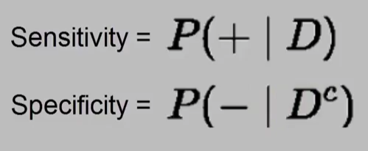

* positive predictive value – probability of having condition given a positive test result
* negative predictive value – probability of having condition given a negative test result
* prevalence of disease – in absence of a test, probability of having condition

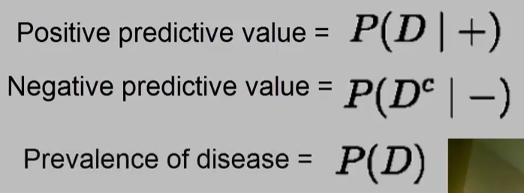

* Example:

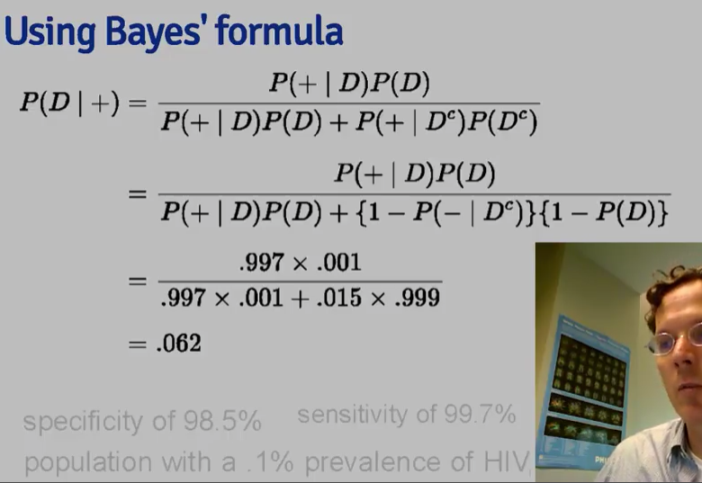

* Example 2: new information that gives indication for different prevalence
* Likelihood ratios –

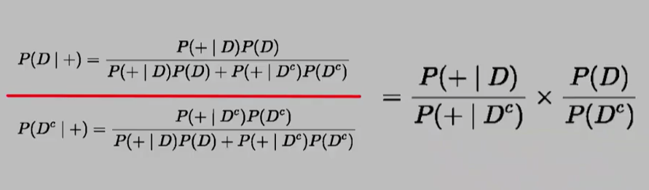

which gives:

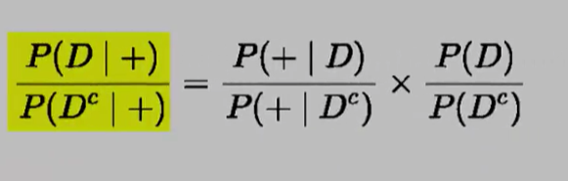

* + Right side: ***post test chance of condition*** - Odds of condition given a positive test result
  + Left side: ***pre-test chance of condition -*** odds of condition in absence of positive test result
  + Middle term: ***diagnostic likelihood ratio*** for positive test result
* post-test odds of D = DLR+ x pre-test odds of D
* **Odds**: divide a probability by (1 – that probabilitiy)
* Example 2:

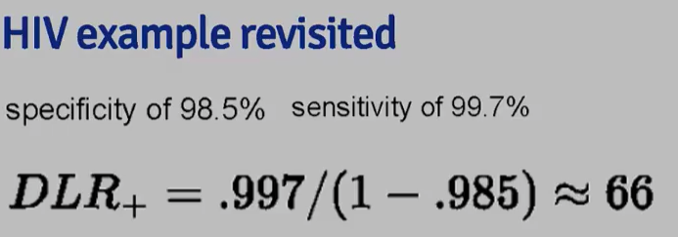

In other words: no matter pre-test odds, times by 66 to get post-test odds. This means hypothesis of conidion is 66 times more supported by data than hypothesis of no-condition.

“So let's go through our example. Suppose that subject has a positive HIV test. If we calculate using our sensitivity and specificity from before, the diagnostic likelihood ratio works out to be 0.997, divided by 1 minus 0.985, which works out to be 66. In other words, no matter what your pre-test odds are, you multiply them times 66 to obtain your post-test odds. Or in other words, the hypothesis of disease is 66 times more supported by the data than the hypothesis of no disease. Now, if the pretest odds are very small, then still multiplying by 66 will result in a still small number, though 66 times larger. Let's just very quickly go over an incidence when a subject has a negative test result in using the DLR minus. So, in this case, the DLR minus from the sensitivity and specificity given before is 0.003. So, therefore, your post-test odds of disease in the light of a negative test result is now 0.3% that of the pre-test odds of the te, disease. Or in other words, the hypothesis of disease is supported 0.003 times that of the hypothesis of the absence of disease given the negative test result. “

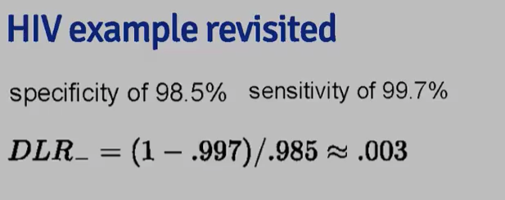

### 03 03 - Independence

* **Important lesson: you can’t just multiply probabilities together (UNLESS THEY ARE INDEPENDENT EVENTS)**
  + COMMON ERROR: multiply probabilities when events are not independent

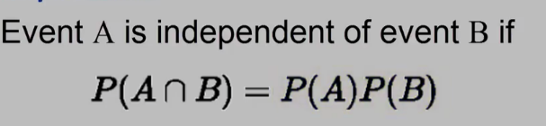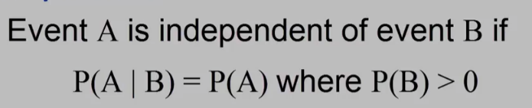

* Convicted on statistics: <http://understandinguncertainty.org/node/545>



* Sally Clark, mother convicted of death of two children (age 3months and 2 months)
  + first death treated as SIDS
  + second death treated as suspicious – leading to conviction
  + no witnesses
  + prosecution used medical witnesses – one witness used glaringly incorrect analysis that brought entire case to doubt by appeals court
  + Sir Meadow: child abuse expert, made testimony as to the odds of two SIDS cases in one family
    - made an assumption of independence: the death of second child was independent of death of first child – this assumption means that SIDS occurs randomly with no known outside cause that confounds both estimates
    - A hidden cause might make a family more vulnerable to SIDS.
    - Since SIDS causes are unknown, there is no evidence for SIDS to be considered independent events
    - For the case there was a need to prove beyond all reasonable doubt that the two SIDS events are independent. Not possible in this case.
      * There could be an inherited disorder, there could be an environmental condition that was not considered in the estimator (and therefore not idependent)
  + ***Prosecutors Fallacy:***

The second mistake arising from Professor Meadow’s evidence as to probabilities is known as the “Prosecutor’s Fallacy”. This consists of showing that the “innocent” explanation for certain facts is highly improbable – and then deducing that the “guilty” explanation is therefore the correct one. This type of mistake is particularly likely to occur in trials such as that of Sally Clark, where there are only two realistic options open to the jury – either the defendant committed murder, or her children died from unexplained, and comparatively rare, natural causes. For Sally Clark, once the jury accepted that there was only a 1 in 73 million chance that the deaths occurred due to SIDS, it was a short and easy step to conclude that this was the same probability as the probability of any other natural (but unexplained) cause of death; and that there was therefore a 1 in 73 million chance that she was not guilty of murder. It would be hard not to convict in those circumstances.

* + Also a case of asking the wrong question:
    - This Case asked: “what is probability that these deaths were natural?”
      * answered as: 1 in 73 million
    - Proper question: “is it more likely that these deaths were natural rather than deliberate?”
      * repeat unexpected infant deaths (second deaths in same family) studies showed that 2/3 of second deaths were caused by natural type causes
    - evidence clearly moved from her field of competence to a completely different area of expertise.
  + Incorrect use of the study
    - design of study cited was not in light of a named individual with specific set of circumstances:
    - the study did not consider all possible causes in the group deaths, let alone all the possible causes of the particular case outcome
    - similar to the lightning strike comic – did not consider all the information available
    - NOT PERMISSABLE TO MAKE ANY INFERENCE ABOUT SPECIFIC FACTS RELATED TO SALLY CLARK BASED ON THE FINDINGS OF THIS STUDY
    - **Ecological Fallacy** – mistaken assumption that the data which is correct for the group is also correct for all individuals within a group
* **Another similar case:**

This was another example of the Prosecutor’s Fallacy in action. (i) The prosecution sought to persuade the jury that the presence of firearm discharge residue in Barry George’s coat pocket showed that he had fired a gun. (ii) In order to prove this, the prosecution showed that, before the event, it was highly unlikely that this residue would find its way into a person’s pocket by innocent contamination. (iii) At the trial after the event, the court was therefore invited to discount that innocent explanation, in favour of a guilty explanation. (iv) Nobody told the jury that the guilty explanation was just as likely as the innocent explanation; and it appears that nobody asked that question.

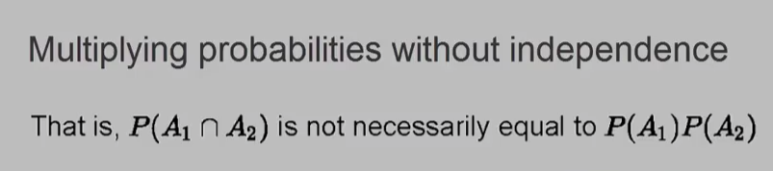

* ***Identically distributed, Independent Variables (IID)***
  + random variables are said to be IID if they are independent and identically distributed
  + Independent: statistically unrelated from one another
  + Identically Distributed: all having been drawn from the same population distribution
* IID random variables are default model for random samples
  + principle conceptual model whether you have random variables or not… in this class?

## Module 4: Expected Values

### Expected values

The empirical average is a very intuitive idea; it's the middle of our data in a sense. But, what is it estimating? We can formally define the middle of a population distribution. This is the expected value. Expected values are very useful for characterizing populations and usually represent the first thing that we're interested in estimating.

### 04- 01 Expected values

* ***Statistical Inference*** – the process of making conclusions about populations from noisy data that was drawn from it.
* the expected value is the middle of a population distribution
* assume that populations and the randomness governing our sample is given by densities and mass functions
  + don’t need to talk about the whole function, only need characteristics of the densities and mass functions
  + most useful are called expected values, there are also sample quantiles
* Mean = expected value, the center of a distribution, as mean changes so the distribution moves
* Variance = spread of data around the mean
* Quantiles = the probabilities of where other data lie compared to a sample constituent based on the distribution

INFERENECE IS TO USE ASSUMPTIONS ABOUT A SAMPLE VALUE (MEAN, VARIANCE, STANDARD DEVIAITION, etc.) TO ESTIMATE THE POPULATION CHARACTERISTICS.

* Expected value is summation of value times the probability of that value in the density mass
  + Center of mass of the population
* 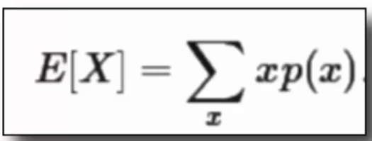
  + Center of Mass concept for the sample mean (and the expected value)
    - where for the sample data a mean is calculated

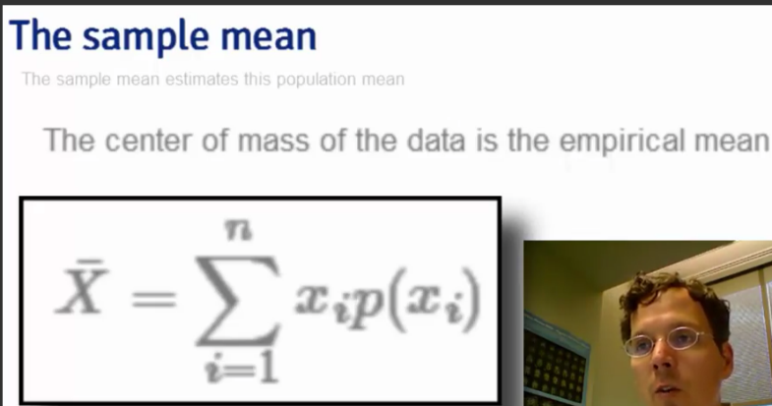

* In R function, manipulate( ) to change the values to change the histograms in the example.
* Mean Squared Error = measure of inbalance of an estimated mean to the sample mean.

### 04- 02 Expected values, simple examples

* Population Expected Value:

### 04- 03 Expected values for PDFs

* Center of Mass for a probability density function: uniform density E(x) = 0.5
* Assumption Conclusion for Statistical Inference: the mean of the sample mean is exactly the same as the mean of the population (the estimator is unbiased from the estimand)
* Simulation variability for large number of iterations closes to true estimands
  + Averages of results have distributions that are centered very near the true values after many iterations
  + Expected means may have no TRUE meaning (i.e. 0.5 for a coin flip, no half flips exist), but they are useful to identify the whereabouts of the true estimands
* **Summary**:
  + Expected values are properties of distributions
  + The population mean is the center of mass of population
  + the sample mean is the center of mass of the observed data
  + the sample mean is an estimate of the population mean (estimand)
  + the sample mean is unbiased
    - the population mean of its distribution is the mean that it is trying to estimate
  + the more data that goes into the sample mean, the more concentrated its density / mass function is around the population mean

## Practical R Exercises in swirl 1

### Setup

R.version.string

install.packages(“swirl”)

packageVersion(“swirl”)

install_from_swirl(“Statistical Inference”)

swirl()

Do these exercises:

* Introduction
* Probability 1
* Probability 2
* Conditional Probability
* Expectations

### Assignment: swirl Lesson 1: Introduction

statistical inference lets scientists formulate conclusions from data and quantify the uncertainty arising from using incomplete data.

The uncertainty could arise from incomplete or bad data.

* Small sample size
* Selection bias
* A poorly designed study

Types of problems addressed with statistical inference

* Testing the effectiveness of a medical treatment
* Determining a causative mechanism underlying a disease
* Estimating the proportion of people who will vote for a candidate
* Testing the efficacy of a new drug
* Constructing a medical image from fMRI data
* Polling before an election to predict its outcome

emphasize a couple of important points here

* First, a statistic (singular) is a number computed from a sample of data. We use statistics to infer information about a population.
* Second, a random variable is an outcome from an experiment.
* Deterministic processes, such as computing means or variances, applied to random variables, produce additional random variables which have their own distributions. It's important to keep straight which distributions you're talking about.
* Finally, there are two broad flavors of inference.
* The first is frequency, which uses "long run proportion of times an event occurs in independent, identically distributed repetitions."
* The second is Bayesian in which the probability estimate for a hypothesis is updated as additional evidence is acquired.

### Assignment: swirl Lesson 2: Probability1

**probability**, the study of quantifying the likelihood of particular events occurring.

* The probability of a particular outcome of an experiment is the ratio of the number of ways that outcome can occur to all possible outcomes of the experiment.
* Since the probability of a particular outcome or event E is the ratio of ways that E could occur to the number of all possible outcomes or events, the probability of E, denoted P(E), is always between 0 and 1.
* Impossible events have a probability of 0 (since they can't occur) and events that are certain to occur have a probability of 1.
* If A and B are two independent events then the probability of them both occurring is the product of the probabilities. P(A&B) = P(A) * P(B)
* The probability of at least one of two events, A and B, occurring is the sum of their individual probabilities minus the probability of their intersection. P(A U B) = P(A) + P(B) - P(A&B).
* It follows that if A and B are disjoint or mutually exclusive, i.e. only one of them can occur, then P(A U B) = P(A)+P(B) .

### Assignment: swirl Lesson 3: Probability2

| Recall that a random variable is a numerical outcome of an experiment.

| It can be discrete (take on only a countable number of possibilities),

| or continuous (take on any value on the real line or subset of it).

| Continuous random variables are usually associated with measurements of

| time, distance, or some biological process since they can take on any

| value, often within some specified range. Limitations of precision in

| taking the measurements may imply that the values are discrete; we in

| fact consider them continuous.

A ***probability mass function (PMF)*** gives the probability that a discrete random variable is exactly equal to some value.

* For instance, suppose we have a coin which may or may not be fair. Let x=0 represent a 'heads' outcome and x=1 represent a 'tails' outcome of a coin toss. If p is the probability of 'heads' which of the following represents the PMF of the coin toss? The variable x is either 0 (heads) or 1 (tails). (p^(1-x))*(1-p)^x

A ***probability density function*** is associated with a continuous random variable. To quote from Wikipedia, it "is a function that describes the relative likelihood for this random variable to take on a given value. The probability of the random variable falling within a particular range of values is given by ... the area under the density function but above the horizontal axis and between the lowest and greatest values of the range.

* It must be nonnegative everywhere, and the area under it must equal one.

The ***cumulative distribution function (CDF)*** of a random variable X, either discrete or continuous, is the function F(x) equal to the probability that X is less than or equal to x. In the example above, the area of the blue triangle represents the probability that the random variable was less than or equal to the value 1.6.

* If you're familiar with calculus you might recognize that when you're computing areas under curves you're actually integrating functions.
* When the random variable is continuous, as in the example, the PDF is the derivative of the CDF. So integrating the PDF (the line represented by the diagonal) yields the CDF. When you evaluate the CDF at the limits of integration the result is an area.

The ***survivor function S(x)*** of a random variable X is defined as the function of x equal to the probability that the random variable X is greater than the value x. This is the complement of the CDF F(x), in our example, the portion of the lower triangle that is not shaded.

The ***quantile*** v of a CDF is the point x_v at which the CDF has the value v. More precisely, F(x_v)=v. A percentile is a quantile in which v is expressed as a percentage.

A probability model connects data to a population using assumptions.

Be careful to distinguish between population medians and sample medians.

A sample median is an estimator of a population median (the estimand).

### Assignment: swirl Lesson 4: ConditionalProbability

We represent the conditional probability of an event A given that B has occurred with the notation P(A|B). More specifically, we define the conditional probability of event A, given that B has occurred with the following.

P(A|B) = P(A & B)/ P(B) . P(A|B) is the probability that BOTH A and B occur divided by the probability that B occurs.

From the definition of P(A|B), we can write P(A&B) = P(A|B) * P(B), right? Let's use this to express P(B|A).

P(B|A) = P(B&A)/P(A) = P(A|B) * P(B)/P(A). This is a simple form of ***Bayes' Rule*** which relates the two conditional probabilities.

* Suppose we don't know P(A) itself, but only know its conditional probabilities, that is, the probability that it occurs if B occurs and the probability that it occurs if B doesn't occur. These are P(A|B) and P(A|~B), respectively. We use ~B to represent 'not B' or 'B complement'.
* We can then express P(A) = P(A|B) * P(B) + P(A|~B) * P(~B) and substitute this is into the denominator of Bayes' Formula.
* We can then express P(A) = P(A|B) * P(B) + P(A|~B) * P(~B) and substitute this is into the denominator of Bayes' Formula: P(B|A) = P(A|B) * P(B) / ( P(A|B) * P(B) + P(A|~B) * P(~B) )

Suppose we know the accuracy rates of the test for both the positive| case (positive result when the patient has HIV) and negative (negative test result when the patient doesn't have HIV). These are referred to as test sensitivity and specificity, respectively.

* P(+|D) and P(-|~D)

Suppose a person gets a positive test result and comes from a population with a HIV prevalence rate of .001. We'd like to know the probability that he really has HIV. Which of the following represents this?

* P(D|+)

By Bayes' Formula, P(D|+) = P(+|D) * P(D) / ( P(+|D) * P(D) + P(+|~D) * P(~D) )

We can use the prevalence of HIV in the patient's population as the value for P(D). Note that since P(~D)=1-P(D) and P(+|~D) = 1-P(-|~D) we can calculate P(D|+). In other words, we know values for all the terms on the right side of the equation. Let's do it!

* Disease prevalence is .001. Test sensitivity (+ result with disease) is 99.7% and specificity (- result without disease) is 98.5%. First compute the numerator, P(+|D)*P(D). (This is also part of the denominator.)
* Now put the pieces together to compute the probability that the patient has the disease given his positive test result, P(D|+). Plug your last two answers into the formula :

P(+|D) * P(D) / ( P(+|D) * P(D) + P(+|~D) * P(~D) ) to compute P(D|+)

* So the patient has a 6% chance of having HIV given this positive test result. The expression P(D|+) is called the positive predictive value. Similarly, P(~D|-), is called the negative predictive value, the probability that a patient does not have the disease given a negative test result.

The diagnostic likelihood ratio of a positive test, DLR_+, is the ratio of the two + conditional probabilities, one given the presence of disease and the other given the absence. Specifically, DLR_+ = P(+|D) / P(+|~D). Similarly, the DLR_- is defined as a ratio. Which of the following do you think represents the DLR_-? P(-|D) / P(-|~D)

Recall that P(+|D) and P(-|~D), (test sensitivity and specificity respectively) are accuracy rates of a diagnostic test for the two possible results. They should be close to 1 because no one would take an inaccurate test, right? Since DLR_+ = P(+|D) / P(+|~D) we recognize the numerator as test sensitivity and the denominator as the complement of test specificity.

* expect DLR+ to be large
* expect DLR- to be small

Now a little more about likelihood ratios. Recall Bayes Formula. P(D|+) = P(+|D) * P(D) / ( P(+|D) * P(D) + P(+|~D) * P(~D) ) and notice that if we replace all occurrences of 'D' with '~D', the denominator doesn't change. This means that if we formed a ratio of P(D|+) to P(~D|+) we'd get a much simpler expression (since the complicated denominators would cancel each other out). Like this....

* P(D|+) / P(~D|+) = P(+|D) * P(D) / (P(+|~D) * P(~D)) = P(+|D)/P(+|~D) * P(D)/P(~D)
* The left side of the equation represents the post-test odds of disease given a positive test result. The equation says that the post-test odds of disease equals the pre-test odds of disease (that is, P(D)/P(~D) ) times the DLR_+
* In other words, a DLR_+ value equal to N indicates that the hypothesis of disease is N times more supported by the data than the hypothesis of no disease.

Taking the formula above and replacing the '+' signs with '-' yields a formula with the DLR_-. Specifically, P(D|-) / P(~D|-) = P(-|D) / P(-|~D) * P(D)/P(~D). As with the positive case, this relates the odds of disease post-test, P(D|-) / P(~D|-), to those of disease pre-test, P(D)/P(~D).

The equation P(D|-) / P(~D|-) = P(-|D) / P(-|~D) * P(D)/P(~D) says what about the post-test odds of disease relative to the pre-test odds of disease given negative test results?

* post-test odds are less than pre-test odds

Two events, A and B, are independent if they have no effect on each other. Formally, P(A&B) = P(A)*P(B). It's easy to see that if A and B are independent, then P(A|B)=P(A). The definition is similar for random variables X and Y.

* If the chance of developing a disease with a genetic or environmental component is p, is the chance of both you and your sibling developing that disease p*p? NO – not independent cases.

Random variables are said to be iid if they are independent and identically distributed. By ***independent*** we mean

"***statistically unrelated from one another***". Identically distributed means that "all have been drawn from the same population distribution".

* Random variables which are iid are the default model for random samples and many of the important theories of statistics assume that variables are iid. We'll usually assume our samples are random and variables are iid.

### Assignment: swirl Lesson 5: Expectations

The expected value of a random variable X, E(X), is a measure of its central tendency. For a discrete random variable X with PMF p(x), E(X) is defined as a sum, over all possible values x, of the quantity x*p(x). E(X) represents the center of mass of a collection of locations and weights, {x, p(x)}.

Another term for expected value is mean. Recall your high school definition of arithmetic mean (or average) as the sum of a bunch of numbers divided by the number of numbers you added together. This is consistent with the formal definition of E(X) if all the numbers are equally weighted.

One of the nice properties of the expected value operation is that it's linear. This means that, if c is a constant, then E(cX) = c*E(X). Also, if X and Y are two random variables then E(X+Y)=E(X)+E(Y). It follows that E(aX+bY)=aE(X)+bE(Y).

For a continuous random variable X, the expected value is defined analogously as it was for the discrete case. Instead of summing over discrete values, however, the expectation integrates over a continuous function.

It follows that for continuous random variables, E(X) is the area under the function t*f(t), where f(t) is the PDF (probability density function) of X. This definition borrows from the definition of center of mass of a continuous body.

sample expected values estimate the population versions.

* the mean of all sample means is the mean of the population (central limit theorem)
* The expected value or mean of the sample mean is the population mean. What this means is that the sample mean is an unbiased estimator of the population mean.

Formally, an estimator e of some parameter v is unbiased if its expected value equals v, i.e., E(e)=v. We can show that the expected value of a sample mean equals the population mean with some simple algebra.

* Let X_1, X_2, ... X_n be a collection of n samples from a population with mean mu. The mean of these is (X_1 + X_2 + ... + X_n)/n.
* What's the expected value of the mean? Recall that E(aX)=aE(X), so E( (X_1+..+X_n)/n ) = 1/n * (E(X_1) + E(X_2) + ... + E(X_n)) = (1/n)*n*mu = mu.
* Each E(X_i) equals mu since X_i is drawn from the population with mean mu. We expect, on average, a random X_i will equal mu.

Let's recap. Expected values are properties of distributions. The average, or mean, of random variables is itself a random variable and its associated distribution itself has an expected value. The center of this distribution is the same as that of the original distribution.

* A sample mean is unbiased.

### Week 1 Quiz

Quiz: Quiz 16 questions

Due: Jun 12, 2016

6/6 correct

see pdf copy

## Week 2: Variability, Distribution, & Asymptotics

### Variability

An important characterization of a population is how spread out it is. One of the key measures of spread is variability. We measure population variability with the sample variance, or more often we consider the square root of both, called the standard deviation. The reason for taking the standard deviation is because that measure has the same units as the population. So if our population is a length measurement in meters, the standard deviation is in meters (whereas the variance is in meters squared).

Variability has many important uses in statistics. First, the population variance is itself an intrinsically interesting quantity that we want to estimate. Secondly, variability in our estimates is what makes them not imprecise. An important aspect of statistics is quantifying the variability in our estimates.

## Module 5: Variability

### 05 01 Introduction to variability

* population mean – where distribution is centered
* variance of a random variable is the measure of spread

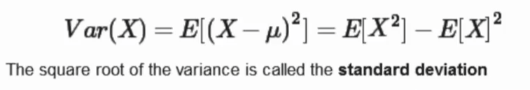

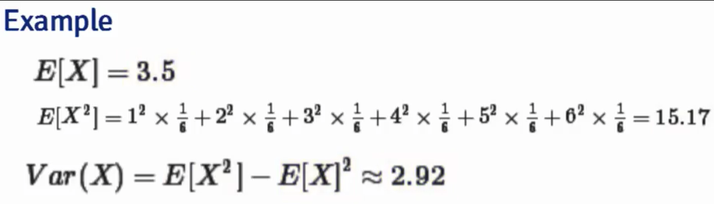

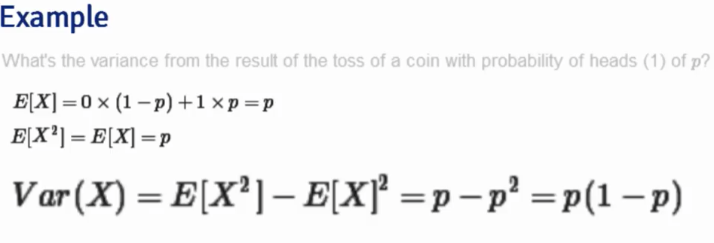

* The Sample Variance directly analogous to population variance

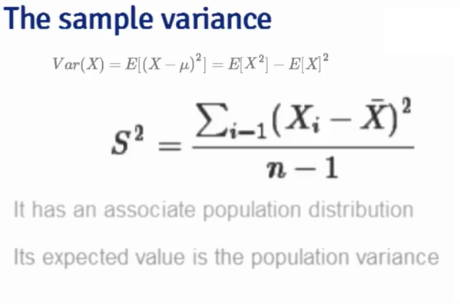

### 05 02 Variance simulation examples

* simulate 10 standard normal and get their sample variance (repeat 10000 times)
* no matter the sample size, the sample variance will approach the population variance
  + more data yields a closer (less variance) to the population variance
* Sample Variance is a good estimate of the population variance
  + unbiased estimator
  + ***the n-1 denomiator makes it unbiased***

### 05 03 Standard error of the mean

* the average(mean) of a random sample from a population is itself a random variable
  + the mean of the means is the population mean
* the variance of the mean gets closer to zero as there are more data (n-samples increases)
  + this is useful since there is only one sample mean in any given data set
  + you can estimate sigma squared and n to estimate the variance
* Standard Error of a mean (variability measure in the mean)

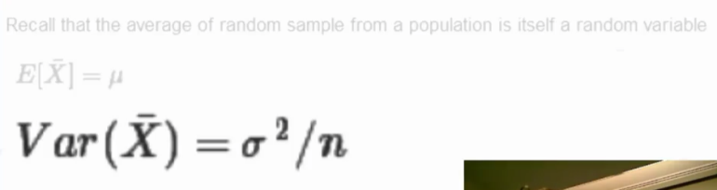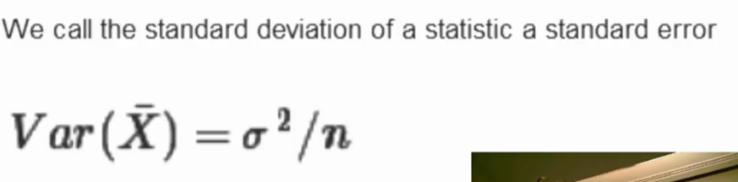

* Summary
  + sample variance (s squared) estimates the population variance (sigma squared)
  + s squared is random variable that gets centered closer to sigma squared as n-samples increases
  + variance of the sample mean is sigma squared divided by n
  + logical estimate of variance of sample mean is = s^2 / n
  + logical estimate of the ***standard error*** is S/sqrt(n) - variance of the sample mean
  + S, the standard deviation of sample, talks about how variable the population is
  + S/sqrt(n) , the standard error, talks about how variable averages of random samples of size n from the population are
  + Standard normals have variance of 1
  + means of n standard normals have standard deviation of 1/sqrt(n)
* Poisson(4) have variance of 4, means of random samples of n Poisson(4) have standard deviation of 2/sqrt(n)
* Biased coin flips have variance of 0.25, means of random samples of n coin flips have standard deviation of 1/(2*sqrt(n))

### 05 04 Variance data example

* see video
* we do not have the population density – we only have a sample
* standard deviaitions are in better units (inches for example)
* ***Summary:***
  + ***sample variance is estimate of population variance***
  + ***the distribution of the sample variance is centered at what it is estimating (unbiased)***
  + ***sample variance gets more concentrated around the population variance with larger sample sizes***
  + ***the variance of the sample mean is the population variance divided by n***

## Module 6: Distributions

### Distributions

Some probability distributions are so important that we need to internalize their characteristics. In these lectures we cover the most important probability distributions.

### 06 01 Binomial distribution

* ***Bernoulli distribution***: result of a binary outcome
  + one of the simplest distributions: Jacob ***Bernoulli*** – mathematician
  + random variables take only values 1 or 0 with probability p and 1-p
  + mean is p
  + variance is p(1-p)
  + Bernoulli mass function is below:

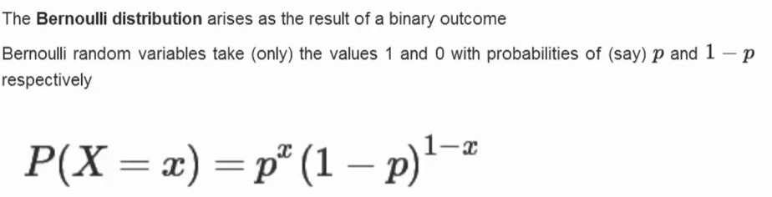

* ***Binomial Distribution***: sum of *iid*, bernoulli random variables

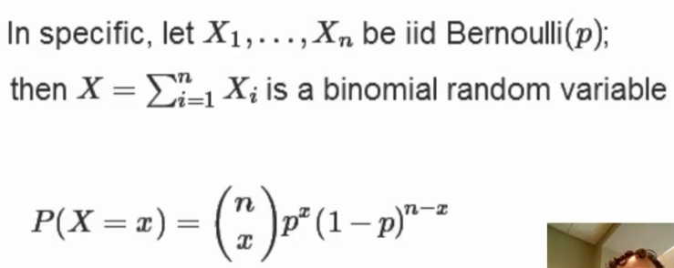

where:

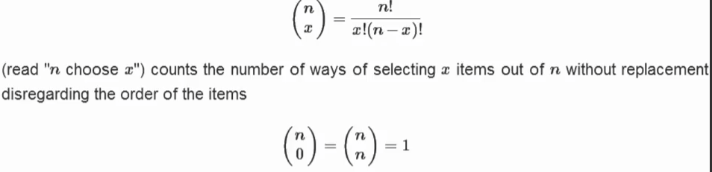

* + Example: what is probability of getting 7 girls in 8 children if 0.50 probability of boy/girl?
    - 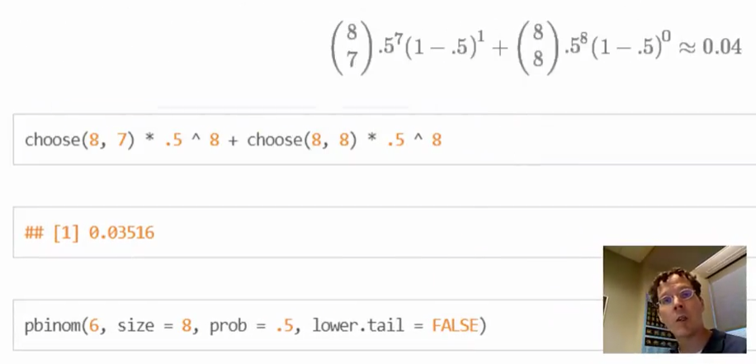

### 06 02 Normal distribution

* Gaussian distribution with mean mu and variance of sigma squared
  + standard normal has mean=0 and standard deviation = 1

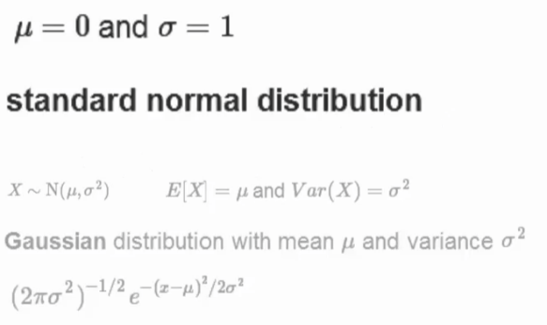

* probability area between the standard deviations are the same for all normal distributions
  + same calculations give way to compare different normal distributions
  + 1 SD ~ 34% either side of mean = 68% of area
  + 2 SD ~ 95% of area (with 2.5% in either tail)
  + 3 SD ~ 99% of mass area
* Can convert any normal to a standard normal:

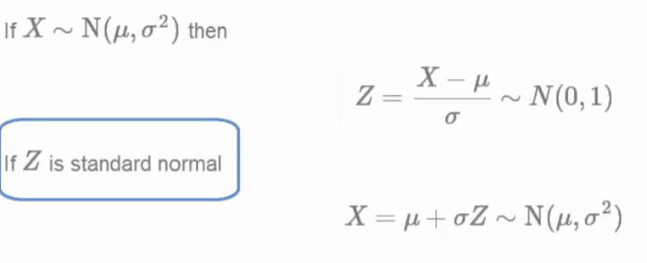

Some facts about normal density distributions:

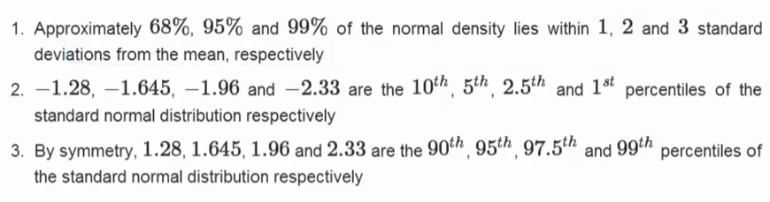

* Example: what is the 95th percentile of N(mu, sigmasqd) distribution?
  + qnorm( 0.95, mean = mu, sd = sigma )
  + mu + 1.645sig
* Example: what is the probability that N(mu, sigmasqd) RV is larger than x?
  + pnorm( x, mean = mu, sd = sigma, lower.tail = FALSE)
* Example: see below for probability

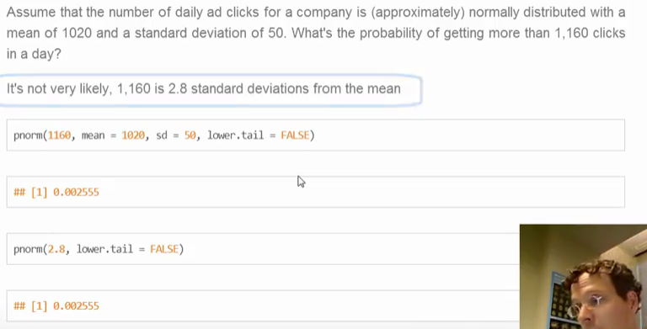

* Example: see below for quantile

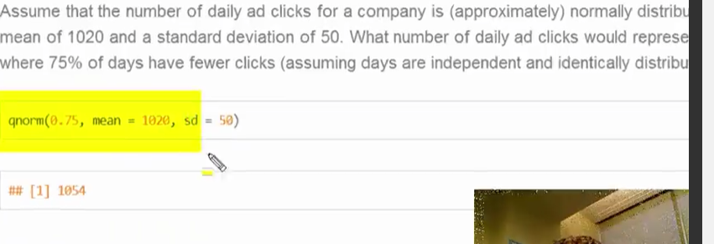

### 06 03 Poisson

* Poisson distribution: used to model counts
  + Normal distribution is most useful, but Poisson is common application
  + mean and variance are equal
  + counts must be non-negative values

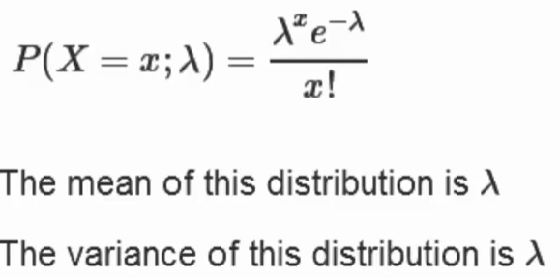

* Uses for Poisson distribution
  + model count data
    - arrival times, clicks
  + model event-time or survival data
    - biostats: cancer trials with new therapy, time to recurrence of symptoms
      * limited time of the survey/trial
      * some of the recurrences will stretch out past the deadline
      * so called “censoring” problem due to limited view
  + model contingency tables
    - classify across come breakout characteristics: hair color, race, gender
    - Poisson is default model for contingency tables

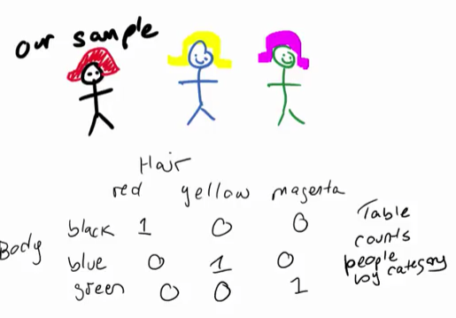

* + Used to approximate binomial distribution when n large, and p small
    - very common in epidemiology
    - binomial when n is large and p is small (air particulate effects on disease: big population in city, small occurences, small particles)
  + Model rates

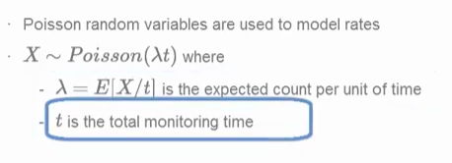

* Example: see below

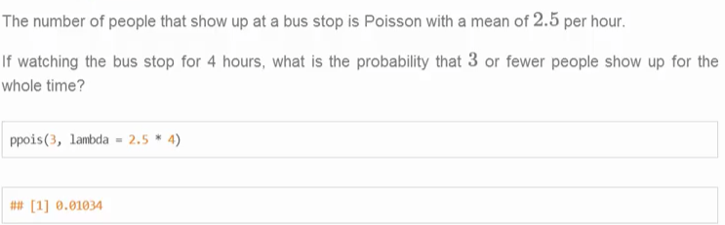

* Example: model a binomial distribution

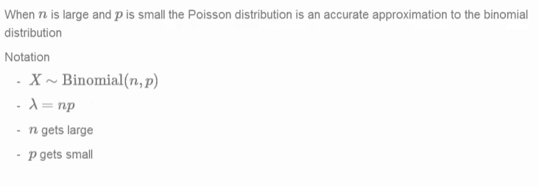

* + use the lambda for the Poisson distribution



## Module 7: Asymptotics

### Asymptotics

Asymptotics are an important topic in statistics. Asymptotics refers to the behavior of estimators as the sample size goes to infinity. Our very notion of probability depends on the idea of asymptotics. For example, many people define probability as the proportion of times an event would occur in infinite repetitions. That is, the probability of a head on a coin is 50% because we believe that if we were to flip it infinitely many times, we would get exactly 50% heads.

We can use asymptotics to help us figure out things about distributions without knowing much about them to begin with. A profound idea along these lines is the **Central Limit Theorem. It states that the distribution of averages is often normal, even if the distribution that the data is being sampled from is very non-normal. This helps us create robust strategies for creating statistical inferences when we're not willing to assume much about the generating mechanism of our data.**

### 07 01 Asymptotic and LLN

* **asymptotic**: term for behavior of statistics as the sample size (or some other relevant quantity) limits to infinity (or some other relevant number like zero)
  + in this class for when sample size limits toward infinity
  + Usefule for simple statistical inference and approximations
  + basis for frequency interpretation of probabilities (long run proportion of event occurences)
* Limits of random variables
  + allow us to talk about the large sample distribution of sample means of a collection of iid observations
  + Law of Large Numbers: intuitive, average limits to what it is estimating (the population mean)
    - eventually converges toward a population value
    - cumulative means converges to the true population mean
    - in R: cumsum( ) to calculate the cumulative means
* **Consistent**
  + An estimator is ***consistent*** if it converges to what you want to estimate
    - collecting an infinite amount of data provides the “right” answer
  + Law of Large Numbers says that the sample mean of iid samples is consistent for population mean
  + The sample variance and sample standard deviation of sample random variables are consistent as well

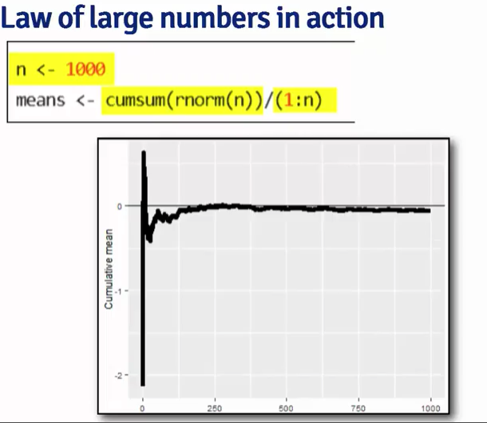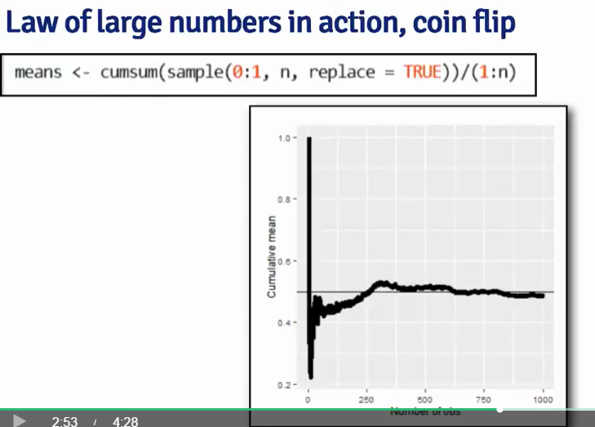

### 07 02 Asymptotic and the CLT

* ***Central Limit Theorem***: states the distribution of averages of iid variables (properly normalized) becomes that of a standard normal as the sample sizes increases.
  + applies to an almost endless number of populations
  + changing the population standard deviation (unknown) with the sample standard deviation (known) does not changes the central limit theorem
  + for large n-sample size the distribution of below is standard normal

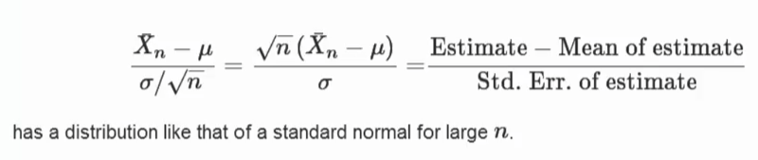



* Chi-squared statistic – a function of normal random variables
* Example: central limit theorem states that the distribution is normal standard

Fair coin example:

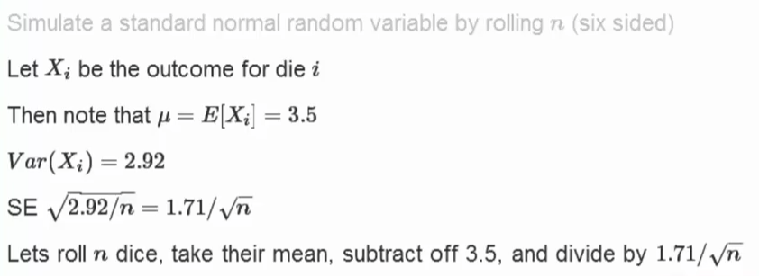

another one (unfair coin)

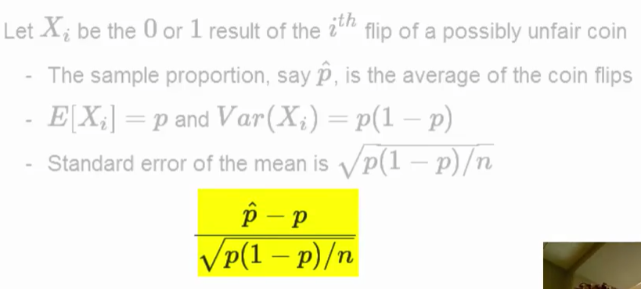

* when you have a biased coin, how unfair it is tends to increase the number of iterations required to converge
* ***Galton Board***
  + <https://www.youtube.com/watch?v=6YDHBFVIvIs>
  + you can’t say much about one ball path (too hard to predict)
  + buy you can say with some confidence about the pattern of many balls

### 07 03 Asymptotic and confidence intervals

* practical application of CLT
* probability that the interval contains mu (population mean)
  + 95% of intervals from random samples would contain mu

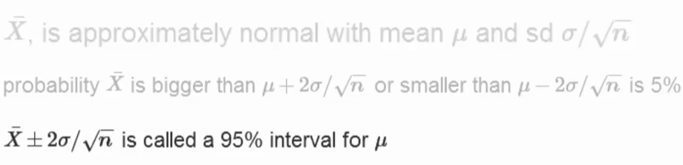

* Example: confidence interval for height of sons

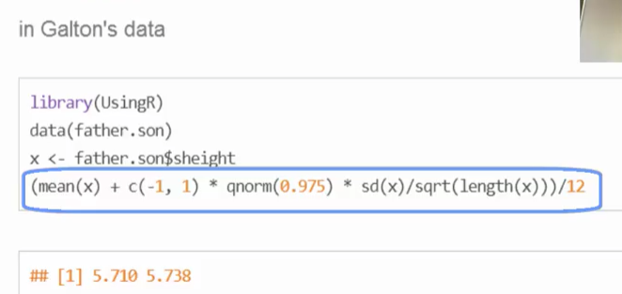

* Example: binomial confidence interval

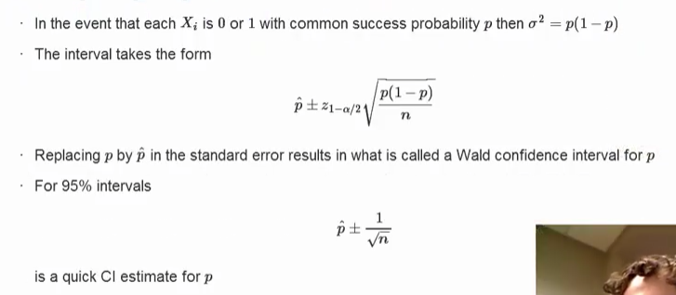

* Example: quick election confidence intervals

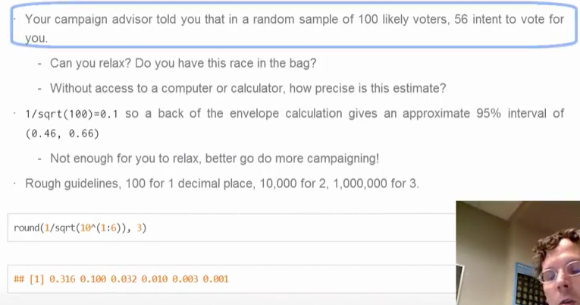

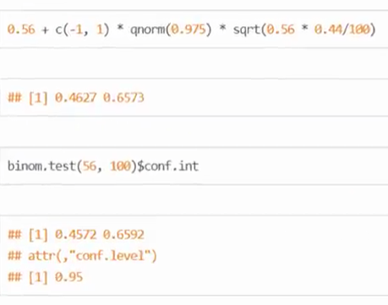

* Simulation: flip a coin many times

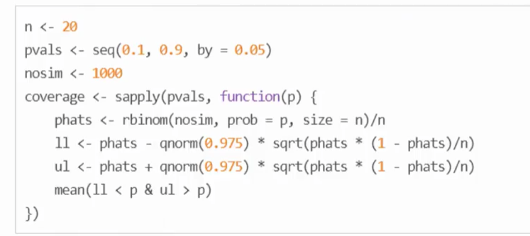

* + Monte Carlo Error: did only a 1000 iterations, not infinite number
  + CLT may not be great with smaller n for some problems
    - n is not large enough for CLT to be applicable
    - when n is larger, the performance (coverage) is better

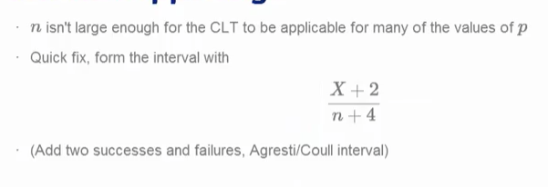

* Another Interval (conservative):
  + add two successes and 2 failures interval (instead of Wald interval)
* Poisson Intervals (argument for using the Agresti/Coulli interval

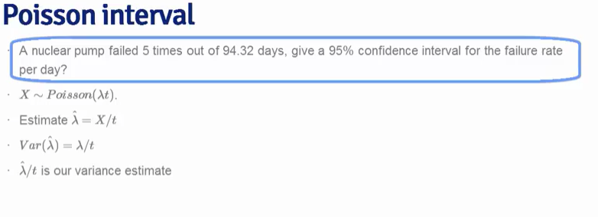

* see above
* In R below:

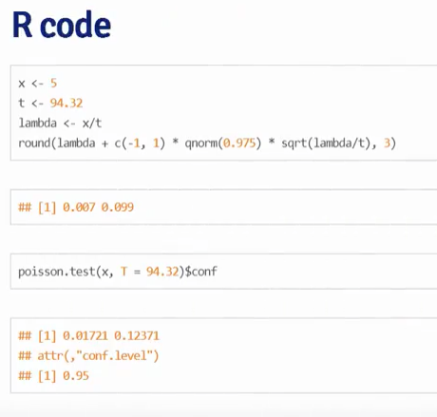

* Poisson Simulation



* + shows that coverage is very bad for small values of lambda
  + COVERAGE: proportion of times the upper and lower limits of 95% confidence interval calculated contains the lambda
* As monitoring time goes to infinity, the coverage factor closes to 100%
* As number of monitoring events goes lower, there is less coverage of lambda

Summarize:

* Law of large numbers – averages of iid samples converges to the population means that they are estimating
* Central Limit Theorem – averages are approximately normal with distributions centered at the population mean, with standard deviation equal to the standard error of the mean, DOES NOT guarantee n is large enough to be accurate.
* taking the mean and adding and subtracting the relevant normal quantile times the SE yields the confidence interval for the mean
  + adding and subtracting 2 SEs works for 95% intervals (1.96 more accurate)
* Confidence intervals get wider as the coverage increases (you need to ensure, certainty, there is doubt)
  + the more sure you want to be, the wider the interval must be
* Poisson and binomial cases have exact intervals that don’t require the CLT
  + ***but a quick fix for small sample size binomial is add 2 success and 2 failures.***

## Practical R Exercises in swirl Part 2

During this week of the course you should complete the following lessons in the Statistical Inference swirl course:

* Variance
* CommonDistros
* Asymptotics

### Assignment: swirl Lesson 1: Variance

| In this lesson, we'll discuss variances of distributions which, like

| means, are useful in characterizing them. While the mean characterizes

| the center of a distribution, the variance and its square root, the

| standard deviation, characterize the distribution's spread around the

| mean. As the sample mean estimates the population mean, so the sample

| variance estimates the population variance.

| The variance of a random variable, as a measure of spread or dispersion,

| is, like a mean, defined as an expected value. It is the expected

| squared distance of the variable from its mean. Squaring the distance

| makes it positive so values less than and greater than the mean are

| treated the same. In mathematical terms, if X comes from a population

| with mean mu, then

| Var(X) = E( (X-mu)^2 ) = E( (X-E(X))^2 ) = E(X^2)-E(X)^2

Recall that

| E(X), the expected value of a random variable from the population, is

| mu, the mean of that population.

| Finally, it's easy to show from the definition and the linearity of

| expectations that, if a is a constant, then Var(aX)=a^2*Var(X). This

| will come in handy later.

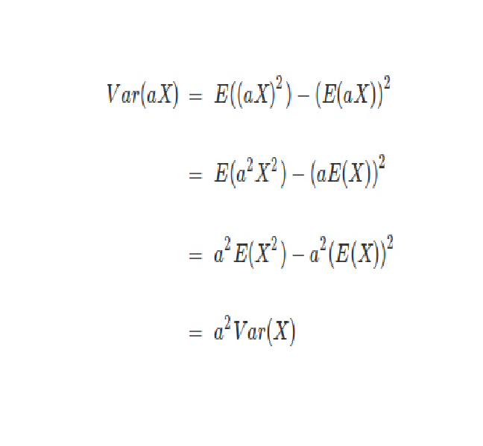

| Let's practice computing the variance of a dice roll now. First we need

| to compute E(X^2). From the definition of expected values, this means

| we'll take a weighted sum over all possible values of X^2. The weight is

| the probability of X occurring.

| Just as we distinguished between a population mean and a sample mean we

| have to distinguish between a population variance sigma^2 and a sample

| variance s^2. They are defined similarly but with a slight difference.

| The sample variance is defined as the sum of n squared distances from

| the sample mean divided by (n-1), where n is the number of samples or

| observations. We divide by n-1 because this is the number of degrees of

| freedom in the system. The first n-1 samples or observations are

| independent given the mean. The last one isn't independent since it can

| be calculated from the sample mean used in the formula.

| In other words, the sample variance is ALMOST the average squared

| deviation from the sample mean.

| As with the sample mean, the sample variance is also a random variable

| with an associated population distribution. Its expected value or mean

| is the population variance and its distribution gets more concentrated

| around the population variance with more data. The sample standard

| deviation is the square root of the sample variance.

| Now recall that the means of unbiased estimators equal the values

| they're trying to estimate. We can infer from the above that the sample

| variance is an unbiased estimator of population variance.

| Recall that the average of random samples from a population is itself a

| random variable with a distribution centered around the population mean.

| Specifically, E(X') = mu, where X' represents a sample mean and mu is

| the population mean.

| We can show that, if the population is infinite, the variance of the

| sample mean is the population variance divided by the sample size.

| Specifically, Var(X') = sigma^2 / n. Let's work through this in four

| short steps.

| Which of the following does Var(X') equal? Here X' represents the sample

| mean and 'Sum(X_i)' represents the sum of the n samples X_1,...X_n.

| Assume these samples are independent.

Var(1/n * Sum(X_i))

| Which of the following does Var(1/n * Sum(X_i)') equal?

1/n^2*Var(Sum(X_i))

| Recall that Var is an expected value and expected values are linear.

| Also recall that our samples X_1, X_2,...,X_n are independent. What does

| Var(Sum(X_i)) equal?

Sum(Var(X_i))

| Finally, each X_i comes from a population with variance sigma^2. What

| does Sum(Var(X_i)) equal? As before, Sum is taken over n values.

n*(sigma)^2

| So we've shown that

| Var(X')=Var(1/n*Sum(X_i))=(1/n^2)*Var(Sum(X_i))=(1/n^2)*Sum(sigma^2)=sigma^2/n

| for infinite populations when our samples are independent.

| The standard deviation of a statistic is called its standard error, so

| the standard error of the sample mean is the square root of its

| variance.

| We just showed that the variance of a sample mean is sigma^2 / n and we

| estimate it with s^2 / n. It follows that its square root, s / sqrt(n),

| is the standard error of the sample mean.

| The sample standard deviation, s, tells us how variable the population

| is, and s/sqrt(n), the standard error, tells us how much averages of

| random samples of size n from the population vary. Let's see this with

| some simulations.

Standard uniform

| distributions have variance 1/12. The theory tells us the standard error

| of means of independent samples of size n would have which standard

| error?

1/sqrt(12*n)

Poisson(4) are distributions with variance 4;

| what standard error would means of random samples of n Poisson(4) have?

2/sqrt(n)

> sd(apply(matrix(rnorm(10000),1000),1,mean))

[1] 0.3154588

> sd(apply(matrix(runif(10000),1000),1,mean))

[1] 0.090426

> sd(apply(matrix(rpois(10000,4),1000),1,mean))

[1] 0.6250327

Fair coin flips have variance 0.25;

| means of random samples of n coin flips have what standard error?

1/(2*sqrt(n))

| Finally, here's something interesting. Chebyshev's inequality helps

| interpret variances. It states that the probability that a random

| variable X is at least k standard deviations from its mean is less than

| 1/(k^2). In other words, the probability that X is at least 2 standard

| deviations from the mean is less than 1/4, 3 standard deviations 1/9, 4

| standard deviations 1/16, etc.

| However this estimate is quite conservative for random variables that

| are normally distributed, that is, with bell-curve distributions. In

| these cases, the probability of being at least 2 standard deviations

| from the mean is about 5% (as compared to Chebyshev's upper bound of

| 25%) and the probability of being at least 3 standard deviations from

| the mean is roughly .2%.

### Assignment: swirl Lesson 2: CommonDistros

| The first distribution we'll examine is the Bernoulli which is

| associated with experiments which have only 2 possible outcomes. These

| are also called (by people in the know) binary trials.

| For simplicity, we usually say that Bernoulli random variables take only

| the values 1 and 0. Suppose we also specify that the probability that

| the Bernoulli outcome of 1 is p. Which of the following represents the

| probability of a 0 outcome? 1-p

| If the probability of a 1 is p and the probability of a 0 is 1-p which

| of the following represents the PMF of a Bernoulli distribution? Recall

| that the PMF is the function representing the probability that X=x.

p^x * (1-p)^(1-x)

Recall the definition of the expectation of a random variable. Suppose

| we have a Bernoulli random variable and, as before, the probability it

| equals 1 (a success) is p and probability it equals 0 (a failure) is

| 1-p. What is its mean?

p

| Given the same Bernoulli random variable above, which of the following

| represents E(X^2)

p

| Use the answers of the last two questions to find the variance of the

| Bernoulli random variable. Recall Var = E(X^2)-(E(X))^2

p(1-p)

| Binomial random variables are obtained as the sum of iid Bernoulli

| trials. Specifically, let X_1, ..., X_n be iid Bernoulli(p) random

| variables; then X = X_1 + X_2 + ... X_n is a binomial random variable.

| Binomial random variables represent the number of successes, k, out of n

| independent Bernoulli trials. Each of the trials has probability p.

| The PMF of a binomial random variable X is the function representing the

| probability that X=x. In other words, that there are x successes out of

| n independent trials. Which of the following represents the PMF of a

| binomial distribution? Here x, the number of successes, goes from 0 to

| n, the number of trials, and choose(n,x) represents the binomial

| coefficient 'n choose x' which is the number of ways x successes out of

| n trials can occur regardless of order.

| To take the value x, the random variable X must have x 'successes'. Each

| of these occurs with probability p. It also must have n-x 'failures',

| each of which occurs with probability (1-p). We don't care about the

| order in which the successes and failures occur so we have to multiply

| by choose(n,x).

choose(n,x) * p^x * (1-p)^(n-x)

| Suppose we were going to flip a biased coin 5 times. The probability of

| tossing a head is .8 and a tail .2. What is the probability that you'll

| toss at least 3 heads.

> choose(5,3)*(0.8^3)*(1-0.8)^(5-3) + choose(5,4)*(0.8^4)*(1-0.8)^(5-4) + choose(5,5)*(0.8^5)*(1-0.8)^(5-5)

[1] 0.94208

> pbinom(2, 5, 0.8, lower.tail=FALSE)

[1] 0.94208

| Another very common distribution is the normal or Gaussian. It has a

| complicated density function involving its mean mu and variance sigma^2.

| The key fact of the density formula is that when plotted, it forms a

| bell shaped curve, symmetric about its mean mu. The variance sigma^2

| corresponds to the width of the bell, the higher the variance, the

| fatter the bell. We denote a normally distributed random variable X as X

| ~ N(mu, sigma^2)

| When mu = 0 and sigma = 1 the resulting distribution is called the

| standard normal distribution and it is often labeled Z.

| Approximately 68%, 95% and 99% of the normal density lie within 1, 2 and

| 3 standard deviations from the mean, respectively. These are shown in

| the three shaded areas of the figure. For example, the darkest portion

| (between -1 and 1) represents 68% of the area.

| Here are two useful facts concerning normal distributions. If X is a

| normal random variable with mean mu and variance sigma^2, i.e., X ~

| N(mu,sigma^2),

| then the random variable Z defined as Z = (X -mu)/sigma is normally

| distributed with mean 0 and variance 1, i.e., Z ~ N(0, 1). (Z is

| standard normal.)

| The converse is also true. If Z is standard normal, i.e., Z ~ N(0,1),

| then the random variable X defined as X = mu + sigma*Z is normally

| distributed with mean mu and variance sigma^2, i.e., X ~ N(mu, sigma^2)

| Suppose you have a normal distribution with mean 1020 and standard

| deviation of 50 and you want to compute the probability that the

| associated random variable X > 1200. The easiest way to do this is to

| use R's pnorm function in which you specify the quantile (1200), the

| mean (1020) and standard deviation (50). You also must specify that the

| lower.tail is FALSE since we're asking for a probability that the random

| variable is greater than our quantile. Do this now.

> pnorm(1200, 1020, 50, lower.tail=FALSE)

[1] 0.0001591086

| For practice, using the same distribution, find the 75% percentile. Use

| qnorm and specify the probability (.75), the mean (1020) and standard

| deviation (50). Since we want to include the left part of the curve we

| can use the default lower.tail=TRUE.

> qnorm(0.75, 1020, 50, lower.tail=TRUE)

[1] 1053.724

| Note that R functions pnorm and qnorm are inverses. What would you

| expect pnorm(qnorm(.53)) to return?

> pnorm(qnorm(0.53))

[1] 0.53

> qnorm(pnorm(0.53))

[1] 0.53

| Now let's talk about our last common distribution, the Poisson. This is,

| as Wikipedia tells us, "a discrete probability distribution that

| expresses the probability of a given number of events occurring in a

| fixed interval of time and/or space if these events occur with a known

| average rate and independently of the time since the last event."

| In other words, the Poisson distribution models counts or number of

| event in some interval of time. From Wikipedia, "Any variable that is

| Poisson distributed only takes on integer values."

| The PMF of the Poisson distribution has one parameter, lambda. As with

| the other distributions the PMF calculates the probability that the

| Poisson distributed random variable X takes the value x. Specifically,

| P(X=x)=(lambda^x)e^(-lambda)/x!. Here x ranges from 0 to infinity.

| The mean and variance of the Poisson distribution are both lambda.

| Poisson random variables are used to model rates such as the rate of

| hard drive failures. We write X~Poisson(lambda*t) where lambda is the

| expected count per unit of time and t is the total monitoring time.

| For example, suppose the number of people that show up at a bus stop is

| Poisson with a mean of 2.5 per hour, and we want to know the probability

| that at most 3 people show up in a 4 hour period. We use the R function

| ppois which returns a probability that the random variable is less than

| 3. We only need to specify the quantile (3) and the mean (2.5 * 4). We

| can use the default parameters, lower.tail=TRUE and log.p=FALSE. Try it

| now.

> ppois(3, 2.5*4, lower.tail=TRUE, log.p=FALSE)

[1] 0.01033605

| Finally, the Poisson distribution approximates the binomial distribution

| in certain cases. Recall that the binomial distribution is the discrete

| distribution of the number of successes, k, out of n independent binary

| trials, each with probability p. If n is large and p is small then the

| Poisson distribution with lambda equal to n*p is a good approximation to

| the binomial distribution.

| To see this, use the R function pbinom to estimate the probability that

| you'll see at most 5 successes out of 1000 trials each of which has

| probability .01. As before, you can use the default parameter values

| (lower.tail=TRUE and log.p=FALSE) and just specify the quantile, size,

| and probability.

> pbinom(5,1000,0.01,lower.tail=TRUE, log.p=FALSE)

[1] 0.06613951

| Now use the function ppois with quantile equal to 5 and lambda equal to

| n*p to see if you get a similar result.

> ppois(5,1000*0.01)

[1] 0.06708596

| See how they're close? Pretty cool, right? This worked because n was

| large (1000) and p was small (.01).

### Assignment: swirl Lesson 3: Asymptotics

| In this lesson, we'll discuss asymptotics, a topic which describes how

| statistics behave as sample sizes get very large and approach infinity.

| Pretending sample sizes and populations are infinite is useful for

| making statistical inferences and approximations since it often leads to

| a nice understanding of procedures.

| Asymptotics generally give no assurances about finite sample

| performance, but they form the basis for frequency interpretation of

| probabilities (the long run proportion of times an event occurs).

| The Law of Large Numbers (LLN) says that the average (mean) approaches

| what it's estimating. We saw in our simulations that the larger the

| sample size the better the estimation. As we flip a fair coin over and

| over, it eventually converges to the true probability of a head (.5).

| The LLN forms the basis of frequency style thinking.

| We say that an estimator is CONSISTENT if it converges to what it's

| trying to estimate. The LLN says that the sample mean of iid samples is

| consistent for the population mean. This is good, right?

Based on our previous lesson do you think the sample variance (and hence

| sample deviation) are consistent as well? YES

| Now for something really important - the CENTRAL LIMIT THEOREM (CLT) -

| one of the most important theorems in all of statistics. It states that

| the distribution of averages of iid variables (properly normalized)

| becomes that of a standard normal as the sample size increases.

| Let's dissect this to see what it means. First, 'properly normalized'

| means that you transformed the sample mean X'. You subtracted the

| population mean mu from it and divided the difference by sigma/sqrt(n).

| Here sigma is the standard deviation of the population and n is the

| sample size.

| Second, the CLT says that for large n, this normalized variable,

| (X'-mu)/(sigma/sqrt(n)) is almost normally distributed with mean 0 and

| variance 1. Remember that n must be large for the CLT to apply.

Since the

| population std deviation sigma is unknown, sigma/sqrt(n) is often

| approximated by what?

the standard error of the sample mean

| Let's rephrase the CLT. Suppose X_1, X_2, ... X_n are independent,

| identically distributed random variables from an infinite population

| with mean mu and variance sigma^2. Then if n is large, the mean of the

| X's, call it X', is approximately normal with mean mu and variance

| sigma^2/n. We denote this as X'~N(mu,sigma^2/n).

| Notice that the CLT said nothing about the original population being

| normally distributed. That's precisely where its usefulness lies! We can

| assume normality of a sample mean no matter what kind of population we

| have, as long as our sample size is large enough and our samples are

| independent. Let's look at how it works with a binomial experiment like

| flipping a coin.

| Recall that if the probability of a head (call it 1) is p, then the

| probability of a tail (0) is 1-p. The expected value then is p and the

| variance is p-p^2 or p(1-p).

| Here's a figure from the slides showing the results of 3 such trials

| where each trial is for a different value of n (10, 20, and 30) and the

| coin is fair,so E(X)=.5 and the standard error is 1/(2sqrt(n)). Notice

| how with larger n (30) the histogram tightens up around the mean 0.

the same experiment, this time

| using a biassed coin. We set the probability of a head to .9, so E(X)=.9

| and the standard error is sqrt(.09/n) Again, the larger the sample size

| the more closely the distribution looks normal, although with this

| biassed coin the normal approximation isn't as good as it was with the

| fair coin.

| Here's another example of applying this formula from the slides. Suppose

| you were running for office and your pollster polled 100 people. Of

| these 60 claimed they were going to vote for you. You'd like to estimate

| the true proportion of people who will vote for you and you want to be

| 95% confident of your estimate. We need to find the limits that will

| contain the true proportion of your supporters with 95% confidence, so

| we'll use the formula p' +/- 1/sqrt(n) to answer this question. First,

| what value would you use for p', the sampled estimate?

| Another technique for calculating confidence intervals for binomial

| distributions is to replace p with p'. This is called the Wald

| confidence interval. We can also use the R function qnorm to get a more

| precise quantile value (closer to 1.96) instead of our ballpark estimate

| of 2.

> 0.6 + c(-qnorm(0.975)*sqrt(0.6*(1-0.6)/100), qnorm(0.975)*sqrt(0.6*(1-0.6)/100))

[1] 0.5039818 0.6960182

| Keep trying! Or, type info() for more options.

| Type .6 + c(-1,1)*qnorm(.975)*sqrt(.6*.4/100) at the command prompt.

> .6 + c(-1,1)*qnorm(.975)*sqrt(.6*.4/100)

[1] 0.5039818 0.6960182

| As an alternative to this Wald interval, we can also use the R function

| binom.test with the parameters 60 and 100 and let all the others

| default. This function "performs an exact test of a simple null

| hypothesis about the probability of success in a Bernoulli experiment."

| (This means it guarantees the coverages, uses a lot of computation and

| doesn't rely on the CLT.) This function returns a lot of information but

| all we want now are the values of the confidence interval that it

| returns. Use the R construct x$conf.int to find these now.

> binom.test(60,100)$conf.int

[1] 0.4972092 0.6967052

attr(,"conf.level")

[1] 0.95

| Suppose we flip a coin a small number of times, say 20. Also suppose we

| have a function mywald which takes a probability p, and generates 30

| sets of 20 coin flips using that probability p. It uses the sampled

| proportion of success, p', for those 20 coin flips to compute the upper

| and lower bounds of the 95% Wald interval, that is, it computes the two

| numbers p'+/- qnorm(.975) * sqrt(p' * (1-p') / n) for each of the 30

| trials. For the given true probability p, we count the number of times

| out of those 30 trials that the true probability p was in the Wald

| confidence interval. We'll call this the coverage.

| To make sure you understand what's going on, try running mywald now with

| the probability .2. It will print out 30 p' values (which you don't

| really need to see), followed by 30 lower bounds, 30 upper bounds and

| lastly the percentage of times that the input .2 was between the two

| bounds. See if you agree with the percentage you get. Usually it

| suffices to just count the number of times (out of the 30) that .2 is

| less than the upper bound.

| A quick fix to the problem of having a small n is to use the

| Agresti/Coull interval. This simply means we add 2 successes and 2

| failures to the counts when calculating the proportion p'. Specifically,

| if X is the number of successes out of the 20 coin flips, then instead

| of setting p'=X/20, let p'=(X+2)/24. We use 24 as the number of trials

| since we've added 2 successes and 2 failures to the counts. Note that we

| still use 20 in the calculation of the upper and lower bounds.

| Let's move on to Poisson distributions and confidence intervals. Recall

| that Poisson distributions apply to counts or rates. For the latter, we

| write X~Poisson(lambda*t) where lambda is the expected count per unit of

| time and t is the total monitoring time.

| Here's another example from the slides. Suppose a nuclear pump failed 5

| times out of 94.32 days and we want a 95% confidence interval for the

| failure rate per day. The number of failures X is Poisson distributed

| with parameter (lambda*t). We don't observe the failure rate, but we

| estimate it as x/t. Call our estimate lambda_hat, so lambda_hat=x/t.

| According to theory, the variance of our estimated failure rate is

| lambda/t. Again, we don't observe lamdba, so we use our estimate of it

| instead. We thus approximate the variance of lambda_hat as lambda_hat/t.

| So lamb is our estimated mean and lamb/t is our estimated variance. The

| formula we've used to calculate a 95% confidence interval is est mean +

| c(-1,1)*qnorm(.975)*sqrt(est var). Use this formula now making the

| appropriate substitutions.

> poisson.test(5, 94.32)

Exact Poisson test

data: 5 time base: 94.32

number of events = 5, time base = 94.32, p-value < 2.2e-16

alternative hypothesis: true event rate is not equal to 1

95 percent confidence interval:

0.01721254 0.12371005

sample estimates:

event rate

0.05301103

Better results with larger lambda and longer monitor times (higher lambda and/or t)

Summary:

* Law of Large Numbers says averages of iid samples converge to the population means they are estimating.
* The CLT tells the averages are approximately normal for large enough sample sizes
* CLT says averages have a normal distribution centered at the standard error
* To calculate a confidence interval for a mean you take the sample mean and add and subtract the relevant normal quantile times the standard error
* For a 95% confidence interval approximately how many standard errors would you add and subtract from the sample mean? 2
* If you wanted increased coverage what would you do to your confidence interval? increase it
* If you had less variability in your data would your confidence interval get bigger or smaller? smaller
* If you had larger sample size would your confidence interval get bigger or smaller? smaller
* A quick fix for small sample size binomial calculations is what? add 2 successes and 2 failures

### Week 2 Quiz

Quiz: Quiz 2 (8 questions)

Due June 19, 11:59 PM PDT

6/8 first attempt

8/8 second attempt

> choose(5,4)*0.5^5 + choose(5,5)*0.5^5

[1] 0.1875

> ?ppois

> ppois(16,15, lower.tail=TRUE)

[1] 0.6641232

> ppois(14,15,lower.tail=TRUE)

[1] 0.4656537

> ?pnorm

> ppois(10,5*3,lower.tail=TRUE)

[1] 0.1184644

> qnorm(0.95,1100, 75)

[1] 1223.364

> pnorm(0.95,1100,7.5)

[1] 0

> qnorm(0.95,1100,7.5)

[1] 1112.336

> pnorm(70,80,10)

[1] 0.1586553

> qnorm(0.95,1100,75)

[1] 1223.364

> qnorm(0.95,1100,7.5)

[1] 1112.336

> pbinom(3,5,0.5)

[1] 0.8125

> pbinom(3,5,0.5,lower.tail=FALSE)

[1] 0.1875

> pnorm(16,15,1)-pnorm(14,15,1)

[1] 0.6826895

> ppois(10,15,lower.tail=TRUE)

[1] 0.1184644

> ppois(10,15)

[1] 0.1184644

## Week 3: Intervals, Testing, & Pvalues

## Module 8: Confidence intervals

When we estimate something using statistics, usually that estimate comes with uncertainty. Take, for example, election polling. When we get a polled percentage of voters that favor a candidate, we were only able to sample a small subset of voters. Therefore, our estimate has uncertainty associated with it.

Confidence intervals are a convenient way to communicate that uncertainty in estimates.

### 08 01 T confidence intervals

* confidence intervals using the CLT take form of:
  + Estimate +/- Z-Quantile form Standard Normal Distribution * Standard Error estimate
  + Z-scores
  + Normal distributions are indexed by 2 parameters (mean and variance) 2 Degrees of freedom
* For small sample sizes this method doesn’t work as well
  + If you use Standard Normal distribution for small sample sizes, you can get confidence intervals that are too narrow
* T-Confidence Interval or Gosset’s T-distribution
  + Estimate +/- T-Quantile * Standard Error estimate
  + T-scores
* T-interval will be good to start (after more data it becomes more and more normal)
* William Gosset (invented under “Student” in 1908)
  + he worked for Guinness brewery
* T-Distribution
  + larger tails than normal distribution
  + indexed by one parameter called degrees of freedom (gets more standard normal with more DFs – i.e. more data)
  + assumes underlying data are iid Gaussian
    - Using S is not normal, but using sigma instead is normal
  + For small sample sizes the distribution more closely resembles the T-distribution
  + Looks like a squashed normal distribution (heavier tails)
  + Above the 50% percentile, the standard normal and t-distributions diverge significantly for small sample sizes
  + 1.96 SE for standard normal could be as high as 4+ SE
  + T-dist confidence interval will always be wider than standard normal

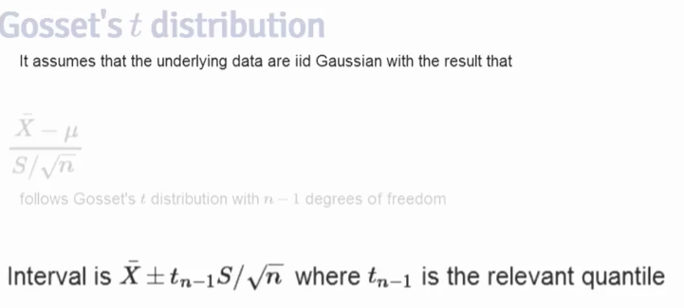

* Notes:
  + t-interval assumes data are iid normal (can have some robustness against this assumption)
  + works well when distribution is roughly symmetrical and mound shaped
  + paired observations are often analyzed using t-interval by taking differences (or log differences)
  + for large degrees of freedom, t quantiles become more standard normal (usually start with t-interval due to this)
  + For skewed distributions, the spirit of t-interval assumptions are violated
    - usually taking a log or using summary stat like mean will help fix this
    - for skewed data, centering the interval at the mean doesn’t have as much sense
  + For highly discrete data (like binary or Poisson data) other intervals are available

### 08 02 T confidence intervals example

* Sleep Data
  + Gosset’s Biometrika paper data
  + shows increase in hours for 10 patients on two soporific drugs (sleep meds)
  + Example:
    - must acknowledge the pairwise data (same subject which change with meds)
      * compare the differences per subject
    - if not acknowledge the study design, then you can only compare the variation in the two GROUPS which may not be as strong
* Different ways of getting the t-interval in R:

> data(sleep)

> head(sleep)

extra group ID

1 0.7 1 1

2 -1.6 1 2

3 -0.2 1 3

4 -1.2 1 4

5 -0.1 1 5

6 3.4 1 6

> tail(sleep)

extra group ID

15 -0.1 2 5

16 4.4 2 6

17 5.5 2 7

18 1.6 2 8

19 4.6 2 9

20 3.4 2 10

> g1 <- sleep$extra[1:10]

> g2 <- sleep$extra[11:20]

> difference <- g2-g1

> mn <- mean(difference)

> s <- sd(difference)

> n <- 10

> mn + c(-1,1) * qt(0.975, n-1) * s/sqrt(n)

[1] 0.7001142 2.4598858

> t.test(difference)

One Sample t-test

data: difference

t = 4.0621, df = 9, p-value = 0.002833

alternative hypothesis: true mean is not equal to 0

95 percent confidence interval:

0.7001142 2.4598858

sample estimates:

mean of x

1.58

> t.test(g2, g1, paird=TRUE) THIS WAS A TYPO ERROR

Welch Two Sample t-test

data: g2 and g1

t = 1.8608, df = 17.776, p-value = 0.07939

alternative hypothesis: true difference in means is not equal to 0

95 percent confidence interval:

-0.2054832 3.3654832

sample estimates:

mean of x mean of y

2.33 0.75

> t.test(g2, g1, paired=TRUE)

Paired t-test

data: g2 and g1

t = 4.0621, df = 9, p-value = 0.002833

alternative hypothesis: true difference in means is not equal to 0

95 percent confidence interval:

0.7001142 2.4598858

sample estimates:

mean of the differences

1.58

> t.test(extra ~ I(relevel(group,2)), paired=TRUE, data = sleep)

Paired t-test

data: extra by I(relevel(group, 2))

t = 4.0621, df = 9, p-value = 0.002833

alternative hypothesis: true difference in means is not equal to 0

95 percent confidence interval:

0.7001142 2.4598858

sample estimates:

mean of the differences

1.58

### 08 03 Independent group T intervals

* Problem: compare mean blood pressure between two groups in randomized trial
  + group one – received treatment, group two – received placebo
  + Data Science uses term A-B Testing
    - perform randomization to balance unobserved covariates that contaminate results
  + not a paired t-test since the groups are not matched
* Pooled variance – weighted variance of two groups by numbers of observations in the groups
  + interval assumes a constant variance across the two groups (randomization helps here)

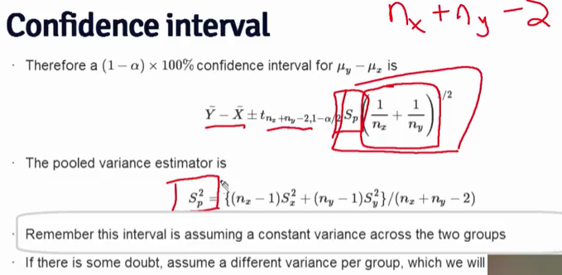

* without raw data, calculate the interval in R:

> sp <- sqrt((7 * 15.34^2 + 20* 18.23^2)/ (8+21-2))

> s[]

[1] 1.229995

> 132.86 - 127.44 + c(-1,1)*qt(0.975,27) * sp * (1/8 + 1/21)^0.5

[1] -9.521097 20.361097

* + interval contains 0, so cannot rule out 0 difference between two groups
* 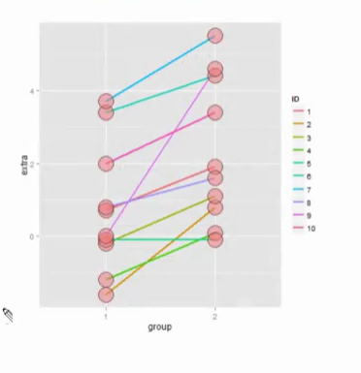Example: mistakenly treat sleep data as not paired data.
  + not taking into account the pairing gives a very different interval (and conclusion)

> n1 <- length(g1)

> n2 <- length(g2)

> sp <- sqrt( ((n1-1) * sd(g1)^2 + (n2-1) *sd(g2)^2) / (n1+n2-2))

> sp

[1] 1.898625

> md <- mean(g2) - mean(g1)

> semd <- sp * sqrt(1/n1 + 1/n2)

> rbind(md + c(-1,1) * qt(0.975, n1+n2-2) * semd, t.test(g2,g1, paired=FALSE, var.equal=TRUE)$conf, t.test(g2,g1,paired=TRUE)$conf)

[,1] [,2]

[1,] -0.2038740 3.363874

[2,] -0.2038740 3.363874

[3,] 0.7001142 2.459886

* Example: check weight
  + weights of chicks from birth until a couple weeks later.

> library(datasets)

> data("ChickWeight")

> library(reshape2)

Warning message:

package ‘reshape2’ was built under R version 3.2.4

> #define weight gain or loss

> wideCW <- dcast(ChickWeight, Diet + Chick ~ Time, value.var="weight")

> names(wideCW)[-(1:2)] <- paste("time", names(wideCW)[-(1:2)], sep="")

> dim(wideCW)

[1] 50 14

> dim(ChickWeight)

[1] 578 4

> library(dplyr)

> wideCW <- mutate(wideCW, gain = time21-time0)

> str(wideCW)

'data.frame': 50 obs. of 15 variables:

$ Diet : Factor w/ 4 levels "1","2","3","4": 1 1 1 1 1 1 1 1 1 1 ...

$ Chick : Ord.factor w/ 50 levels "18"<"16"<"15"<..: 1 2 3 4 5 6 7 8 9 10 ...

$ time0 : num 39 41 41 41 42 41 41 42 42 43 ...

$ time2 : num 35 45 49 48 51 47 44 50 51 48 ...

$ time4 : num NA 49 56 53 59 54 52 61 61 55 ...

$ time6 : num NA 51 64 60 68 58 63 71 72 62 ...

$ time8 : num NA 57 68 65 85 65 74 84 83 65 ...

$ time10: num NA 51 68 67 96 73 81 93 89 71 ...

$ time12: num NA 54 67 71 90 77 89 110 98 82 ...

$ time14: num NA NA 68 70 92 89 96 116 103 88 ...

$ time16: num NA NA NA 71 93 98 101 126 113 106 ...

$ time18: num NA NA NA 81 100 107 112 134 123 120 ...

$ time20: num NA NA NA 91 100 115 120 125 133 144 ...

$ time21: num NA NA NA 96 98 117 124 NA 142 157 ...

$ gain : num NA NA NA 55 56 76 83 NA 100 114 ...

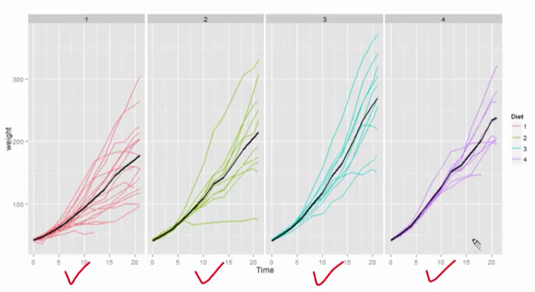

* First and last diets look as though the last one is faster weight gain (hypothesis)
  + more variability on 1
  + less samples on 4
  + violin plots show the variation for each diet at each time

|  |
| --- |
| > wideCW14 <- subset(wideCW, Diet %in% c(1,4))  > dim(wideCW14)  [1] 30 15  > rbind( t.test(gain ~ Diet, paired=FALSE, var.equal = TRUE, data=wideCW14)$conf, t.test(gain ~ Diet, paired=FALSE, var.equal=FALSE, data=wideCW14)$conf)  [,1] [,2]  [1,] -108.1468 -14.81154  [2,] -104.6590 -18.29932 |

* In both cases, the entire interval is below zero, so valid to suggest that the weight gain for the first diet is less than the fourth.

### 08 04 A note on unequal variance

* if X and Y are iid normal, with potentially different means and variances.

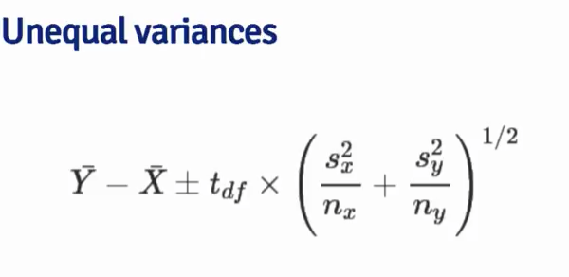

* degrees of freedom calculation for unequal variances (and means) -- DoF can be fractional.

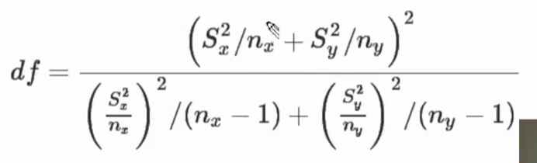

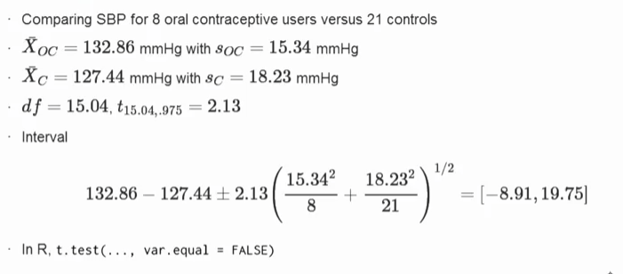

* Summary
  + create intervals when groups have a small number of observations or are not equal variance/mean
  + for binomial data, there are lots of ways to compare two groups
    - Relative risk, risk difference, odds ratio
    - Chi-squared tests, normal approximations, exact tests
  + For count data, theres also Chi-squared tests and exact tests

## Module 9: Hypothesis testing

**Hypothesis testing**

Deciding between two hypotheses is a core activity in scientific discovery. Statistical hypothesis testing is the formal inferential framework around choosing between hypotheses.

### 09 01 Hypothesis testing

* hypothesis testing is concerned with making decisions using data
* null hypothesis is specified to represent the status quo (Ho) H-not
* The null hypothesis is assumed true unless statistical evidence is able to reject it.
* Example: sleep disorder breathing

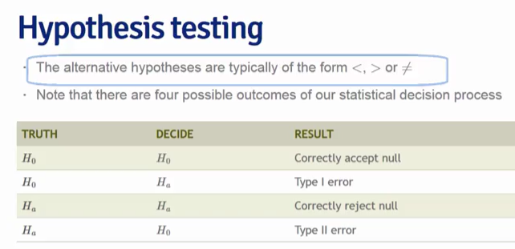

* Type 1 error = incorrectly reject the null hypothesis
* Type 2 error = incorrectly fail to reject the null hypothesis
  + Increasing the type 1 error decreases type 2 error and vice versa
  + courts assume innocent (null hypothesis)
    - increasing the number of free people staying free also increases the number of criminals staying free

### 09 02 Example of choosing a rejection region

* reasonable strategy is to reject null if mean of sample was larger than some constant
  + constant takes into consideration of variance of sample
  + typically constant is chosen such that probability of a Type 1 error (alpha) is 0.05 or some other low number
    - 5% probability of rejecting the null hypothesis when in fact the hypothesis is correct
* Example:
  + Standard error = 10/sqrt(100) = 1
  + Ho has sample N(30, 1)
  + Want to set C so that probability of X > C, under Ho is 0.05

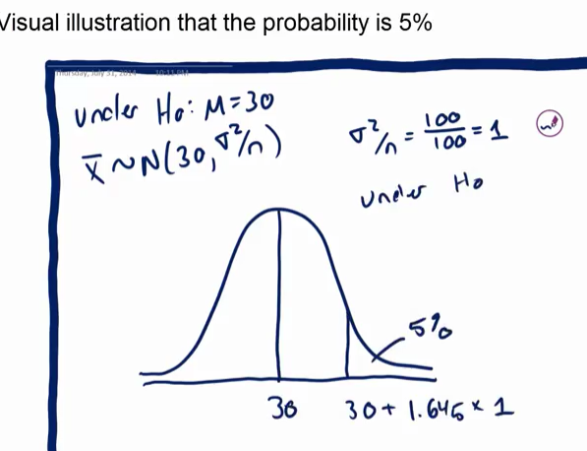

* C = 30 + 1 * 1.645 = 31.645
* So reject Ho when Xmean > 31.645 (only 5% chance to Type 1 error)

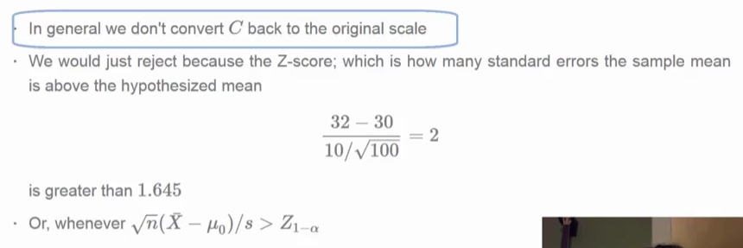

### 09 03 T tests

* using a T-distribution instead of a normal distribution

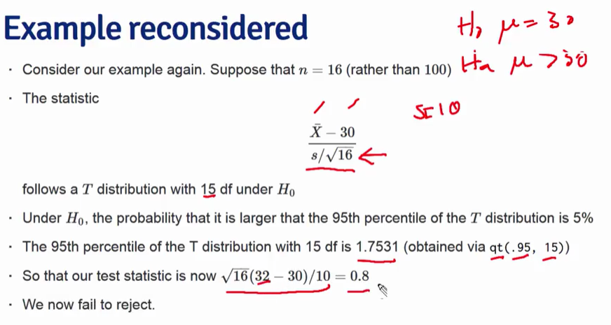

* Two-sided tests (reject if mean is too large or too small)
  + shifts the quantile used (5% Type 1 error rate uses 0.975 and 0.025
* Example: test if mean of sons heights is same as mean of fathers heights.
  + Data is paired (son with father)

> data(father.son)

> t.test(father.son$sheight - father.son$fheight)

One Sample t-test

data: father.son$sheight - father.son$fheight

t = 11.789, df = 1077, p-value < 2.2e-16

alternative hypothesis: true mean is not equal to 0

95 percent confidence interval:

0.8310296 1.1629160

sample estimates:

mean of x

0.9969728

> t.test(father.son$sheight, father.son$fheight, paired=TRUE)

Paired t-test

data: father.son$sheight and father.son$fheight

t = 11.789, df = 1077, p-value < 2.2e-16

alternative hypothesis: true difference in means is not equal to 0

95 percent confidence interval:

0.8310296 1.1629160

sample estimates:

mean of the differences

0.9969728

* Reject the null hypothesis since the t-score is very high.

### 09 04 Two group testing

* suppose that n = 16 (not 100)
* the test statistic is how many estimated standard errors from the hypothesized mean the sameple mean is follows a t-distribution (with 15 df under Ho)

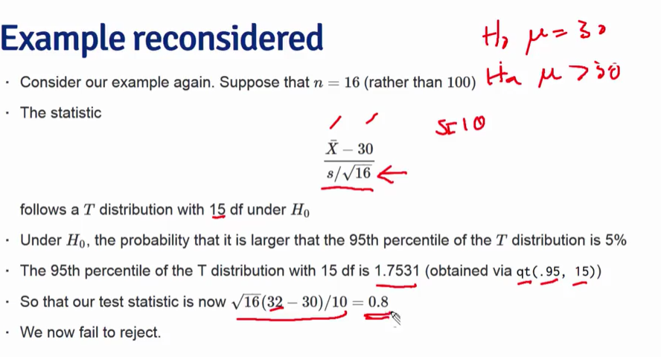

* Two Sided Tests
  + mandated to do two sided tests (know when this is)
  + reject test statistic when either too small or too large
  + remember to split the rejection probability to the two tails
  + two ways to think about it:
    - larger than qt( 0.975, 15) or smaller than qt(0.025, 15)
    - absolute value of statistic is larger than qt(0.975, 15)
* In R, use functions:
  + t = 11.79 (the t-statistic)
  + df = 1077 (the degrees of freedom from 1078 pairs)
    - probably not much different from z-test
  + 95% confidence interval (0.8831, 1.163) practical look at the results due to being in same units as the data
* If mean is in the confidence interval, then evidence supports the validity of that mean statistic
  + if Ho is interval is same as checking the two-sided hypothesis test
  + If mean is within the interval – fail to reject
  + If mean is outside the interval – reject the hypothesis
* For Two Group Intervals:
  + two group t-tests
  + rejection rules are same
  + test Ho: mu1 = mu2

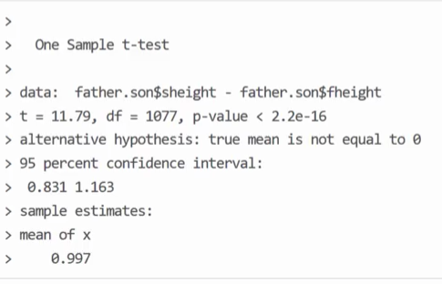

* Example for Two Group T-test
  + t-score is how many standard errors the statistic is from the mean

> library(datasets)

> data(ChickWeight)

> library(reshape2)

> #define weight gain or loss

> wideCW <- dcast(ChickWeight, Diet + Chick ~ Time, value.var="weight")

> names(wideCW)[-(1:2)] <- paste("time", names(wideCW)[-(1:2)], sep="")

> library(dplyr)

> wideCW <- mutate(wideCW, gain = time21-time0)

> wideCW14 <- subset(wideCW, Diet %in% c(1,4))

> t.test( gain ~ Diet, paired=FALSE, var.equal=TRUE, data=wideCW14)

Two Sample t-test

data: gain by Diet

t = -2.7252, df = 23, p-value = 0.01207

alternative hypothesis: true difference in means is not equal to 0

95 percent confidence interval:

-108.14679 -14.81154

sample estimates:

mean in group 1 mean in group 4

136.1875 197.6667

> t.test( gain ~ Diet, paired=FALSE, var.equal=FALSE, data=wideCW14)

Welch Two Sample t-test

data: gain by Diet

t = -2.9615, df = 20.937, p-value = 0.007464

alternative hypothesis: true difference in means is not equal to 0

95 percent confidence interval:

-104.65901 -18.29932

sample estimates:

mean in group 1 mean in group 4

136.1875 197.6667

* Exact Binomial Test
  + friend with 8 children, 7 of them are girls and none are twins
  + Ho: p=0.5, Ha: p > 0.5
  + due to discreteness you can’t get an exact 5% test
    - for larger sample sizes you can treat as normal
    - can use Clopper/Pearson interval which is a way to do a binomial discrete two-sided test
    - P-value is the most common way to compute the rejection region

## Module 10: P-values

### P-values

P-values are a convenient way to communicate the results of a hypothesis test. When communicating a P-value, the reader can perform the test at whatever Type I error rate that they would like. Just compare the P-value to the desired Type I error rate and if the P-value is smaller, reject the null hypothesis.

Formally, the P-value is the probability of getting data as or more extreme than the observed data in favor of the alternative. The probability calculation is done assuming that the null is true. In other words if we get a very large T statistic the P-value answers the question "How likely would it be to get a statistic this large or larger if the null was actually true?". If the answer to that question is "very unlikely", in other words the P-value is very small, then it sheds doubt on the null being true, since you actually observed a statistic that extreme.

* P-Values
  + assume the null hypothesis is true
  + P-value is probability of getting data as or more extreme than the observed data in favor of alternative hypothesis
  + When you get a large t-statistic then you can get a sense at how likely the null is true from p-value

### 10 01 P-values

* P-values are the most common measure of statistical significance.
  + comes with almost all hypothesis test software
* Controversial among statisticians: use and misuse issues
  + Apparently indiscriminate use (false assumptions?)
  + <http://warnercnr.colostate.edu/~anderson/thompson1.html>
    - list of 400+ references to how p-value should not be used.
  + Statistical Evidence: A Likelihood Paradigm by Richard Royall
  + Toward Evidence-Based Medical Statistics. 1: The P Value Fallacy by Steve Goodman
  + The Earth is Round (p < 0.05) by Cohen

<http://simplystatistics.org/2012/01/06/p-values-and-hypothesis-testing-get-a-bad-rap-but-we/>

* ***The goal is to establish a meaningful effect size***
  + P-value is one way to do this (assumptions, assumptions, assumptions)
* The Problem:
  + easily misinterpreted
  + not calibrated by sample size
  + ignores existing information or knowledge about parameter in question
  + p-values may be small (significant) when the parameter of interest is scientifically uninteresting (trivial results that add no new knowledge)
* Example statement: “under the null the chance of observing something this convincing is 0.65”
  + explains that the observation can easily happen by chance in setting that is uninteresting
  + for a p-value of significance, then more work is needed to decide if the parameter is scientifically interesting.
* p-value can be a method to provide decision algorithms for acceptance/approval protocols
  + government regulations
  + manufacturing
* **p-value useful properties for applied statisticians**
  + easy to calculate, even for complicated statistics
    - permutation and bootstrap procedures
  + relatively easy to understand
    - roughly same interpretation independent of complexity
    - bounded 0 to 1
    - they are prior probabilities (not posterior probabilities – this is not well understood)
  + simple, universal properties
    - uniformly distributed under the null
  + calibrated to error rates scientists care about
    - there are false positives (or false negatives)
    - ***publication bias*** = Studies with significant results often do not appear to be superior to studies with a null result with respect to quality of design. Significant results are 3 times more likely to be published.
  + useful for multiple testing correction
  + reproducible

<https://normaldeviate.wordpress.com/2013/03/14/double-misunderstandings-about-p-values/>

* Two misunderstandings:
  + p-value is not the probability of Ho (null hypothesis) given the data.
  + p-value is not the probability of something conditional on Ho (null hypothesis).
* P-values are FREQUENTIST
  + Ho is not a random variable
  + it makes no sense to talk about the posterior probability of Ho
  + it makes no sense to talk about conditioning on Ho
    - you can only condition on things that were random in first place
  + this is not bayes and Ho is not random, it is not accurate to say “probability conditional on theta

<https://errorstatistics.com/2013/06/14/p-values-cant-be-trusted-except-when-used-to-argue-that-p-values-cant-be-trusted/>

* P-values can’t be trusted except when used to argue that P-values can’t be trusted!
* Often criticisms of p-value use ignore the problem (incorrect use, bad assumptions, bad scientific method, etc.)

<https://errorstatistics.com/2016/05/10/my-slides-the-statistical-replication-crisis-paradoxes-and-scapegoats/>

* American Statistical Society (ASA) statement on p-values
  + The statistical community has been deeply concerned about issues of reproducibility and replicability of scientific conclusions.
  + Much confusion and even doubt about the validity of science is rising.
    - Such doubt can lead to radical choices such as to ban p-values.
  + Misunderstanding or misuse of statistical inference is only one cause of the “reproducibility crisis”
* Replication crisis (in social science and biology) – more programs to restore credibility
  + fraud busting
  + reproducibility studies
* Methodology reforms
  + Preregistration of research questions
* Case History:
  + <https://en.wikipedia.org/wiki/Diederik_Stapel>
    - social psychologist PhD – fabricated and manipulated data for over 7 years in research of behavioral economics
    - system pressure to score, publish
    - very few checks and balances
    - researchers often work alone
    - Human Factors: impatient, overambitious, reckless
  + Open Science Collaboration
    - reproducibility project for psychology in 2011-2015
* Don’t throw out the error control baby with the bad statistics bathwater
  + error statistical methods , also called sampling theory
    - must be used correctly
    - collect, model, draw inferences from data to claims about the underlying processes
    - inferences may be in error
    - claim should have method capability to control and alert for error
  + p-values
    - test conformity of particular data under analysis with Ho
    - test statistic is larger than it is more inconsistent with Ho
    - p = p(t) = P(T>= t; Ho)
    - frequency of large differences matter (T-test versus normal standard)
    - ***a small p-value doesn’t warrant inferring a genuine effect H, let alone a scientific conclusion H\****
* Paradox for significance tests
  + Critics: it is much too easy to get small p-values
  + You: Why do they find it so difficult to replicate small p-values found in research done by others.
    - the OSC reproducibility project found only 36 / 100 experiments yield similar small p-values.
* Political Principle: (R.A. Fisher) – it is easy to lie with statistics by selective reporting
  + finagling, cherry-picking, P-hacking, significance seeking
  + all this is helped by Big Data (data isn’t reproducible in many cases)
* Problem: rejecting a null taken as support for some non-null claim C.
* Problem: minimal requirement for a stringent or severe test
  + if data Xc agrees with claim C, but the test procedure had little or no capability of finding flaws with C (even if claim is incorrect), then Xo provided poor evidence for C.
* Problem: experimental design
  + looking for experiment that will rarely fail to give a statistically significant result
  + experimentally demonstrable
* Problem: one statistically significant result does not mean it is a substantive conclusion.
  + replication of the experiment
  + independent replication
  + improvement of the experimental design and testing under other conditions (further research)
* **ASA Six Principles**
  + P-values can indicate how incompatible the data are with specified statistical model
  + P-values do not measure the probability that the studied hypothesis is true or probability that the data were produced by random chance alone
  + Scientific conclusions and business or policy decisions should not be based on whether a p-value passes a specific threshold.
  + Proper inference requires full reporting and transparency
  + A p-value or statistical significance does not measure the size of an effect or the importance of a result.
  + By itself, a p-value does not provide a good measure of evidence regarding a model or hypothesis
* Probabilism, Long Run Performance, Probativism (severe testing)
* Long run performance is key to frequentist methods (necessary)
  + a single case at hand cannot say how well it avoided sources of misinterpreting data
* Conventional Priors?
  + bayes
* Fisherian tests
* Popperian criteria of severe tests
* Neyman-Pearson (N-P) tests
* NHSTs encourage move from H to H* - supposed move from statistical to substantive
  + abuse of the tests
* Neyman-Pearson (N-P) tests:
  + A null and alternative hypotheses that exaust the parameter space.
  + Fallacy of rejection is impossible
  + Rejecting the null only indicates statistical alternatives
* Who the hell only reports p-values?
* Larger sample sizes don’t indicate more significance
  + toast vs. house fire on smoke alarm
* Replication for fraudbusting is not a sole source answer:
  + pushback to the bullying that this method implies (McCarthyism)
  + Must consult with original authors for the hidden (mis-interpreted) aspects of the research
* Recognize Limitations:
  + One hypothesis must always be: our results point to the inability of our study to severely probe the phenomenon of interest
* Much of the confusion comes from PHILISOPHICAL DIFFERENCES in view of what is being done.

<http://ist-socrates.berkeley.edu/~maccoun/PP279_Cohen1.pdf>

* What is a P-value?
  + Idea: suppose nothing is going on – status quo – how unusual is it to see the estimate we got from data in hand?
    - probability of getting data as or more extreme
  + Approach:
    - Define hypothetical distribution of a data summary (statistic) when nothing is going on – this is the null hypothesis with a null distribution.
    - Calculate the summary/statistic with the data we have (test statistic)
    - Compare what we calculated to our hypothetical distribution and see if the value is extreme (p-value)
  + P-value is probability under the null hypothesis of obtaining evidence as extreme or more extreme than that obtained
  + If p-value is small, then either Ho is true and observed data supporting the alternative hypothesis was just very unlikely OR the Ho is false.
* Attained Significance Level
  + - the smallest value of p for which you would reject the null
    - good so you can set the alpha level
    - if p-value is less than alpha level then you reject null hypothesis
    - for two sided hypothesis test, double the smaller of the two one sided hypothesis test values
* Software usually defaults to two-sided tests
* Chi-squared tests are generally two sided

### 10 02 P-value further examples

* suppose a friend has 8 children, 7 of which are girls and none are twins
* if each gender has independent 0.5 probability for each birth
* what is probability for 7 or more girls out of 8 births

> choose(8,7) * 0.5^8 + choose(8,8) * 0.5^8

[1] 0.03515625

> pbinom(6, size=8, prob=0.5, lower.tail=FALSE)

[1] 0.03515625

* Poisson Example:
  + suppose hospital has an infection rate of 10 infections per 100 person/days at risk (rate of 0.1) during the last monitoring period
  + assume an infection rate of 0.05 is an important policy bench mark
  + want to avoid triggering policy within random fluctuations
  + Under Ho: lambda = 0.05 so that lambda100 = 5
  + Consider Halpha: lambda > 0.05

> ppois(10-1, 5, lower.tail=FALSE)

[1] 0.03182806

* + 0.03 probability of seeing 10 infections for 100 person days of risk when expected real infection rate is 0.05

### Knitr: Just enough knitr to do the project

For the course project, you'll need to use knitr. In the following video, I give you just enough knitr to do the project. If you haven't already, Roger Peng's course on Reproducible Research covers knitr quite well.

* not much new from the project stuff in reproducible research.

## Practical R Exercises in swirl Part 3

### Assignment: swirl Lesson 1: T Confidence Intervals

#show 4 different calls to t.test

#display as 4 long array

rbind(

mn + c(-1, 1) * qt(.975, n-1) * s / sqrt(n),

as.vector(t.test(difference)$conf.int),

as.vector(t.test(g2, g1, paired = TRUE)$conf.int),

as.vector(t.test(extra ~ I(relevel(group, 2)), paired = TRUE, data = sleep)$conf.int)

)

| T_Confidence_Intervals. (Slides for this and other Data Science courses

| may be found at github

| https://github.com/DataScienceSpecialization/courses/. If you care to

| use them, they must be downloaded as a zip file and viewed locally. This

| lesson corresponds to 06_Statistical_Inference/08_tCIs.)

| In this lesson, we'll discuss some statistical methods for dealing with

| small datasets, specifically the Student's or Gosset's t distribution

| and t confidence intervals.

| In the Asymptotics lesson we discussed confidence intervals using the

| Central Limit Theorem (CLT) and normal distributions. These needed large

| sample sizes, and the formula for computing the confidence interval was

| Est +/- qnorm *std error(Est), where Est was some estimated value (such

| as a sample mean) with a standard error. Here qnorm represented what?

1: a specified quantile from a normal distribution

2: the population mean

3: the standard error

4: the population variance

Selection: 1

| You got it right!

| In the Asymptotics lesson we also mentioned the Z statistic

| Z=(X'-mu)/(sigma/sqrt(n)) which follows a standard normal distribution.

| This normalized statistic Z is especially nice because we know its mean

| and variance. They are what, respectively?

1: 1 and 0

2: 1 and 1

3: 0 and 1

4: 0 and 0

Selection: 3

| That's a job well done!

| So the mean and variance of the standardized normal are fixed and known.

| Now we'll define the t statistic which looks a lot like the Z. It's

| defined as t=(X'-mu)/(s/sqrt(n)). Like the Z statistic, the t is

| centered around 0. The only difference between the two is that the

| population std deviation, sigma, in Z is replaced by the sample standard

| deviation in the t. So the distribution of the t statistic is

| independent of the population mean and variance. Instead it depends on

| the sample size n.

| As a result, for t distributions, the formula for computing a confidence

| interval is similar to what we did in the last lesson. However, instead

| of a quantile for a normal distribution we use a quantile for a t

| distribution. So the formula is Est +/- t-quantile *std error(Est). The

| other distinction, which we mentioned before, is that we'll use the

| sample standard deviation when we estimate the standard error of Est.

| In the formula for the t statistic t=(X'-mu)/(s/sqrt(n)) what expression

| represents the sample standard deviation?

1: n

2: s

3: mu

4: X'

Selection: 2

| Nice work!

| These t confidence intervals are very handy, and if you have a choice

| between these and normal, pick these. We'll see that as datasets get

| larger, t-intervals look normal. We'll cover the one- and two-group

| versions which depend on the data you have.

| The t distribution, invented by William Gosset in 1908, has thicker

| tails than the normal. Also, instead of having two parameters, mean and

| variance, as the normal does, the t distribution has only one - the

| number of degrees of freedom (df).

| As df increases, the t distribution gets more like a standard normal, so

| it's centered around 0. Also, the t assumes that the underlying data are

| iid Gaussian so the statistic (X' - mu)/(s/sqrt(n)) has n-1 degrees of

| freedom.

| Quick check. In the formula t=(X' - mu)/(s/sqrt(n)), if we replaced s by

| sigma the statistic t would be what asymptotically?.

| With the replacement the formula should look familiar, like a

| standardized normal perhaps?

1: the standard normal

2: the standard abnormal

3: Huh?

4: the population variance

Selection: 1

| You're the best!

| To see what we mean, we've taken code from the slides, the function

| myplot, which takes the integer df as its input and plots the t

| distribution with df degrees of freedom. It also plots a standard normal

| distribution so you can see how they relate to one another.

| Try myplot now with an input of 2.

> myplot(2)

| You are amazing!

| You can see that the hump of t distribution (in blue) is not as high as

| the normal's. Consequently, the two tails of the t distribution absorb

| the extra mass, so they're thicker than the normal's. Note that with 2

| degrees of freedom, you only have 3 data points. Ha! Talk about small

| sample sizes. Now try myplot with an input of 20.

> myplot(20)

| Nice work!

| The two distributions are almost right on top of each other using this

| higher degree of freedom.

| Another way to look at these distributions is to plot their quantiles.

| From the slides, we've provided a second function for you, myplot2,

| which does this. It plots a lightblue reference line representing normal

| quantiles and a black line for the t quantiles. Both plot the quantiles

| starting at the 50th percentile which is 0 (since the distributions are

| symmetric about 0) and go to the 99th.

| Try myplot2 now with an argument of 2.

> myplot2(2)

| Keep working like that and you'll get there!

| The distance between the two thick lines represents the difference in

| sizes between the quantiles and hence the two sets of intervals. Note

| the thin horizontal and vertical lines. These represent the .975

| quantiles for the t and normal distributions respectively. Anyway, you

| probably recognized the placement of the vertical at 1.96 from the

| Asymptotics lesson.

| Check the placement of the horizontal now using the R function qt with

| the arguments .975 for the quantile and 2 for the degrees of freedom

| (df).

> qt(.975, 2)

[1] 4.302653

| You nailed it! Good job!

| See? It matches the horizontal line of the plot. Now run myplot2 with an

| argument of 20.

> myplot2(20)

| All that practice is paying off!

| The quantiles are much closer together with the higher degrees of

| freedom. At the 97.5 percentile, though, the t quantile is still greater

| than the normal. Student's Rules!

| This means the the t interval is always wider than the normal. This is

| because estimating the standard deviation introduces more uncertainty so

| a wider interval results.

| So the t-interval is defined as X' +/- t_(n-1)*s/sqrt(n) where t_(n-1)

| is the relevant quantile. The t interval assumes that the data are iid

| normal, though it is robust to this assumption and works well whenever

| the distribution of the data is roughly symmetric and mound shaped.

| Our plots showed us that for large degrees of freedom, t quantiles

| become close to what?

1: standard normal quantiles

2: very small numbers

3: standard abnormal quantiles

4: very large numbers

Selection: 1

| That's a job well done!

| Although it's pretty great, the t interval isn't always applicable. For

| skewed distributions, the spirit of the t interval assumptions (being

| centered around 0) are violated. There are ways of working around this

| problem (such as taking logs or using a different summary like the

| median).

| For highly discrete data, like binary, intervals other than the t are

| available.

| However, paired observations are often analyzed using the t interval by

| taking differences between the observations. We'll show you what we mean

| now.

| We hope you're not tired because we're going to look at some sleep data.

| This was the data originally analyzed in Gosset's Biometrika paper,

| which shows the increase in hours for 10 patients on two soporific

| drugs.

| We've loaded the data for you. R treats it as two groups rather than

| paired. To see what we mean type sleep now. This will show you how the

| data is stored.

> sleep

extra group ID

1 0.7 1 1

2 -1.6 1 2

3 -0.2 1 3

4 -1.2 1 4

5 -0.1 1 5

6 3.4 1 6

7 3.7 1 7

8 0.8 1 8

9 0.0 1 9

10 2.0 1 10

11 1.9 2 1

12 0.8 2 2

13 1.1 2 3

14 0.1 2 4

15 -0.1 2 5

16 4.4 2 6

17 5.5 2 7

18 1.6 2 8

19 4.6 2 9

20 3.4 2 10

| You are doing so well!

| We see 20 entries, the first 10 show the results (extra) of the first

| drug (group 1) on each of the patients (ID), and the last 10 entries the

| results of the second drug (group 2) on each patient (ID).

| Here we've plotted the data in a paired way, connecting each patient's

| two results with a line, group 1 results on the left and group 2 on the

| right. See that purple line with the steep slope? That's ID 9, with 0

| result for group 1 and 4.6 for group 2.

| If we just looked at the 20 data points we'd be comparing group 1

| variations with group 2 variations. Both groups have quite large ranges.

| However, when we look at the data paired for each patient, we see that

| the variations in results are usually much smaller and depend on the

| particular subject.

| To clarify, we've defined some variables for you, namely g1 and g2.

| These are two 10-long vectors, respectively holding the results of the

| 10 patients for each of the two drugs. Look at the range of g1 using the

| R command range.

> range(g1)

[1] -1.6 3.7

| Excellent work!

| So g1 values go from -1.6 to 3.7. Now look at the range of g2. We see

| that the ranges of both groups are relatively large.

> range(g2)

[1] -0.1 5.5

| Nice work!

| Now let's look at the pairwise difference. We can take advantage of R's

| componentwise subtraction of vectors and create the vector of difference

| by subtracting g1 from g2. Do this now and put the result in the

| variable difference.

> difference <- g2-g1

| You are really on a roll!

| Now use the R function mean to find the average of difference.

> mean(difference)

[1] 1.58

| You're the best!

| See how much smaller the mean difference in this paired data is compared

| to the group variations?

| Now use the R function sd to find the standard deviation of difference

| and put the result in the variable s.

> s <- sd(difference)

| You got it right!

| Now recall the formula for finding the t confidence interval, X' +/-

| t_(n-1)*s/sqrt(n). Make the appropriate substitutions to find the 95%

| confidence intervals for the average difference you just computed. We've

| stored that average difference in the variable mn for you to use here.

| Remember to use the R construct c(-1,1) for the +/- portion of the

| formula and the R function qt with .975 and n-1 degrees of freedom for

| the quantile portion. Our data size is 10.

| Type mn + c(-1,1)*qt(.975,9)*s/sqrt(10) at the command prompt.

> mn + c(-1,1) * qt(0.975, 9) * s/sqrt(10)

[1] 0.7001142 2.4598858

| All that practice is paying off!

| This says that with probability .95 the average difference of effects

| (between the two drugs) for an individual patient is between .7 and 2.46

| additional hours of sleep.

| We could also just have used the R function t.test with the argument

| difference to get this result. (You can use the default values for all

| the other arguments.) As with the other R test functions, this returns a

| lot of information. Since all we're interested in at the moment is the

| confidence interval we can pick this off with the construct x$conf.int.

| Try this now.

> t.test(difference)$conf.int

[1] 0.7001142 2.4598858

attr(,"conf.level")

[1] 0.95

| You got it right!

| Here's code from the slides which shows four different ways of using

| t.test (including the two we just went through) to find the confidence

| interval of this data. The code also shows how to display the intervals

| nicely in a 4 x 2 array.

Error in editor(file = file, title = title) :

argument "name" is missing, with no default

| Leaving swirl now. Type swirl() to resume.

> options(editor="internal")

> swirl()

| Welcome to swirl! Please sign in. If you've been here before, use the

| same name as you did then. If you are new, call yourself something

| unique.

What shall I call you? rich

| Would you like to continue with one of these lessons?

1: Statistical Inference T Confidence Intervals

2: No. Let me start something new.

Selection: 1

| Attempting to load lesson dependencies...

| Package ‘ggplot2’ loaded correctly!

| Package ‘jpeg’ loaded correctly!

| Here's code from the slides which shows four different ways of using

| t.test (including the two we just went through) to find the confidence

| interval of this data. The code also shows how to display the intervals

| nicely in a 4 x 2 array.

| We now present methods, using t confidence intervals, for comparing

| independent groups.

| Suppose that we want to compare the mean blood pressure between two

| groups in a randomized trial. We'll compare those who received the

| treatment to those who received a placebo. Unlike the sleep study, we

| cannot use the paired t test because the groups are independent and may

| have different sample sizes.

| So our goal is to find a 95% confidence interval of the difference

| between two population means. Let's represent this difference as mu_y -

| mu_x. How do we do this? Recall our formula X' +/- t_(n-1)*s/sqrt(n).

| First we need a sample mean, but we have two, X' and Y', one from each

| group. It makes sense that we'd have to take their difference (Y'-X') as

| well, since we're looking for a confidence interval that contains the

| difference mu_y-mu_x. Now we need to specify a t quantile. Suppose the

| groups have different sizes n_x and n_y.

| For one group we used the quantile t_(.975,n-1). What do you think we'll

| use for the quantile of this problem?

| We lose one degree of freedom from each group because we've calculated

| the sample mean from each group, so we add the two sizes and subtract

| two.

1: t_(.975,n_x+n_y-2)

2: t_(.975,n_y-n_x-2)

3: t_(.975,n_x-1)

4: t_(.975,n_x+n_y-1)

Selection: 1

| Your dedication is inspiring!

| The only term remaining is the standard error which for the single group

| is s/sqrt(n). Let's deal with the numerator first. Our interval will

| assume (for now) a common variance s^2 across the two groups. We'll

| actually pool variance information from the two groups using a weighted

| sum. (We'll deal with the more complicated situation later.)

| We call the variance estimator we use the pooled variance. The formula

| for it requires two variance estimators (in the form of the standard

| deviation), S_x and S_y, one for each group. We multiply each by its

| respective degrees of freedom and divide the sum by the total number of

| degrees of freedom. This weights the respective variances; those coming

| from bigger samples get more weight.

| Which of the following represents the numerator of this expression?

1: (n_x)(S_x)+(n_y)(S_y)

2: (n_x-1)(S_x)^2+(n_y-1)(S_y)^2

3: (n_x)(S_x)^2+(n_y)(S_y)^2

Selection: 2

| That's correct!

| Which of the following represents the total number of degrees of

| freedom?

1: (n_x+n_y+2)

2: (n_x+n_y-1)

3: (n_x+n_y)

4: (n_x-1)+(n_y-1)

Selection: 4

| You're the best!

| Now recall we're calculating the standard error term which for the

| single group case was s/sqrt(n). We've got the numerator done, by

| pooling the sample variances. How do we handle the 1/sqrt(n) portion? We

| can simply add 1/n_x and 1/n_y and take the square root of the sum. Then

| we MULTIPLY this by the sample variance to complete the estimate of the

| standard error.

| Now we'll plug in some numbers from the slides based on an example from

| Rosner's book Fundamentals of Biostatistics, a very good, if heavy,

| reference book. We want to compare blood pressure from two independent

| groups.

| The first is a group of 8 oral contraceptive users and the second is a

| group of 21 controls. The two means are X'_{oc}=132.86 and

| X'_{c}=127.44, and the two sample standard deviations are s_{oc}= 15.34

| and s_{c}= 18.23. Let's first compute the numerator of the pooled sample

| variance by weighting the sum of the two by their respective sample

| sizes. Recall the formula (n_x-1)(S_x)^2+(n_y-1)(S_y)^2 and fill in the

| values to create a variable sp.

| Type sp <- 7*15.34^2 + 20*18.23^2 at the command prompt. Here 7 and 20

| are each one less than the given sample sizes, and 15.34 and 18.23 are

| the respective standard deviations. We square these to convert them to

| variances.

> sp <- 7*15.34^2 + 20*18.23^2

| Perseverance, that's the answer.

| Now how many degrees of freedom are there? Put your answer in the

| variable ns.

| Add the two sample sizes and subtract 2. Put the result in ns.

> ns <- 8+21-2

sw

| All that practice is paying off!

| Now divide sp by ns, take the square root and put the result back in sp.

> sp <- sqrt(sp/np)

Error: object 'np' not found

> sp <- sqrt(sp/ns)

| That's correct!

| Now to find the 95% confidence interval. Recall our basic formula X' +/-

| t_(n-1)*s/sqrt(n) and all the changes we need to make for working with

| two independent samples. We'll plug in the difference of the sample

| means for X' and our variable ns for the degrees of freedom when finding

| the t quantile. For the standard error, we multiply sp by the square

| root of the sum 1/n_{oc} + 1/n_{c}. The values for this problem are

| X'_{oc}=132.86 and X'_{c}=127.44, n_{oc}=8 and n_{c}=21. Be sure to use

| the R construct c(-1,1) for the +/- portion and the R function qt with

| the correct percentile and degrees of freedom.

| Type 132.86-127.44+c(-1,1)*qt(.975,ns)*sp*sqrt(1/8+1/21) at the command

| prompt.

> 132.86-127.44+c(-1,1)*qt(.975,ns)*sp*sqrt(1/8+1/21)

[1] -9.521097 20.361097

| You are doing so well!

| Notice that 0 is contained in this 95% interval. That means that you

| can't rule out that the means of the two groups are equal since a

| difference of 0 is in the interval.

| Getting tired? Let's revisit the sleep problem and instead of looking at

| the data as paired over 10 subjects we'll look at it as two independent

| sets each of size 10. Recall the data is stored in the two vectors g1

| and g2; we've also stored the difference between their means in the

| variable md.

| Let's compute the sample pooled variance and store it in the variable

| sp. Recall that this is the sqrt(weighted sums of sample variances/deg

| of freedom). The weight of each is the sample size-1. Use the R function

| var to compute the variances of g1 and g2. The degrees of freedom is

| 10+10-2 = 18.

| Type sp <- sqrt((9*var(g1)+9*var(g2))/18) at the command prompt.

> sp <- sqrt((9*var(g1)+9*var(g2))/18)

| You got it right!

| Now the last term of the formula, the standard error of the mean

| difference, is simply sp times the square root of the sum 1/10 + 1/10.

| Find the 95% t confidence interval of the mean difference of the two

| groups g1 and g2. Substitute md and sp into the formula you used above.

| Type md + c(-1,1)*qt(.975,18)*sp*sqrt(1/5) at the command prompt.

> md + c(-1,1)*qt(0.975,18)*sp*sqrt(1/10+1/10)

[1] -0.203874 3.363874

| That's the answer I was looking for.

| We can check this manual calculation against the R function t.test.

| Since we subtracted g1 from g2, be sure to place g2 as your first

| argument and g1 as your second. Also make sure the argument paired is

| FALSE and var.equal is TRUE. We only need the confidence interval so use

| the construct x$conf. Do this now.

> t.test(g2,g1, paired=FALSE, var.equal=TRUE)$conf.int

[1] -0.203874 3.363874

attr(,"conf.level")

[1] 0.95

| Not exactly. Give it another go. Or, type info() for more options.

| Type t.test(g2,g1,paired=FALSE,var.equal=TRUE)$conf at the command

| prompt.

> t.test(g2,g1, paired=FALSE, var.equal=TRUE)$conf

[1] -0.203874 3.363874

attr(,"conf.level")

[1] 0.95

| You are amazing!

| Pretty cool that it matches, right? Note that 0 is again in this 95%

| interval so you can't reject the claim that the two groups are the same.

| (Recall that this is the opposite of what we saw with paired data.)

| Let's run t.test again, this time with paired=TRUE and see how different

| the result is. Don't specify var.equal and look only at the confidence

| interval.

> t.test(g2,g1, paired=TRUE, var.equal=TRUE)$conf

[1] 0.7001142 2.4598858

attr(,"conf.level")

[1] 0.95

| Almost! Try again. Or, type info() for more options.

| Type t.test(g2,g1,paired=TRUE)$conf at the command prompt.

> t.test(g2,g1, paired=TRUE)$conf

[1] 0.7001142 2.4598858

attr(,"conf.level")

[1] 0.95

| Excellent job!

| Just as we saw when we ran t.test on our vector, difference! See how the

| interval excludes 0? This means the groups when paired have much

| different averages.

| Now let's talk about calculating confidence intervals for two groups

| which have unequal variances. We won't be pooling them as we did before.

| In this case the formula for the interval is similar to what we saw

| before, Y'-X' +/- t_df * SE, where as before Y'-X' represents the

| difference of the sample means. However, the standard error SE and the

| quantile t_df are calculated differently from previous methods. Here SE

| is the square root of the sum of the squared standard errors of the two

| means, (s_1)^2/n_1 + (s_2)^2/n_2 .

| When the underlying X and Y data are iid normal and the variances are

| different, the normalized statistic we started this lesson with,

| (X'-mu)/(s/sqrt(n)), doesn't follow a t distribution. However, it can be

| approximated by a t distribution if we set the degrees of freedom

| appropriately.

| The formula for the degrees of freedom is a complicated fraction that no

| one remembers. The numerator is the SQUARE of the sum of the squared

| standard errors of the two sample means. Each has the form s^2/n. The

| denominator is the sum of two terms, one for each group. Each term has

| the same form. It is the standard error of the mean raised to the fourth

| power divided by the sample size-1. More precisely, each term looks like

| (s^4/n^2)/(n-1). We use this df to find the t quantile.

| Here's the formula. You might have to stretch the plot window to get it

| displayed more clearly.

| Let's plug in the numbers from the blood pressure study to see how this

| works. Recall we have two groups, the first with size 8 and

| X'_{oc}=132.86 and s_{oc}=15.34 and the second with size 21 and

| X'_{c}=127.44 and s_{c}=18.23.

| Let's compute the degrees of freedom first. Start with the numerator.

| It's the square of the sum of two terms. Each term is of the form s^2/n.

| Do this now and put the result in num. Our numbers were 15.34 with size

| 8 and 18.23 with size 21.

> num <- (15.34^2/8 + 18.23^2/21)^2

| You are doing so well!

| Now the denominator. This is the sum of two terms. Each term has the

| form s^4/n^2/(n-1). These look a little different than the form

| displayed but they're equivalent. Put the result in the variable den.

| Our numbers were 15.34 with size 8 and 18.23 with size 21.

> den <- 15.34^4/8^2/7 + 18.23^4/21^2/20

| You nailed it! Good job!

| Now divide num by den and put the result in mydf.

> mydf <- num/den

| Keep working like that and you'll get there!

| Now with the R function qt(.975,mydf) compute the 95% t interval. Recall

| the formula. X'_{oc}-X'_{c} +/- t_df * SE. Recall that SE is the square

| root of the sum of the squared standard errors of the two means,

| (s_1)^2/n_1 + (s_2)^2/n_2 . Again our numbers are the following.

| X'_{oc}=132.86 s_{oc}=15.34 and n_{oc}=8 . X'_{c}=127.44 s_{c}=18.23

| and n_{c}=21.

> 132.86-127.44 + c(-1,1)*qt(.975,mydf)*sqrt(15.34^2/8 + 18.2362/21)

[1] -6.306944 17.146944

| Almost! Try again. Or, type info() for more options.

| Type 132.86-127.44num +c(-1,1)*qt(.975,mydf)*sqrt(15.34^2/8 + 18.23^2/21)

| at the command prompt.

> 132.86-127.44 + c(-1,1)*qt(.975,mydf)*sqrt(15.34^2/8 + 18.23^2/21)

[1] -8.913327 19.753327

| Perseverance, that's the answer.

| Don't worry about these nasty calculations. R makes things a lot easier.

| If you call t.test with var.equal set to FALSE, then R calculates the

| degrees of freedom for you. You don't have to memorize the formula.

| Congrats! You've concluded this rather t-dious lesson on all things t

| related - statistics, distributions, intervals. Hope you're not too teed

| off!

### Assignment: swirl Lesson 2: Hypothesis Testing

* The general rule for rejection is if sqrt(n) * ( X' - mu) / s > Z_{1-alpha}.
* We have not fixed the probability of a type II error (accepting H_0 when it is false), which we call beta. The term POWER refers to the quantity 1-beta and it represents the probability of rejecting H_0 when it's false. This is used to determine appropriate sample sizes in experiments.
* No need to worry. If we don't have a large sample size, we can use the t distribution which conveniently uses the same test statistic (X'-mu) / (s/sqrt(n)) we used above. That means that all the examples we just went through would work exactly the same EXCEPT instead of using NORMAL quantiles, we would use t quantiles and n-1 degrees of freedom.

| We'll consider the motivating example from the slides. A respiratory

| disturbance index (RDI) of more than 30 events / hour is considered

| evidence of severe sleep disordered breathing (SDB). Suppose that in a

| sample of 100 overweight subjects with other risk factors for SDB at a

| sleep clinic, the mean RDI (X') was 32 events / hour with a standard

| deviation (s) of 10 events / hour.

| We want to test the null hypothesis H_0 that mu = 30. Our alternative

| hypothesis H_a is mu>30. Here mu represents the hypothesized population

| mean RDI.

| So we have two competing hypotheses, H_0 and H_a, of which we'll have to

| pick one (using statistical evidence). That means we have four possible

| outcomes determined by what really is (the truth) and which hypothesis

| we accept based on our data. Two of the outcomes are correct and two are

| errors.

| Which of the following outcomes would be correct?

1: H_0 is FALSE and we accept it

2: H_0 is TRUE and we reject it

3: H_a is FALSE and we accept it

4: H_a is TRUE and we accept it

Selection: 4

| Excellent job!

| Which of the following outcomes would be an error?

1: H_a is TRUE and we accept it

2: H_0 is FALSE and we reject it

3: H_a is FALSE and we reject it

4: H_0 is TRUE and we reject it

Selection: 4

| Excellent work!

| So it's correct to accept a true hypothesis or reject a false one.

| Pretty clear, right?

| The errors are also clear - rejecting a true hypothesis or accepting a

| false one.

| We distinguish between these two errors. A Type I error REJECTS a TRUE

| null hypothesis H_0 and a Type II error ACCEPTS a FALSE null hypothesis

| H_0.

| Can we ever be sure that we're absolutely right?

1: Yes

2: Let's not get into philosophy now

3: Always

4: No

Selection: 4

| You're the best!

| Since there's some element of uncertainty in questions concerning

| populations, we deal with probabilities. In our hypothesis testing we'll

| set the probability of making errors small. For now we'll focus on Type

| I errors, rejecting a correct hypothesis.

| The probabilities of making these two kinds of errors are related. If

| you decrease the probability of making a Type I error (rejecting a true

| hypothesis), you increase the probability of making a Type II error

| (accepting a false one) and vice versa.

| As in the slides, we'll consider an American court of law. The null

| hypothesis is that the defendant is innocent. If an innocent man is

| convicted what type of error is this?

1: Type I

2: Type II

Selection:

Enter an item from the menu, or 0 to exit

Selection: 1

| Nice work!

| You might send the innocent man to jail by rejecting H_0. Suppose a

| guilty person is not convicted. What type of error is this?

1: Type II

2: Type I

Selection: 1

| All that hard work is paying off!

| Back to sleep (example)! A reasonable strategy would reject the null

| hypothesis if our sample mean X' was larger than some constant C. We

| choose C so that the probability of a Type I error, alpha, is .05 (or

| some other favorite constant). Many scientific papers use .05 as a

| standard level of rejection.

...

|============= | 20%

| This means that alpha, the Type I error rate, is the probability of

| rejecting the null hypothesis when, in fact, it is correct. We don't

| want alpha too low because then we would never reject the null

| hypothesis even if it's false.

...

|============== | 22%

| Recall that the standard error of a sample mean is given by the formula

| s/sqrt(n). Recall in our sleep example we had a sample of 100 subjects,

| our mean RDI (X') was 32 events / hour with a standard deviation (s) of

| 10 events / hour. What is the standard error of the mean in this

| example?

> 10/sqrt(32)

[1] 1.767767

| Not exactly. Give it another go. Or, type info() for more options.

| Divide s by sqrt(n).

> 10/sqrt(100)

[1] 1

| Keep up the great work!

|=============== | 23%

| Under H_0, X' is normally distributed with mean mu=30 and variance 1.

| (We're estimating the variance as the square of the standard error which

| in this case is 1.) We want to choose the constant C so that the

| probability that X is greater than C given H_0 is 5%. That is, P(X > C|

| H_0) is 5%. Sound familiar?

...

|================ | 24%

| Here's a plot to show what we mean. The shaded portion represents 5% of

| the area under the curve and those X values in it are those for which

| the probability that X>C is 5%.

...

|================ | 25%

| The shaded portion represents 5% of the area under this normal density

| curve. Which expression represents the smallest value X for which the

| area is shaded, assuming this is standard normal?

1: dnorm(.95)

2: qt(.95,99)

3: rnorm(.95)

4: qnorm(.95)

Selection: 2

| That's not exactly what I'm looking for. Try again.

| The shading begins at the 95th percentile and the smallest value X for

| which the area is shaded represents the 95th quantile.

1: qt(.95,99)

2: qnorm(.95)

3: dnorm(.95)

4: rnorm(.95)

Selection: 4

| One more time. You can do it!

| The shading begins at the 95th percentile and the smallest value X for

| which the area is shaded represents the 95th quantile.

1: qt(.95,99)

2: dnorm(.95)

3: rnorm(.95)

4: qnorm(.95)

Selection: 3

| Not quite right, but keep trying.

| The shading begins at the 95th percentile and the smallest value X for

| which the area is shaded represents the 95th quantile.

1: rnorm(.95)

2: dnorm(.95)

3: qt(.95,99)

4: qnorm(.95)

Selection: 2

| Nice try, but that's not exactly what I was hoping for. Try again.

| The shading begins at the 95th percentile and the smallest value X for

| which the area is shaded represents the 95th quantile.

1: rnorm(.95)

2: dnorm(.95)

3: qnorm(.95)

4: qt(.95,99)

Selection: 4

| Not quite! Try again.

| The shading begins at the 95th percentile and the smallest value X for

| which the area is shaded represents the 95th quantile.

1: qt(.95,99)

2: rnorm(.95)

3: dnorm(.95)

4: qnorm(.95)

Selection: 4

| You got it!

|================= | 27%

| The 95th percentile of a standard normal distribution is 1.645 standard

| deviations from the mean, so in our example we have to set C to be 1.645

| standard deviations MORE than our hypothesized mean of 30, that is, C =

| 30 + 1.645 * 1 = 31.645 (recall that the variance and standard deviation

| equalled 1).

...

|================== | 28%

| This means that if our OBSERVED (sample) mean X' >= C, then it's only a

| 5% chance that a random draw from this N(30,1) distribution is larger

| than C.

...

|=================== | 29%

| Recall that our observed mean X' is 32 which is greater than C=31.645,

| so it falls in that 5% region. What do we do with H_0?

1: give it another chance

2: reject it

3: fail to reject it

Selection: 2

| You are really on a roll!

|==================== | 30%

| So the rule "Reject H_0 when the sample mean X' >= 31.645" has the

| property that the probability of rejecting H_0 when it is TRUE is 5%

| given the model of this example - hypothesized mean mu=30, variance=1

| and n=100.

...

|==================== | 31%

| Instead of computing a constant C as a cutpoint for accepting or

| rejecting the null hypothesis, we can simply compute a Z score, the

| number of standard deviations the sample mean is from the hypothesized

| mean. We can then compare it to quantile determined by alpha.

...

|===================== | 33%

| How do we do this? Compute the distance between the two means (32-30)

| and divide by the standard error of the mean, that is (s/sqrt(n)).

...

|====================== | 34%

| What is the Z score for this example? Recall the Z score is X'-mu

| divided by the standard error of the mean. In this example X'=32, mu=30

| and the standard error is 10/sqrt(100)=1.

> (30-32)/1

[1] -2

| You almost had it, but not quite. Try again. Or, type info() for more

| options.

| Divide 2 by 1.

> 2/1

[1] 2

| You're the best!

|======================= | 35%

| The Z score is 2. The quantile is 1.645, so since 2>1.645. What do we do

| with H_0?

1: reject it

2: give it another chance

3: fail to reject it

Selection: 1

| Your dedication is inspiring!

|======================= | 36%

| The general rule for rejection is if sqrt(n) * ( X' - mu) / s >

| Z_{1-alpha}.

...

|======================== | 37%

| Our test statistic is (X'-mu) / (s/sqrt(n)) which is standard normal.

...

|========================= | 39%

| This means that our test statistic has what mean and standard deviation?

1: 0 and 0

2: 0 and 1

3: 1 and 1

4: 1 and 0

Selection: 4

| Nice try, but that's not exactly what I was hoping for. Try again.

| The standard normal is centered around 0 and has a standard deviation of

| 1.

1: 1 and 0

2: 1 and 1

3: 0 and 1

4: 0 and 0

Selection: 3

| Great job!

|========================== | 40%

| Let's review and expand. Our null hypothesis is that the population mean

| mu equals the value mu_0 and alpha=.05. (This is the probability that we

| reject H_0 if it's true.) We can have several different alternative

| hypotheses.

...

|=========================== | 41%

| Suppose our first alternative, H_a, is that mu < mu_0. We would reject

| H_0 (and accept H_a) when our observed sample mean is significantly less

| than mu_0. That is, our test statistic (X'-mu) / (s/sqrt(n)) is less

| than Z_alpha. Specifically, it is more than 1.64 standard deviations to

| the left of the mean mu_0.

...

|=========================== | 42%

| Here's a plot to show what we mean. The shaded portion represents 5% of

| the area under the curve and those X values in it are those which are at

| least 1.64 standard deviations less than the mean. The probability of

| this is 5%. This means that if our sample mean fell in this area, we

| would reject a true null hypothesis, mu=mu_0, with probability 5%.

...

|============================ | 43%

| We already covered the alternative hypothesis H_a that mu > mu_0 but

| let's review it. We would reject H_0 (and accept H_a) when our sample

| mean is what?

1: significantly greater than mu_0

2: equal to mu_0

3: significantly less than mu_0

4: huh?

Selection:

Enter an item from the menu, or 0 to exit

Selection: 3

| Try again. Getting it right on the first try is boring anyway!

| If we accept H_a, that the true mu is greater than the H_0 value mu_0 we

| would want our sample mean to be greater the mu_0.

1: significantly greater than mu_0

2: equal to mu_0

3: huh?

4: significantly less than mu_0

Selection: 4

| Almost! Try again.

| If we accept H_a, that the true mu is greater than the H_0 value mu_0 we

| would want our sample mean to be greater the mu_0.

1: equal to mu_0

2: significantly greater than mu_0

3: significantly less than mu_0

4: huh?

Selection: 2

| You are quite good my friend!

|============================= | 45%

| This means that our test statistic (X'-mu) / (s/sqrt(n)) is what?

1: equal to mu_0

2: at least 1.64 std dev greater than mu_0

3: huh?

4: at least 1.64 std dev less than mu_0

Selection: 2

| Perseverance, that's the answer.

|============================== | 46%

| Here again is the plot to show this. The shaded portion represents 5% of

| the area under the curve and those X values in it are those which are at

| least 1.64 standard deviations greater than the mean. The probability of

| this is 5%. This means that if our observed mean fell in this area we

| would reject a true null hypothesis, that mu=mu_0, with probability 5%.

...

|=============================== | 47%

| Finally, let's consider the alternative hypothesis H_a that mu is simply

| not equal to mu_0, the mean hypothesized by the null hypothesis H_0. We

| would reject H_0 (and accept H_a) when our sample mean is significantly

| different than mu_0, that is, either less than OR greater than mu_0.

...

|=============================== | 48%

| Since we want to stick with a 5% rejection rate, we divide it in half

| and consider values at both tails, at the .025 and the .975 percentiles.

| This means that our test statistic (X'-mu) / (s/sqrt(n)) is less than

| .025, Z_(alpha/2), or greater than .975, Z_(1-alpha/2).

...

|================================ | 49%

| Here's the plot. As before, the shaded portion represents the 5% of the

| area composing the region of rejection. This time, though, it's composed

| of two equal pieces, each containing 2.5% of the area under the curve.

| The X values in the shaded portions are values which are at least 1.96

| standard deviations away from the hypothesized mean.

...

|================================= | 51%

| Notice that if we reject H_0, either it was FALSE (and hence our model

| is wrong and we are correct to reject it) OR H_0 is TRUE and we have

| made an error (Type I). The probability of this is 5%.

...

|================================== | 52%

| Since our tests were based on alpha, the probability of a Type I error,

| we say that we "fail to reject H_0" rather than we "accept H_0". If we

| fail to reject H_0, then H_0 could be true OR we just might not have

| enough data to reject it.

...

|================================== | 53%

| We have not fixed the probability of a type II error (accepting H_0 when

| it is false), which we call beta. The term POWER refers to the quantity

| 1-beta and it represents the probability of rejecting H_0 when it's

| false. This is used to determine appropriate sample sizes in

| experiments.

...

|=================================== | 54%

| What do you think we call the region of values for which we reject H_0?

1: the rejection region

2: the region of interest

3: the shady tails

4: the waggy tails

5: the abnormal region

Selection: 2

| That's not exactly what I'm looking for. Try again.

| Which choice has the word 'reject' in it?

1: the rejection region

2: the shady tails

3: the region of interest

4: the abnormal region

5: the waggy tails

Selection: 1

| All that hard work is paying off!

|==================================== | 55%

| Note that so far we've been talking about NORMAL distributions and

| implicitly relying on the CENTRAL LIMIT THEOREM (CLT).

...

|===================================== | 57%

| Remember the CLT. For a distribution to be approximated by a normal what

| does the sample size have to be?

1: abnormal

2: small

3: normal

4: large

Selection: 3

| Try again. Getting it right on the first try is boring anyway!

| As the sample size gets bigger the distribution looks normal.

1: normal

2: abnormal

3: small

4: large

Selection: 4

| Perseverance, that's the answer.

|====================================== | 58%

| No need to worry. If we don't have a large sample size, we can use the t

| distribution which conveniently uses the same test statistic (X'-mu) /

| (s/sqrt(n)) we used above. That means that all the examples we just

| went through would work exactly the same EXCEPT instead of using NORMAL

| quantiles, we would use t quantiles and n-1 degrees of freedom.

...

|====================================== | 59%

| We said t distributions were very handy, didn't we?

...

|======================================= | 60%

| Let's go back to our sleep disorder example and suppose our sample

| size=16 (instead of 100). As before, (sample mean) X'=32, (standard

| deviation) s=10. H_0 says the true mean mu=30, and H_a is that mu>30.

| With this smaller sample size we use the t test, but our test statistic

| is computed the same way, namely (X'-mu)/(s/sqrt(n))

...

|======================================== | 61%

| What is the value of the test statistic (X'-mu)/(s/sqrt(n)) with sample

| size 16?

> (32-30)/(10/sqrt(16))

[1] 0.8

| You got it right!

|========================================= | 63%

| How many degrees of freedom do we have with a sample size of 16?

> 16-1

[1] 15

| All that hard work is paying off!

|========================================== | 64%

| Under H_0, the probability that the test statistic is larger than the

| 95th percentile of the t distribution is 5%. Use the R function qt with

| the arguments .95 and the correct number of degrees of freedom to find

| the quantile.

> qt(.95,15)

[1] 1.75305

| Excellent job!

|========================================== | 65%

| So the test statistic (.8) is less than 1.75, the 95th percentile of the

| t distribution with 15 df. This means that our sample mean (32) does not

| fall within the region of rejection since H_a was that mu>30.

...

|=========================================== | 66%

| This means what?

1: we reject H_0

2: we reject H_a

3: we fail to reject H_0

Selection: 3

| You are amazing!

|============================================ | 67%

| Now let's consider a two-sided test. Suppose that we would reject the

| null hypothesis if in fact the sample mean was too large or too small.

| That is, we want to test the alternative H_a that mu is not equal to 30.

| We will reject if the test statistic, 0.8, is either too large or too

| small.

...

|============================================= | 69%

| As we discussed before, we want the probability of rejecting under the

| null to be 5%, split equally as 2.5% in the upper tail and 2.5% in the

| lower tail. Thus we reject if our test statistic is larger than qt(.975,

| 15) or smaller than qt(.025, 15).

...

|============================================= | 70%

| Do you expect qt(.975,15) to be bigger or smaller than qt(.95,15)?

1: bigger

2: smaller

Selection: 1

| That's the answer I was looking for.

|============================================== | 71%

| Since the test statistic was smaller than qt(.95,15) will it be bigger

| or smaller than qt(.975,15)?

1: smaller

2: bigger

Selection: 1

| You are quite good my friend!

|=============================================== | 72%

| Now for the left tail, qt(.025,15). What can we say about it?

1: it is greater than 0

2: we don't know anything about it

3: it is less than 0

4: it is bigger than qt(.975,15)

Selection: 3

| Excellent job!

|================================================ | 73%

| Bottom line here is if you fail to reject the one sided test, you know

| that you will fail to reject the two sided.

...

|================================================= | 75%

| So the test statistic .8 failed both sides of the test. That means we ?

1: reject H_0

2: fail to reject H_0

3: reject H_a

4: huh?

Selection: 2

| You got it right!

|================================================= | 76%

| Now we usually don't have to do all this computation ourselves because R

| provides the function t.test which happily does all the work! To prove

| this, we've provided a csv file with the father_son height data from

| John Verzani's UsingR website (http://wiener.math.csi.cuny.edu/UsingR/)

| and read it into a data structure fs for you. We'll do a t test on this

| paired data to see if fathers and sons have similar heights (our null

| hypothesis).

...

|================================================== | 77%

| Look at the dimensions of fs now using the R function dim.

> dim(fs)

[1] 1078 2

| That's the answer I was looking for.

|=================================================== | 78%

| So fs has 1078 rows and 2 columns. The columns, fheight and sheight,

| contain the heights of a father and his son. Obviously there are 1078

| such pairs. We can run t.test on this data in one of two ways. First, we

| can run it with just one argument, the difference between the heights,

| say fs$sheight-fs$fheight. OR we can run it with three arguments, the

| two heights plus the paired argument set to TRUE. Run t.test now using

| whichever way you prefer.

> t.test(fs$fheight,fs$sheight,paired=TRUE)

Paired t-test

data: fs$fheight and fs$sheight

t = -11.789, df = 1077, p-value < 2.2e-16

alternative hypothesis: true difference in means is not equal to 0

95 percent confidence interval:

-1.1629160 -0.8310296

sample estimates:

mean of the differences

-0.9969728

| Your dedication is inspiring!

|==================================================== | 80%

| The test statistic is what?

1: 11.7885

2: .8310296

3: 2.2e-16

4: 0.9969728

Selection: 1

| You got it!

|==================================================== | 81%

| So the test statistic is 11.79 which is quite large so we REJECT the

| null hypothesis that the true mean of the difference was 0 (if you ran

| the test on the difference sheight-fheight) or that the true difference

| in means was 0 (if you ran the test on the two separate but paired

| columns).

...

|===================================================== | 82%

| The test statistic tell us what?

1: the sample mean

2: the true mean

3: the number of estimated std errors between the sample and hypothesized means

4: the true variance

Selection: 3

| Your dedication is inspiring!

|====================================================== | 83%

| We can test this by multiplying the t statistic (11.7885) by the

| standard deviation of the data divided by the square root of the sample

| size. Specifically run 11.7885 * sd(fs$sheight-fs$fheight)/sqrt(1078).

> 11.7885 * sd(fs$sheight-fs$fheight)/sqrt(1078)

[1] 0.9969686

| Excellent job!

|======================================================= | 84%

| This should give you a close match to the mean of x which t.test gave

| you, 0.9969728.

...

|======================================================== | 86%

| Note the 95% confidence interval, 0.8310296 1.1629160, returned by

| t.test. It does not contain the hypothesized population mean 0 so we're

| pretty confident we can safely reject the hypothesis. This tells us that

| either our hypothesis is wrong or we're making a mistake (Type 1) in

| rejecting it.

...

|======================================================== | 87%

| You've probably noticed the strong similarity between the confidence

| intervals we studied in the last lesson and these hypothesis tests.

| That's because they're equivalent!

...

|========================================================= | 88%

| If you set alpha to some value (say .05) and ran many tests checking

| alternative hypotheses against H_0, that mu=mu_0, the set of all

| possible values for which you fail to reject H_0 forms the (1-alpha)%

| (that is 95%) confidence interval for mu_0.

...

|========================================================== | 89%

| Similarly, if a (1-alpha)% interval contains mu_0, then we fail to

| reject H_0.

...

|=========================================================== | 90%

| Let's see how hypothesis testing works with binomial distributions by

| considering the example from the slides. A family has 8 children, 7 of

| whom are girls and none are twins. Let the null hypothesis be that

| either gender is equally likely, like an iid coin flip.

...

|============================================================ | 92%

| So our H_0 is that p=.5, where p is the probability of a girl. We want

| to see if we should reject H_0 based on this sample of size 8. Our H_a

| is that p>.5, so we'll do a one-sided test, i.e., look at only the right

| tail of the distribution.

...

|============================================================ | 93%

| Let's set alpha, the level of our test, to .05 and find the

| probabilities associated with different rejection regions, where a

| rejection region i has at least i-1 girls out of a possible 8.

...

|============================================================= | 94%

| We've defined for you a 9-long vector, mybin, which shows nine

| probabilities, the i-th of which is the probability that there are at

| least i-1 girls out of the 8 possible children. Look at mybin now.

> mybin

[1] 1.00000000 0.99609375 0.96484375 0.85546875 0.63671875 0.36328125

[7] 0.14453125 0.03515625 0.00390625

| You are quite good my friend!

|============================================================== | 95%

| So mybin[1]=1.0, meaning that with probability 1 there are at least 0

| girls, and mybin[2]=.996 is the probability that there's at least 1 girl

| out of the 8, and so forth. The probabilities decrease as i increases.

| What is the least value of i for which the probability is less than .05?

> 7

[1] 7

| That's not exactly what I'm looking for. Try again. Or, type info() for

| more options.

| mybin[7]=.144 and mybin[8]=.035.

> 8

[1] 8

| Perseverance, that's the answer.

|=============================================================== | 96%

| So mybin[8]=.03 is the probability of having at least 7 girls out of a

| sample of size 8 under H_0 (if p actually is .5) which is what our

| sample has. This is less than .05 so our sample falls in this region of

| rejection. Does that mean we accept or reject H_0, (that either gender

| is equally likely) based on this sample of size 8?

1: reject H_0

2: accept H_0

Selection: 2

| Try again. Getting it right on the first try is boring anyway!

| Our sample had 7 daughters which is in the region of rejection. H_0 is

| OUT.

1: reject H_0

2: accept H_0

Selection: 1

| You nailed it! Good job!

|=============================================================== | 98%

| Finally, we note that a 2-sided test would mean that our alternative

| hypothesis is that p is not equal to .5, and it's not obvious how to do

| this with a binomial distribution. Don't worry, though, because the next

| lesson on p-values will make this clearer. It's interesting that for

| discrete distributions such as binomial and Poisson, inverting 2-sided

| tests is how R calculates exact tests. (It doesn't rely on the CLT.)

...

|================================================================ | 99%

| Congrats! We confidently hypothesize that you're happy to have finished

| this lesson. Can we test this?

...

|=================================================================| 100%

| Would you like to receive credit for completing this course on

| Coursera.org?

### Assignment: swirl Lesson 3: P Values

* create a null hypothesis
* calculate a test statistic from the data
* compare the test statistic to a z or t quantile

| P_Values. (Slides for this and other Data Science courses may be found

| at github https://github.com/DataScienceSpecialization/courses/. If you

| care to use them, they must be downloaded as a zip file and viewed

| locally. This lesson corresponds to

| 06_Statistical_Inference/10_pValues.)

...

|== | 2%

| In this lesson, as the name suggests, we'll discuss p-values which have

| nothing to do with urological testing. Instead they are the most common

| measure of statistical significance.

...

|=== | 5%

| However, because they're popular they're used a lot, and often they're

| misused or misinterpreted. In this lecture we'll focus on how to

| generate them and interpret them correctly.

...

|===== | 7%

| The question motivating p-values is this. Given that we have some null

| hypothesis concerning our data (for example, its mean), how unusual or

| extreme is the sample value we get from our data? Is our test statistic

| consistent with our hypothesis? So there are, implicitly, three steps we

| have to take to answer these types of questions.

...

|====== | 10%

| What do you think the first step is?

1: Consult your crystal ball

2: Compare the test statistic to a Z or t quantile

3: Calculate a test statistic from the data

4: Create a null hypothesis

Selection: 4

| You got it!

|======== | 12%

| So we have to begin with a null hypothesis which is a reasoned guess at

| some distribution of a data summary (a statistic). Recall from the last

| lesson that the null hypothesis H_0 is a baseline against which we'll

| measure an alternative hypothesis using the actual observed data.

...

|========= | 14%

| So you propose a null hypothesis. What's the next step?

1: Go back to the crystal ball

2: Calculate a test statistic from the given data

3: Compare the test statistic to a Z or t score

4: Reject H_0

Selection: 2

| All that hard work is paying off!

|=========== | 17%

| Now you have a proposed statistic (from your reasoned hypothesis) and a

| test statistic computed from your gathered data. What's the final step?

1: Calculate a test statistic from the given data

2: Go back to the crystal ball

3: Compare the test statistic to the hypothetical distribution

4: Reject H_0

Selection: 3

| Your dedication is inspiring!

|============ | 19%

| Your comparison tells you how "extreme" the test value is toward the

| alternative hypothesis. The p-value is the probability under the null

| hypothesis of obtaining evidence as or more extreme than your test

| statistic (obtained from your observed data) in the direction of the

| alternative hypothesis.

...

|============== | 21%

| So if the p-value (probability of seeing your test statistic) is small,

| then one of two things happens. EITHER H_0 is true and you have observed

| a rare event (in this unusual test statistic) OR H_0 is false. Let's go

| through an example.

...

|=============== | 24%

| Suppose that you get a t statistic of 2.5 with 15 df testing H_0, (that

| mu = mu_0) versus an alternative H_a (that mu > mu_0). We want to find

| the probability of getting a t statistic as large as 2.5.

...

|================= | 26%

| R can help us! We can use the R function pt, the distribution function

| of the t distribution. This function returns one of two probabilities,

| EITHER the probability of X > q (if lower.tail is FALSE) OR X <= q (if

| lower.tail is TRUE), where q is a quantile argument. Here we'll set

| q=2.5, df=15, lower.tail=FALSE since H_a says that mu>mu_0. We have to

| gauge the extremity in the direction of H_a. Run this now.

> qt(2.5, 15, lower.tail=FALSE)

[1] NaN

Warning message:

In qt(2.5, 15, lower.tail = FALSE) : NaNs produced

| That's not the answer I was looking for, but try again. Or, type info()

| for more options.

| Type pt(2.5, 15, lower.tail=FALSE) at the command prompt.

> pt(2.5, 15, lower.tail=FALSE)

[1] 0.0122529

| You are doing so well!

|=================== | 29%

| This result tells us that, if H_0 were true, we would see this large a

| test statistic with probability 1% which is rather a small probability.

...

|==================== | 31%

| What should we do?

1: Reject H_0

2: Consult the crystal ball

3: Fail to reject H_0

Selection: 1

| You're the best!

|====================== | 33%

| Another way to think about a p-value is as an attained significance

| level. This is a fancy way of saying that the p-value is the smallest

| value of alpha at which you will reject the null hypothesis.

| Another way to think about a p-value is as an attained significance

| level. This is a fancy way of saying that the p-value is the smallest

| value of alpha at which you will reject the null hypothesis.

...

|======================= | 36%

| Recall the example from our last lesson in which we computed a test

| statistic of 2. Our H_0 said that mu_0 = 30 and the alternative H_a that

| mu > 30. Assume we used a Z test (normal distribution). We rejected the

| one sided test when alpha was set to 0.05.

...

|========================= | 38%

| Why did we reject? Find the quantile associated with this test, that's

| the place to start. Use qnorm at the 95th percentile.

> qnorm(.95)

[1] 1.644854

| All that hard work is paying off!

|========================== | 40%

| We rejected H_0 because our data (the test statistic actually) favored

| H_a. The test statistic 2 (shown by the vertical blue line) falls in the

| shaded portion of this figure because it exceeds the quantile. As you

| know, the shaded portion represents 5% of the area under the curve.

...

|============================ | 43%

| Now try the 99th percentile to see if we would still reject H_0.

> qnorm(.99)

[1] 2.326348

| You nailed it! Good job!

|============================= | 45%

| Would we reject H_0 if alpha were .01?

1: No

2: Yes

Selection: 1

| Excellent work!

|=============================== | 48%

| Again, a picture's worth a thousand words, right? The vertical line at

| the test statistic 2 is not in the region of rejection.

...

|================================ | 50%

| So our data (the test statistic) tells us what the attained significance

| level is. We use the R function pnorm to give us this number. With the

| default values, specifically lower.tail=TRUE, this gives us the

| probability that a random draw from the distribution is less than or

| equal to the argument. Try it now with the test statistic value 2. Use

| the default values for all the other arguments.

> pnorm(2)

[1] 0.9772499

| Nice work!

|================================== | 52%

| Just as we thought, somewhere between .95 (where we rejected) and .99

| (where we failed to reject). That's reassuring.

...

|==================================== | 55%

| Now let's find the p value associated with this example. As before,

| we'll use pnorm. But this time we'll set the lower.tail argument to

| FALSE. This gives us the probability of X exceeding the test statistic,

| that is, the area under the curve to the right of test statistic. Try it

| now with the test statistic value 2.

> pnorm(2, lower.tail=FALSE)

[1] 0.02275013

| You are amazing!

|===================================== | 57%

| This tells us that the attained level of significance is about 2%.

...

|======================================= | 60%

| By reporting a p-value, instead of an alpha level and whether or not you

| reject H_0, reviewers of your work can hypothesis test at any alpha

| level they choose. The general rule is that if the p-value is less than

| the specified alpha you reject the null hypothesis and if it's greater

| you fail to reject.

...

|======================================== | 62%

| For a two sided hypothesis test, you have to double the smaller of the

| two one-sided p values. We'll see an example of this shortly. Most

| software assumes a two-sided test and automatically doubles the p value.

...

|========================================== | 64%

| Now for the two-sided test. Recall the binomial example from the last

| lesson - the family with 8 children, 7 of whom are girls. You want to

| test H_0, that p=.5, where p is the probability of a girl (like a fair

| coin flip). H_a is that p is not equal to .5. It's either greater or

| less than .5.

...

|=========================================== | 67%

| This is a two-sided test. First we find the probability of having at

| least i girls, for i running from 0 to 8. We have a vector of these

| probabilities, mybin. Look at it now.

>

> mybin

[1] 1.00000000 0.99609375 0.96484375 0.85546875 0.63671875 0.36328125

[7] 0.14453125 0.03515625 0.00390625

| That's the answer I was looking for.

|============================================= | 69%

| The second last value shows us that the probability of having at least 7

| girls (out of 8 children) is .035, assuming that genders are equally

| likely (p=.5). You can verify this with the R function pbinom, with the

| arguments 6, size=8, prob=.5, and lower.tail=FALSE. (This last yields

| the probability that X>6.) Try this now.

> pbinom(6, size=8, prob=0.5, lower.tail=FALSE)

[1] 0.03515625

| That's the answer I was looking for.

|============================================== | 71%

| We see a probability of about .03. Should we reject or fail to reject

| H_0 if alpha = .05?

1: Fail to reject

2: Reject

Selection: 2

| You got it right!

|================================================ | 74%

| We see a probability of about .03. Should we reject or fail to reject

| H_0 if alpha = .04?

1: Fail to reject

2: Reject

Selection: 2

| You got it!

|================================================== | 76%

| We see a probability of about .03. Should we reject or fail to reject

| H_0 if alpha = .03?

1: Fail to reject

2: Reject

Selection: 1

| Perseverance, that's the answer.

|=================================================== | 79%

| For the other side of the test we want the probability that X<=7, again

| out of a sample of size 8 with probability .5. Again, we use pbinom,

| this time with an argument of 7 and lower.tail=TRUE. Try this now.

> pbinom(7, lower.tail=TRUE)

Error in pbinom(7, lower.tail = TRUE) :

argument "size" is missing, with no default

> pbinom(7, size=8, prob=0.5, lower.tail=TRUE)

[1] 0.9960938

| You got it!

|===================================================== | 81%

| So it's pretty likely (probability .996) that out of 8 children you'll

| have at most 7 girls. The p value of this two sided test is 2*the

| smaller of the two one-sided values. In this case the lower value is

| .035, so 2*.035 is the p-value for this two-sided test.

...

|====================================================== | 83%

| Now a final example using a Poisson distribution. Remember that this is

| discrete and it involves counts or rates of counts. The example from the

| slides involves rates of infections in a hospital.

...

|======================================================== | 86%

| Suppose that the hospital has an infection rate of 10 infections per 100

| person/days at risk. This is a rate of 0.1. Assume that an infection

| rate of 0.05 is the benchmark. This is our alpha level, recognize it?

| With this model, could the observed rate (.1) be larger than the

| benchmark 0.05 by chance or does it indicate a problem?

...

|========================================================= | 88%

| In other words, H_0 says that lambda = 0.05 so lambda_0 * 100 = 5, and

| H_a says that lambda > 0.05. Is H_0 true and our observed rate (.1) is

| just a fluke OR should we reject H_0 ?

...

|=========================================================== | 90%

| As before, R has the handy function ppois, which returns probabilities

| for Poisson distributions. We want the probability of seeing at least 9

| infections using a lambda value of 5 and lower.tail=FALSE. As when we

| used pbinom we have to use 9 as the argument since we're looking for a

| probability of a value greater than the argument. Try this now.

> ppois(9, 5, lower.tail=FALSE)

[1] 0.03182806

| Great job!

|============================================================ | 93%

| We see a probability of about .03. Should we reject or fail to reject

| H_0? (Remember those helpful pictures with shaded areas. Smaller areas

| mean smaller probabilities and vice versa.)

1: Reject

2: Fail to reject

Selection: 2

| You're close...I can feel it! Try it again.

| Remember the picture of areas. The probability .03 is less than the

| benchmark of .05.

1: Reject

2: Fail to reject

Selection: 1

| Perseverance, that's the answer.

|============================================================== | 95%

| So we reject the infection rate hypothesized by H_0 since the data

| favors H_a, indicating that the rate is much higher.

...

|=============================================================== | 98%

| Congrats! You finished this lesson. We hope you p-valued it.

### Quiz: Quiz 3

Due June 26, 11:59 PM PDT

1. In a population of interest, a sample of 9 men yielded a sample average brain volume of 1,100cc and a standard deviation of 30cc. What is a 95% Student's T confidence interval for the mean brain volume in this new population?

> 1100 + c(-1,1)*qt(.975,8)*30/sqrt(9)

[1] 1076.94 1123.06

2. A diet pill is given to 9 subjects over six weeks. The average difference in weight (follow up - baseline) is -2 pounds. What would the standard deviation of the difference in weight have to be for the upper endpoint of the 95% T confidence interval to touch 0?

> -2 + c(-1,1)*qt(.975,8)*1/sqrt(9)

[1] -2.768668 -1.231332

> 2*sqrt(9)/qt(.975,8)

[1] 2.601903

3. In an effort to improve running performance, 5 runners were either given a protein supplement or placebo. Then, after a suitable washout period, they were given the opposite treatment. Their mile times were recorded under both the treatment and placebo, yielding 10 measurements with 2 per subject. The researchers intend to use a T test and interval to investigate the treatment. Should they use a paired or independent group T test and interval?

Paired

4. In a study of emergency room waiting times, investigators consider a new and the standard triage systems. To test the systems, administrators selected 20 nights and randomly assigned the new triage system to be used on 10 nights and the standard system on the remaining 10 nights. They calculated the nightly median waiting time (MWT) to see a physician. The average MWT for the new system was 3 hours with a variance of 0.60 while the average MWT for the old system was 5 hours with a variance of 0.68. Consider the 95% confidence interval estimate for the differences of the mean MWT associated with the new system. Assume a constant variance. What is the interval? Subtract in this order (New System - Old System).

> sp <- 9*.6 + 9*.68

> sp <- sp/18

> sp <- sqrt(sp)

> (3-5)+c(-1,1)*qt(.975,18)*sp*sqrt(1/10+1/10)

[1] -2.751649 -1.248351

6. To further test the hospital triage system, administrators selected 200 nights and randomly assigned a new triage system to be used on 100 nights and a standard system on the remaining 100 nights. They calculated the nightly median waiting time (MWT) to see a physician. The average MWT for the new system was 4 hours with a standard deviation of 0.5 hours while the average MWT for the old system was 6 hours with a standard deviation of 2 hours. Consider the hypothesis of a decrease in the mean MWT associated with the new treatment.

What does the 95% independent group confidence interval with unequal variances suggest vis a vis this hypothesis? (Because there's so many observations per group, just use the Z quantile instead of the T.)

> sp <- 100*0.5^2 + 100*2^2

> sp <- sqrt(sp/198)

> (6-4) + c(-1,1)*qt(.975,198)*sp*sqrt(1/100+1/100)

[1] 1.59141 2.40859

7. Suppose that 18 obese subjects were randomized, 9 each, to a new diet pill and a placebo. Subjects’ body mass indices (BMIs) were measured at a baseline and again after having received the treatment or placebo for four weeks. The average difference from follow-up to the baseline (followup - baseline) was −3 kg/m2 for the treated group and 1 kg/m2 for the placebo group. The corresponding standard deviations of the differences was 1.5 kg/m2 for the treatment group and 1.8 kg/m2 for the placebo group. Does the change in BMI over the four week period appear to differ between the treated and placebo groups? Assuming normality of the underlying data and a common population variance, calculate the relevant *90%* t confidence interval. Subtract in the order of (Treated - Placebo) with the smaller (more negative) number first.

> sp <- 8*1.5^2 + 8*1.8^2

> sp <- sp/16

> sp <- sqrt(sp)

> (-3-1) + c(-1,1)*qt(.9,16)*sp*sqrt(1/9+1/9)

[1] -5.044041 -2.955959

> (-3-1) + c(-1,1)*qt(.9,16)*sp*sqrt(1/9+1/9)

[1] -5.044041 -2.955959

> (-3-1) + c(-1,1)*qt(.95,16)*sp*sqrt(1/9+1/9)

[1] -5.363579 -2.636421

# Week 4: Power, Bootstrapping, & Permutation Tests

We will begin looking into power, bootstrapping, and permutation tests.

## Module 11: Power

**Power**

We've talked about a Type I error, rejecting the null hypothesis when it's true. We've structured our hypothesis test so that the probability of this happening is small. The other kind of error we could make is to fail to reject when the alternative is true (Type II error). Or we might think about the probability of rejecting the null when it is false. This is called Power = 1 - Type II error. We don't have as much control over this probability, since we've spent all of our flexibility guaranteeing that the Type I error rate is small.

One avenue for the control of power is at the design phase. There, assuming our finances let us, we can pick a large enough sample size so that we'd be likely to reject if the alternative is true. Thus the most frequent use of power is to help us design studies.

### 11 01 Power

* Power: probability of rejecting the null hypothesis when it is false.
  + low sample size, low power, more likely to fail to reject the null hypothesis
  + comes more into play for null results than for non-null results
* power can be established in the design stage
  + alternative hypothesis near the null hypothesis will have low power
* Type II error: fail to reject null hypothesis when the null is false
  + Power = 1 – beta
  + beta = type II error rate
  + alpha = type I error rate

### 11 02 Calculating Power

* Calculating power for Gaussian data

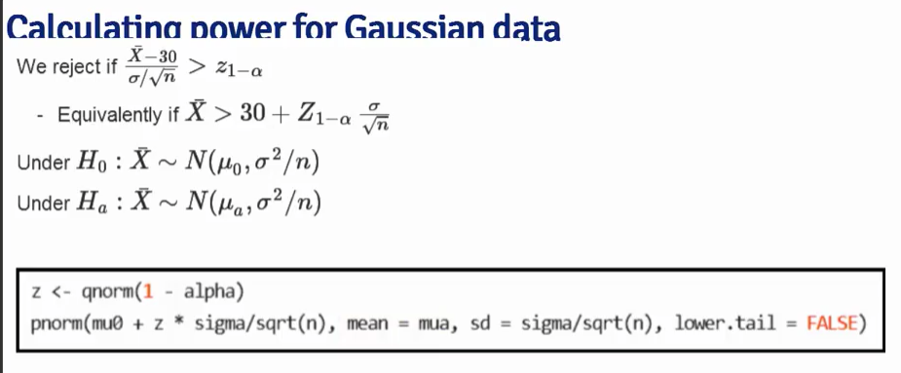

* Example in R:

> mu0 <- 30

> mua <- 32

> sigma <- 4

> n <- 16

> alpha <- 0.05

> z = qnorm(1 - alpha)

> z

[1] 1.644854

> pnorm(mu0 + z * sigma/sqrt(n), mean=mu0, sd=sigma/sqrt(n),lower.tail=FALSE)

[1] 0.05

> pnorm(mu0 + z * sigma/sqrt(n), mean=mua, sd=sigma/sqrt(n),lower.tail=FALSE)

[1] 0.63876

* + ‘z’ is the normal quantile
  + when mean is equal to muO then get the value for alpha
  + when mean is equal to mua ***then get 64% probability of detecting a mean as large as 32 or larger if we conduct the experiment.***
* Power Curves: plot power vs. mua for different sample sizes.
  + more samples then power increases for a particular mua (“more likely to detect a difference if there are more samples in the design….more likely to detect a smaller mua-mu0 difference”)
  + larger mua – mu0 difference then power increases as well (“more likely to detect a difference if the difference is bigger”)

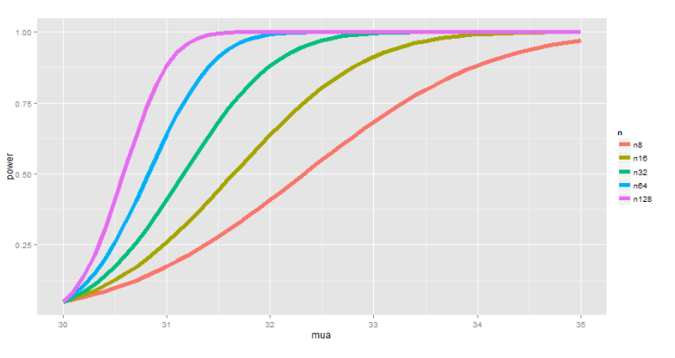

* **Example with manipulate in R:**
  + alpha = area under the null hypothesis curve (red) that is above threshold to indicate where we will reject the null for alternative hypothesis
  + Power = area under blue curve (alt hypothesis) that is likely to reject the null hypothesis
  + Type II error = the other side of the blue curve for the alternate under the alpha threshold
  + Alpha:
    - when alpha is decreased, then Type I error is decreased and power is decreased (need more evidence to reject the null) and type II error rate is increased
    - when alpha is increased then there is higher Type I error, but there is higher power
  + Sigma:
    - when sigma decreases, the threshold for alpha moves (dependent on sigma)
    - with lower variability in sample mean, then the power increases
    - the difference in mua- mu0 still matters
    - when sigma increases (more noise in measurements, more variability) then there is lower power
  + MeanAlternative:
    - increased difference with mu0 then there is more power
    - decreased difference with mu0 then there is less power
  + N (sample size)
    - sample mean variance decreases, the threshold moves, but the power is increased

library(manipulate)

> mu0 = 30

> myplot <- function(simga, mua, n, alpha) { g = ggplot(data.frame(mu=c(27,36)), aes=(x=mu))

+ g = g + stat_function(fun = dnorm, geom="line", args = list(mean = mu0, sd=sigma/sqrt(n)), size=2, col="red")

+ g = g + stat_function(fun - dnorm, geom="line", args = list(mean=mua, sd=sigma/sqrt(n)), size=2, col="blue")

+ xitc = mu0 + qnorm(1-alpha) * sigma/sqrt(n)

+ g= g + geom_vline(xintercept = xitc, size 3)

> xitc = mu0 + qnorm(1-alpha) * sigma/sqrt(n)

> g= g + geom_vline(xintercept = xitc, size=3)

> g}

> manipulate(myplot(sigma, mua, n, alpha), sigma=slider(1, 10, step=1, initial=4), mua=slider(30,35, step=1, initial=32), n = slider(1,50, step=1, initial=16), alpha=slider(0.01, 0.1, step=0.01, initial=0.05))

### 11 03 Notes on power

* There are four variables that determine power of a particular experiment:
  + alternative hypothesis test statistic
  + variation of the sample measurements
  + the sample size
  + the type II error rate (beta)
* You usually will know what alpha you are looking for (based on convention or regulation standard)
* You will have the mu0 for that experiment

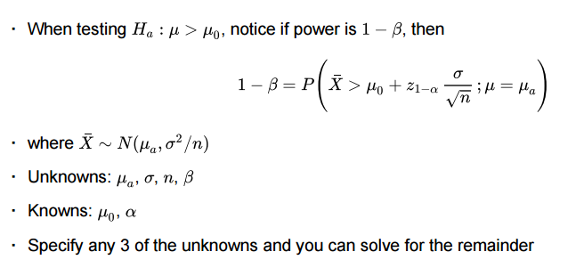

* Usually you will try to solve for n or beta
  + - choose study size (n) based on economy
    - choose beta for power
  + **Rules for Power**:
    - power goes up when alpha is larger
    - power of one sided test is greater than associated two sided test
    - power goes up as mua further from mu0
    - power goes up when n increases
    - Effect size = ( mua-mu0 ) / sigma {unit free and used to compare different experimental designs}

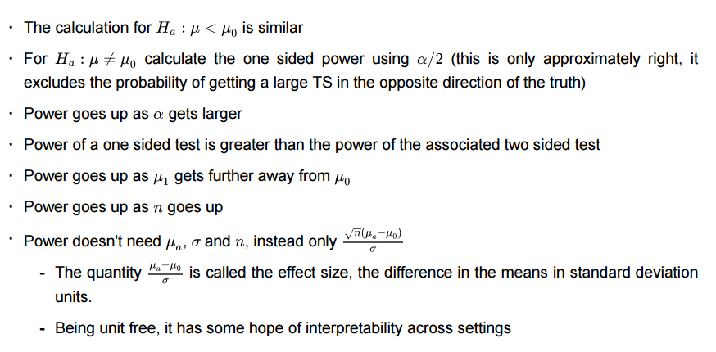

### 11 04 T test power

* T-test power
  + uses a t-quantile
  + test for mu = mua
* In R: power.t.test()
  + give it three values and get the missing value
* Examples in R:
  + power only depends on the effect size ( mua-mu0)/sigma

> power.t.test(n=16, delta=32-30, sd=4, type="one.sample", alt="one.sided")

One-sample t test power calculation

n = 16

delta = 2

sd = 4

sig.level = 0.05

power = 0.6040329

alternative = one.sided

* calculate the sample size (also only depends on the effect size)

> power.t.test(power=0.8, delta=32-30,sd=4, type="one.sample", alt="one.sided")

One-sample t test power calculation

n = 26.13751

delta = 2

sd = 4

sig.level = 0.05

power = 0.8

alternative = one.sided

* Keeping the power test simple with a research question that is binomial or t-stat makes viewing the power easier and leads toward better experimental design.

## Module 12: Multiple Comparisons

### 12 01 Multiple Comparisons

* hypothesis testing with more than one test you need to make a correction so you don’t fool yourself.
* Commonly overused hypothesis testing/significance
  + Error: calculate p-values and report the lowest
  + Correcting for multiple testing avoids false positives
* Two key components:
  + Error measure
  + Correction
* Three Eras of Stats:
  + huge census data sets with simple questions (are there more male or female births?)
  + classical period of Pearson, Fisher, Neyman, Hotelling that developed a theory of optimal inference. Still simple questions (A-B testing) but may have looked to use smaller sample sets.
  + Scientific Mass Production: new tech makes data cheap and easy to collect, with large data sets give statisticians job of answering many questions on the data at one time, which variables matter among the thousands measured, how do you relate unrelated information?
* Examples:
  + DNA machines
  + CTI, MRI scanners
  + biometric data
  + self-monitoring equipment (medical, fitbit)
* <http://xkcd.com/882/>
  + test on jelly beans found no significant correlation ( p > 0.05)
  + test on 20 colors of jelly beans found one jelly bean (p < 0.05)
    - only 5% of coincidence for each jelly bean
    - with 20 tests you expect to find on coincidence test
* For regression model (determine covariance between factors, beta, below) the error types are defined:

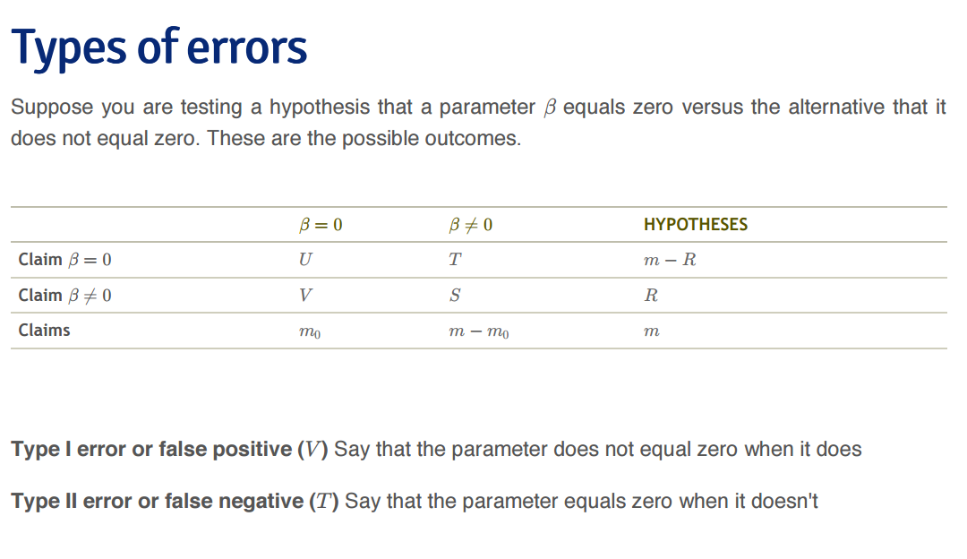

* For multiple testing errors:
  + False Positive Rate – rate at which false positive results are called significant E[V/m0]
    - closely related to type one error
  + Family Wise Error Rate (FWER): probability of at least one false positive Pr( V>= 1)
  + False Discovery Rate (FDR): rate at which claims of significance are false E[V/R]

<https://en.wikipedia.org/wiki/False_positive_rate>

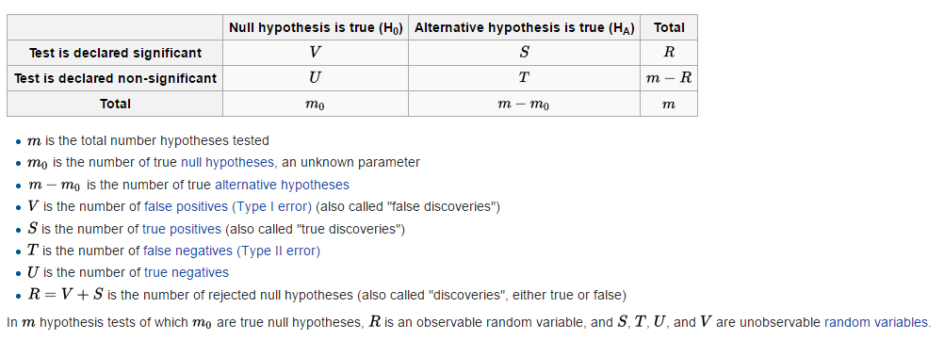

* **Control false positive rate**
  + control procedure such that number of false positive is limited
  + p-values for all P < alpha called significant will control false positive rate at level of alpha on average
* **Control Family Wise Error Rate (FWER)**
  + ***Bonferroni*** ***Correction***
    - do m tests
    - want to control FWER at level alpha so Pr(V >= 1) < alpha
    - calculate p-values normally
    - set alpha-fwer = alpha / m
    - call all p-values less than alpha-fwer significant
    - Easy to calculate, and control allows very few errors, but may be very conservative
    - may test at any combination of levels that add up to alpha
* **False Discovery Rate (FDR)**
  + common in genomics, imaging, astronomy, and signal-processing
  + Idea:
    - 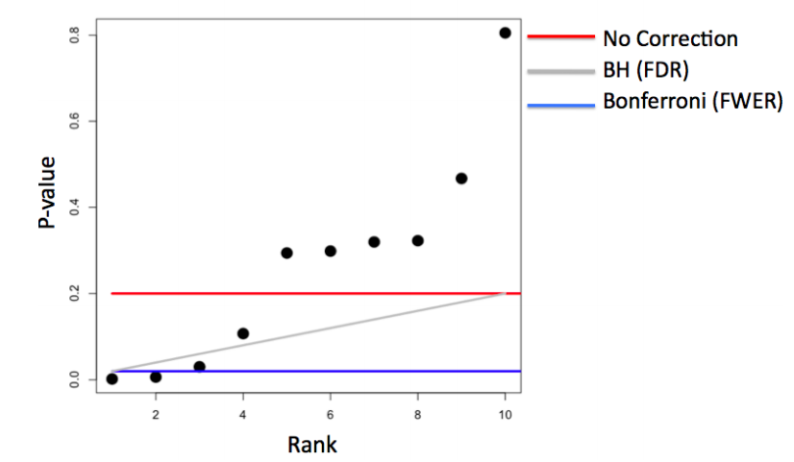do m tests
    - want FDR at level alpha so E[V/R]
    - calculate p-values
    - order the p-values from smallest to largest
    - call any i-th p-value that is less than or equal to alpha * i/m significant
    - easy to calculate, may be much less conservative
    - allows for more false positives, may behave strangely under dependence
* Adjusted P-values
  + adjust the threshold alpha
  + once p-values are adjusted, they are not classically defined p-values
  + see below:

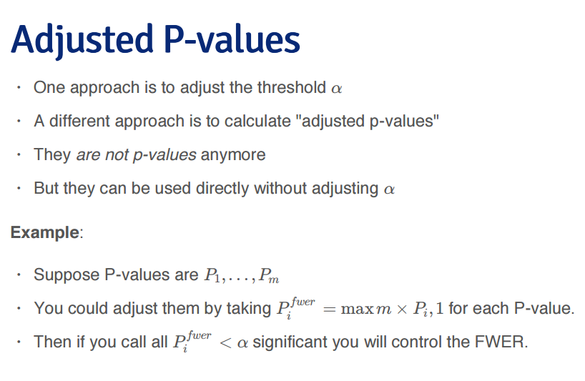

* Example adjustments in R: no true positives

> set.seed(1010093)

> pValues <- rep(NA, 1000)

> for(i in 1:1000){}

> for(i in 1:1000){

+ y <- rnorm(20)

+ x <- rnorm(20)

+ pValues[i] <-summary(lm(y~x))$coeff[2,4]}

> length(pValues)

[1] 1000

> # controls false positive rate

> sum(pValues < 0.05)

[1] 51

> y <- rnorm(20)

> x <- rnorm(20)

> summary(lm(y~x))

Call:

lm(formula = y ~ x)

Residuals:

Min 1Q Median 3Q Max

-1.0767 -0.5740 -0.2273 0.3336 2.2732

Coefficients:

Estimate Std. Error t value Pr(>|t|)

(Intercept) 0.2466 0.2008 1.228 0.235

x 0.1565 0.1968 0.795 0.437

Residual standard error: 0.8853 on 18 degrees of freedom

Multiple R-squared: 0.03395, Adjusted R-squared: -0.01972

F-statistic: 0.6326 on 1 and 18 DF, p-value: 0.4368

> y

[1] -0.003686308 -0.925598129 0.285443538 -0.601917539 -0.774536712

[6] -0.433408054 2.596756152 1.084890941 -0.353259188 0.183944561

[11] -0.603388292 1.227573737 -0.093619714 -0.003676690 -0.061232950

[16] -0.023538822 -0.112393207 0.429862533 1.257377748 1.318503770

> x

[1] 0.84966907 -0.61016251 2.42646658 0.85401048 -0.80435565 0.22124804

[7] 0.49142328 0.06421967 0.03843686 -0.12652267 -1.83185629 0.02492296

[13] -0.70084803 -0.64299837 -0.47669290 -1.30628210 -0.86240952 0.09294811

[19] 0.93800793 -2.08192061

> summary(lm(y~x))$coeff[2,4]

[1] 0.4367516

> # controls FWER

> sum(p.adjust(pValues, method="bonferroni") < 0.05)

[1] 0

> # controls FDR

> sum(p.adjust(pValues, method="BH") <0.05)

[1] 0

* Example adjusted p-values in R: 50% true positives

> set.seed(1010093)

> pValues <- rep(NA, 1000)

> for(i in 1:1000){

+ x <- rnorm(20)

+ #first 500 beta=0, last 500 beta=2

+ if(i <= 500){y <- rnorm(20)}else{y <- rnorm(20, mean=2*x)}

+ pValues[i] <- summary(lm(y~x))$coeff[2,4]

+ }

> trueStatus <- rep(c("zero", "not zero"), each=500)

> table(pValues < 0.05, trueStatus)

trueStatus

not zero zero

FALSE 0 476

TRUE 500 24

> # controls FWER

> table(p.adjust(pValues, method="bonferroni") < 0.05, trueStatus)

trueStatus

not zero zero

FALSE 23 500

TRUE 477 0

> # control FDR

> table(p.adjust(pValues, method="BH") < 0.05, trueStatus)

trueStatus

not zero zero

FALSE 0 487

TRUE 500 13

* **Notes**:
  + a basic Bonferroni/BH correction is usually enough
  + if there is a strong dependence between tests there may be problems
    - consider method “BY”
  + Introduction to Multiple Testing: <http://ies.ed.gov/ncee/pubs/20084018/app_b.asp>

## Module 13: Resampling

### Resampling

Resampling based procedures are ways to perform population based statistical inferences, while living within our data. Data Scientists tend to really like resampling based inferences, since they are very data centric procedures, they scale well to large studies and they often make very few assumptions.

### 13 01 Bootstrapping

* useful for constructing confidence intervals and calculating standard errors for difficult statistics
  + Brian Effron (Stanford) in 1979
  + allows analysts to free from complex mathematics
* Bootstrap gives confidence interval for the median (without the complexity)
* Ambiguous naming for the technique
* Example: behavior of average of 50 die rolls (known population, fair die rolls)
  + uniform 1/6 probability distribution
  + you can calculate the distribution
  + or you can do 50 die rolls and plot the distribution
* Example: behavior of average of 50 die rolls (unknown population stats)
  + unfair die (not uniform pdf)
  + do not know what the population looks like
  + re-roll more samples from the distribution given by the sample in hand
    - create an estimated population distribution
    - use the population distribution to estimate a statistic

### 13 02 Bootstrapping example

* simulating empirical distribution from the samples in hand with equal probability for each sample (with replacement from the sample data)
* generates a sample of size n for a number (B) bootstrap
* apply the median to the resampled data sets
* example in R:
* The estimate is a estimate of the density of the medians from the median of the bootstrapped samples
  + you can get confidence intervals
  + you can get variance, etc.

> library(UsingR)

> data(father.son)

> x <- father.son$sheight

> n <- length(x)

> B <- 10000

> resamples <- matrix(sample(x, n * B, replace=TRUE), B, n)

> dim(resamples)

[1] 10000 1078

> resampledMedians <- apply(resamples, 1, median)

> length(resampledMedians)

[1] 10000

> hist(resampledMedians)

> sd(resampledMedians)

[1] 0.08473704

> median(resampledMedians)

[1] 68.61582

### 13 03 Notes on the bootstrap

* Bootstrap principle, you have a statistic, but not the distribution: use distribution defined by the observed data to estimate the sampling distribution
* In practice bootstrap doesn’t require simulation (but is much easier for most cases)
* Review of the procedure:
  + observed data
  + simulate complete data sets from observed data with replacement
  + calculate statistic for each data set created
  + use the simulated statistic to define a confidence interval or standard deviation to calculate standard error.
* Non-Parametric bootstrap algorithm example:
  + bootstrap procedure calculation for interval of the median from data set of n observations
    - sample n observations with replacement from the observed data resulting in one simulated complete data set
    - repeat this first step for number of bootstrap samples (large B gives smaller monte carlo error) and calculate statistic (median)
    - monte carlo error (is error derived from a too-small number of iterations)
    - medians are approximately from sample distribution of the medians
      * draw a histogram
      * calculate standard deviation to estimate standard error of the median
      * take the 2.5th and 97.5th percentiles as a confidence interval for the median
* Example in R:

> medians <- apply(resamples, 1, median)

> # this is estimated standard error of the median

> sd(medians)

[1] 0.08473704

> # confidence interval of the medians

> quantile(medians, c(0.025, 0.975))

2.5% 97.5%

68.42972 68.81461

> # histogram of bootstrap resamples

> g = ggplot(data.frame(medians = medians), aes(x=medians))

> g = g + geom_histogram(color="black", fill="lightblue", binwidth=0.05)

> g

> # this histogram is an estimate of the sampling distribution of the median

> # if we had a true population to sample from, we would have something similar to this approximation

* Notes on bootstrap example:
  + the example shown here is the non-parametric bootstrap
  + better percentile bootstrap confidence intervals correct for bias
    - recommend BCA interval (bias corrected accelerated interval)
    - function in R, fixes quantiles to use to correct for bias
  + Lots of variations to bootstrap
    - “An Introduction to the Bootstrap”. Effron and Tibshirani.

### 13 04 Permutation tests

* Used for group comparisons
* Procedure:
  + consider null hypothesis that distribution of observations that are the same in each group
  + consider data frame with count, spray
  + permute the spray(group) labels (take vector and sample from the group labels)
  + recalculate the statistic
    - mean difference in counts
    - geometric means
    - t-statistic
  + calculate the percentage of simulations where the simulation statistic was more extreme in favor of the alternative than the observed.
    - this is a permutation based p-value
  + you are performing permutations based on the idea of the interchangeability of group labels.

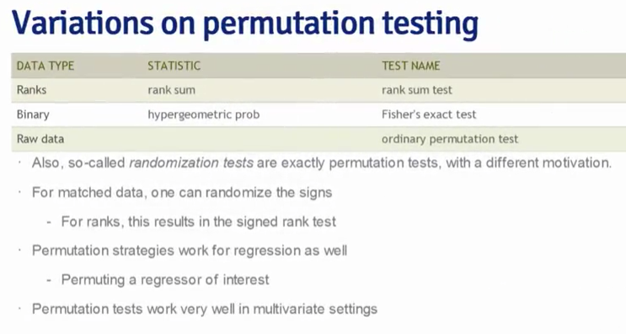

* Example: Spray B vs. C

> # test B vs. C insect kills

> # subset data for just sprays B and C

> subdata <- InsectSprays[InsectSprays$spray %in% c("B","C"),]

> dim(subdata)

[1] 24 2

> # y is the counts of insect kills

> y <- subdata$count

> group <- as.character(subdata$spray)

> # group labels for the sprays lined up with y vector

> dim(subdata[subdata$spray=="B",])

[1] 12 2

> testStat <- function(w,g) mean(w[g=="B"]) - mean(w[g=="C"])

> observedStat <- testStat(y, group)

> # the observed statistic is the difference in mean count B and C sprays

> observedStat

[1] 13.25

> # permute the group labels against the y values that were already there

> # null hypothesis is that the group label is unrelated to the outcome

> permutations <- sapply(1:10000, function(i) testStat(y, sample(group)))

> mean(permutations > observedStat)

[1] 0

> # in other words: in over 10000 permutations we could not find a single case that gave more extreme value than the observed test statistic

### Quiz: Quiz 4

9 questions

Due on July 3, 2016

1.  A pharmaceutical company is interested in testing a potential blood pressure lowering medication. Their first examination considers only subjects that received the medication at baseline then two weeks later. The data are as follows (SBP in mmHg)

|  |  |  |
| --- | --- | --- |
| Subject | Baseline | Week 2 |
| 1 | 140 | 132 |
| 2 | 138 | 135 |
| 3 | 150 | 151 |
| 4 | 148 | 146 |
| 5 | 135 | 130 |

Consider testing the hypothesis that there was a mean reduction in blood pressure? Give the P-value for the associated two sided T test. (Hint, consider that the observations are paired.)

> a = c(140,138,150,148,135)

> b = c(132,135,151,146,130)

> t.test(a,b,paired=TRUE)

Paired t-test

data: a and b

t = 2.2616, df = 4, p-value = 0.08652

alternative hypothesis: true difference in means is not equal to 0

95 percent confidence interval:

-0.7739122 7.5739122

sample estimates:

mean of the differences

3.4

2. A sample of 9 men yielded a sample average brain volume of 1,100cc and a standard deviation of 30cc. What is the complete set of values of *μ*0 that a test of *H*0:*μ*=*μ*0 would fail to reject the null hypothesis in a two sided 5% Students t-test?

> 1100 + c(-1,1)*qt(0.975, 8) * 30/sqrt(9)

[1] 1076.94 1123.06

3. Researchers conducted a blind taste test of Coke versus Pepsi. Each of four people was asked which of two blinded drinks given in random order that they preferred. The data was such that 3 of the 4 people chose Coke. Assuming that this sample is representative, report a P-value for a test of the hypothesis that Coke is preferred to Pepsi using a one sided exact test.

> binom.test(3,4,p=0.5, alternative="greater")

Exact binomial test

data: 3 and 4

number of successes = 3, number of trials = 4, p-value = 0.3125

alternative hypothesis: true probability of success is greater than 0.5

95 percent confidence interval:

0.2486046 1.0000000

sample estimates:

probability of success

0.75

4. Infection rates at a hospital above 1 infection per 100 person days at risk are believed to be too high and are used as a benchmark. A hospital that had previously been above the benchmark recently had 10 infections over the last 1,787 person days at risk. About what is the one sided P-value for the relevant test of whether the hospital is *below* the standard?

> poisson.test(10, 1787, 0.01, alternative="less")

Exact Poisson test

data: 10 time base: 1787

number of events = 10, time base = 1787, p-value = 0.03237

alternative hypothesis: true event rate is less than 0.01

95 percent confidence interval:

0.000000000 0.009492009

sample estimates:

event rate

0.005595971

> poisson.test(10, 1787, 0.01, alternative="greater")

Exact Poisson test

data: 10 time base: 1787

number of events = 10, time base = 1787, p-value = 0.9835

alternative hypothesis: true event rate is greater than 0.01

95 percent confidence interval:

0.003036041 Inf

sample estimates:

event rate

0.005595971

5. Suppose that 18 obese subjects were randomized, 9 each, to a new diet pill and a placebo. Subjects’ body mass indices (BMIs) were measured at a baseline and again after having received the treatment or placebo for four weeks. The average difference from follow-up to the baseline (followup - baseline) was −3 kg/m2 for the treated group and 1 kg/m2 for the placebo group. The corresponding standard deviations of the differences was 1.5 kg/m2 for the treatment group and 1.8 kg/m2 for the placebo group. Does the change in BMI appear to differ between the treated and placebo groups? Assuming normality of the underlying data and a common population variance, give a pvalue for a two sided t test.

> (-3-1)/(sp*sqrt(1/9+1/9))

[1] -5.121475

> sp <- sqrt(((9-1)*1.5^2 + (9-1)*1.8^2) / (9+9-2))

> sp

[1] 1.656804

> t <- (-3-1)/(sp*sqrt(1/9+1/9))

> t

[1] -5.121475

> pt(t,16)*2

[1] 0.0001025174

> df <- 9+9-2

> p <- 2*pt(t,df)

> p

[1] 0.0001025174

6. Brain volumes for 9 men yielded a 90% confidence interval of 1,077 cc to 1,123 cc. Would you reject in a two sided 5% hypothesis test of *H*0:*μ*=1,078?

No you wouldn’t reject.

7. Researchers would like to conduct a study of 100 healthy adults to detect a four year mean brain volume loss of .01 *mm*3. Assume that the standard deviation of four year volume loss in this population is .04 *mm*3. About what would be the power of the study for a 5% one sided test versus a null hypothesis of no volume loss?

> power.t.test(n=100, delta=0.01-0, sd=0.04, type="one.sample", alt="one.sided")

One-sample t test power calculation

n = 100

delta = 0.01

sd = 0.04

sig.level = 0.05

power = 0.7989855

alternative = one.sided

8. Researchers would like to conduct a study of *n* healthy adults to detect a four year mean brain volume loss of .01 *mm*3. Assume that the standard deviation of four year volume loss in this population is .04 *mm*3. About what would be the value of *n* needed for 90% power of type one error rate of 5% one sided test versus a null hypothesis of no volume loss?

> power.t.test(power=0.9, delta=0.01-0, sd=0.04,type="one.sample",alt="one.sided")

One-sample t test power calculation

n = 138.3856

delta = 0.01

sd = 0.04

sig.level = 0.05

power = 0.9

alternative = one.sided

9. As you increase the type one error rate, *α*, what happens to power?

power increases

## Peer Graded Assignment: Statistical Inference Course Project1h

Due in on July 3, 2016

**Instructions**

This is the project for the statistical inference class. In it, you will use simulation to explore inference and do some simple inferential data analysis.

**Review criteria: Statistical Inference Course Project**

The project consists of two parts:

1. A simulation exercise.
2. Basic inferential data analysis.

You will create a report to answer the questions. Given the nature of the series, ideally you'll use knitr to create the reports and convert to a pdf. (I will post a very simple introduction to knitr).

* **However, feel free to use whatever software that you would like to create your pdf.**
* **Each pdf report should be no more than 3 pages with 3 pages of supporting appendix material if needed (code, figures, etcetera).**

Unused Functions for analysis:

# coplot of the length for each supplement dose.

coplot(len ~ dose | supp, data=ToothGrowth, panel=panel.smooth, xlab="ToothGrowth data: length vs. dose, given supplement type")

with(ToothGrowth, interaction.plot(dose, supp, len, fixed = TRUE, col = 2:3))

Fishers F-test compares two group variances. This verifies the homoskedasticity (homogenity of variances).

var.test(a,b)

# if p-value is greater than 0.05, then you have evidence to assume the two variances are homogenous.

qf(0.95,df.num,df.den)

# If tablulated F is greater, then can accept the null hypothesis that the variances are homogenous.

### Review Your Peers: Statistical Inference Course Project

Due in July 6, 2016

Completed 9 July.

## Practical R Exercises in swirl Part 4

### Practice Programming Assignment: swirl Lesson 1: Power

| Power. (Slides for this and other Data Science courses may be found at

| github https://github.com/DataScienceSpecialization/courses/. If you care

| to use them, they must be downloaded as a zip file and viewed locally.

| This lesson corresponds to 06_Statistical_Inference/11_Power.)

| In this lesson, as the name suggests, we'll discuss POWER, which is the

| probability of rejecting the null hypothesis when it is false, which is

| good and proper.

| Hence you want more POWER.

| Power comes into play when you're designing an experiment, and in

| particular, if you're trying to determine if a null result (failing to

| reject a null hypothesis) is meaningful. For instance, you might have to

| determine if your sample size was big enough to yield a meaningful,

| rather than random, result.

| Power gives you the opportunity to detect if your ALTERNATIVE hypothesis

| is true.

Do you recall the definition of a Type II error? Remember, errors are

| bad.

1: Miscalculating a t score

2: Accepting a false null hypothesis

3: Misspelling the word hypothesis

4: Rejecting a true null hypothesis

Selection: 2

| Your dedication is inspiring!

| Beta is the probability of a Type II error, accepting a false null

| hypothesis; the complement of this is obviously (1 - beta) which

| represents the probability of rejecting a false null hypothesis. This is

| good and this is POWER!

| Recall our previous example involving the Respiratory Distress Index and

| sleep disturbances. Our null hypothesis H_0 was that mu = 30 and our

| alternative hypothesis H_a was that mu > 30.

| Which of the following expressions represents our test statistic under

| this null hypothesis? Here X' represents the sample mean, s is the sample

| std deviation, and n is the sample size. Assume X' follows a t

| distribution.

1: (X'-30)/(s/sqrt(n))

2: (X'-30)/(s^2/n)

3: X'/(s^2/n)

4: 30/(s/sqrt(n))

Selection: 1

| All that practice is paying off!

| In the expression for the test statistic (X'-30)/(s/sqrt(n)) what does

| (s/sqrt(n)) represent?

1: a standard sample

2: a standard error

3: a standard measure

4: a standard bearer

5: a standard variance

Selection: 2

| You are amazing!

| Suppose we're testing a null hypothesis H_0 with an alpha level of .05.

| Since H_a proposes that mu > 30 (the mean hypothesized by H_0), power is

| the probability that the true mean mu is greater than the (1-alpha)

| quantile or qnorm(.95). For simplicity, assume we're working with normal

| distributions of which we know the variances.

| Here's the picture we've used a lot in these lessons. As you know, the

| shaded portion represents 5% of the area under the curve. If a test

| statistic fell in this shaded portion we would reject H_0 because the

| sample mean is too far from the mean (center) of the distribution

| hypothesized by H_0. Instead we would favor H_a, that mu > 30. This

| happens with probability .05.

| You might well ask, "What does this have to do with POWER?" Good

| question. We'll look at some pictures to show you.

| First we have to emphasize a key point. The two hypotheses, H_0 and H_a,

| actually represent two distributions since they're talking about means or

| centers of distributions. H_0 says that the mean is mu_0 (30 in our

| example) and H_a says that the mean is mu_a.

| We're assuming normality and equal variance, say sigma^2/n, for both

| hypotheses, so under H_0, X'~ N(mu_0, sigma^2/n) and under H_a, X'~

| N(mu_a, sigma^2/n).

| Here's a picture with the two distributions. We've drawn a vertical line

| at our favorite spot, at the 95th percentile of the red distribution. To

| the right of the line lies 5% of the red distribution.

| Quick quiz! Which distribution represents H_0?

1: the red

2: the blue

Selection: 1

| Great job!

| Which distribution represents H_a?

1: the red

2: the blue

Selection: 2

| You are quite good my friend!

| From the picture, what is the mean proposed by H_a?

1: 36

2: 30

3: 32

4: 28

Selection: 3

| All that practice is paying off!

| See how much of the blue distribution lies to the right of that big

| vertical line?

| That, my friend, is POWER!

| It's the area under the blue curve (H_a) to the right of the vertical

| line.

| Note that the placement of the vertical line depends on the null

| distribution. Here's another picture with fatter distributions. The

| vertical line is still at the 95th percentile of the null (red)

| distribution and 5% of the distribution still lies to its right. The line

| is calibrated to mu_0 and the variance.

| Back to our original picture.

| We've shamelessly stolen plotting code from the slides so you can see H_a

| in action. Let's look at pictures before we delve into numbers. We've

| fixed mu_0 at 30, sigma (standard deviation) at 4 and n (sample size) at

| 16. The function myplot just needs an alternative mean, mu_a, as

| argument. Run myplot now with an argument of 34 to see what it does.

> myplot(34)

| That's a job well done!

| The distribution represented by H_a moved to the right, so almost all

| (100%) of the blue curve is to the right of the vertical line, indicating

| that with mu_a=34, the test is more powerful, i.e., there's a higher

| probability that it's correct to reject the null hypothesis since it

| appears false. Now try myplot with an argument of 33.3.

> myplot(33.3)

| Great job!

| This isn't as powerful as the test with mu_a=34 but it makes a pretty

| picture. Now try myplot with an argument of 30.

> myplot(30)

| You are quite good my friend!

| Uh Oh! Did the red curve disappear? No. it's just under the blue curve.

| The power now, the area under the blue curve to the right of the line, is

| exactly 5% or alpha!

| So what did we learn?

| First, power is a function that depends on a specific value of an

| alternative mean, mu_a, which is any value greater than mu_0, the mean

| hypothesized by H_0. (Recall that H_a specified mu>30.)

| Second, if mu_a is much bigger than mu_0=30 then the power (probability)

| is bigger than if mu_a is close to 30. As mu_a approaches 30, the mean

| under H_0, the power approaches alpha.

| Just for fun try myplot with an argument of 28.

> myplot(28)

| That's correct!

| We see that the blue curve has moved to the left of the red, so the area

| under it, to the right of the line, is less than the 5% under the red

| curve. This then is even less powerful and contradicts H_a so it's not

| worth looking at.

Here's a picture of the power curves for different sample sizes. Again,

| this uses code "borrowed" from the slides. The alternative means, the

| mu_a's, are plotted along the horizontal axis and power along the

| vertical.

| What does the graph show us about mu_a?

1: power is independent of mu_a

2: as it gets bigger, it gets less powerful

3: as it gets bigger, it gets more powerful

Selection: 3

| Keep up the great work!

| What does the graph show us about sample size?

1: power is independent of sample size

2: as it gets bigger, it gets more powerful

3: as it gets bigger, it gets less powerful

Selection: 2

| You're the best!

| Now back to numbers. Our test for determining rejection of H_0 involved

| comparing a test statistic, namely Z=(X'-30)/(sigma/sqrt(n)), against

| some quantile, say Z_95, which depended on our level size alpha (.05 in

| this case). H_a proposed that mu > mu_0, so we tested if Z>Z_95. This is

| equivalent to X' > Z_95 * (sigma/sqrt(n)) + 30, right?

| Recall that nifty R function pnorm, which gives us the probability that a

| value drawn from a normal distribution is greater or less than/equal to a

| specified quantile argument depending on the flag lower.tail. The

| function also takes a mean and standard deviation as arguments.

| Suppose we call pnorm with the quantile 30 + Z_95 * (sigma/sqrt(n)) and

| specify mu_a as our mean argument. This would return a probability which

| we can interpret as POWER. Why?

| Recall our picture of two distributions. 30 + Z_95 * (sigma/sqrt(n))

| represents the point at which our vertical line falls. It's the point on

| the null distribution at the (1-alpha) level.

| Study this picture. Calling pnorm with 30 + Z_95 * (sigma/sqrt(n)) as the

| quantile and mu_a, say 32, as the mean and lower.tail=FALSE does what?

1: returns the area under the red curve to the right of the line

2: returns the area under the red curve to the left of the line

3: returns the area under the blue curve to the left of the line

4: returns the area under the blue curve to the right of the line

Selection: 4

| Excellent job!

| Let's try some examples now. Before we do, what do we know pnorm will

| return if we specify a quantile less than the mean?

1: an answer greater than 1

2: an answer dependent on beta

3: an answer less than .50

4: an answer dependent on alpha

Selection: 4

| You almost had it, but not quite. Try again.

| There are several red herrings in the choices. First pnorm will NEVER

| return a value greater than 1 because density functions by definition

| have areas equal to 1. We haven't specified an alpha or beta either. The

| function pnorm just needs a quantile, mean, and standard deviation. By

| default it looks at the lower tail of the distribution. That leaves one

| choice.

1: an answer dependent on beta

2: an answer greater than 1

3: an answer less than .50

4: an answer dependent on alpha

Selection: 3

| Perseverance, that's the answer.

| First, define a variable z as qnorm(.95)

| First, define a variable z as qnorm(.95)

> z <- qnorm(.95)

| Perseverance, that's the answer.

| Run pnorm now with the quantile 30+z, mean=30, and lower.tail=FALSE.

| We've specified sigma and n so that the standard deviation of the sample

| mean is 1.

> pnorm(30+z,mean=30,sd=1,lower.tail=FALSE)

[1] 0.05

| You are really on a roll!

| That's not surprising, is it? With the mean set to mu_0 the two

| distributions, null and alternative, are the same and power=alpha. Now

| run pnorm now with the quantile 30+z, mean=32, and lower.tail=FALSE.

> pnorm(30+z,mean=32,sd=1,lower.tail=FALSE)

[1] 0.63876

| Nice work!

| See how this is much more powerful? 64% as opposed to 5%. When the sample

| mean is quite different from (many standard errors greater than) the mean

| hypothesized by the null hypothesis, the probability of rejecting H_0

| when it is false is much higher. That is power!

| Let's look again at the portly distributions.

With this standard deviation=2 (fatter distribution) will power be

| greater or less than with the standard deviation=1?

1: the same

2: less than

3: greater

Selection: 2

| Keep up the great work!

| To see this, run pnorm now with the quantile 30+z, mean=32 and sd=1.

| Don't forget to set lower.tail=FALSE so you get the right tail.

> pnorm(30+z,mean=32,sd=1,lower.tail=FALSE)

[1] 0.63876

| That's a job well done!

| Now run pnorm now with the quantile 30+z*2, mean=32 and sd=2. Don't

| forget to set lower.tail=FALSE so you get the right tail.

> pnorm(30+z,mean=32,sd=2,lower.tail=FALSE)

[1] 0.5704709

| Not quite right, but keep trying. Or, type info() for more options.

| Type pnorm(30+z*2,mean=32,sd=2,lower.tail=FALSE) at the command prompt.

> pnorm(30+z*2,mean=32,sd=2,lower.tail=FALSE)

[1] 0.259511

| That's a job well done!

| See the power drain from 64% to 26% ? Let's review some basic facts about

| power. We saw before in our pictures that the power of the test depends

| on mu_a. When H_a specifies that mu > mu_0, then as mu_a grows and

| exceeds mu_0 increasingly, what happens to power?

1: it doesn't change

2: it decreases

3: it increases

Selection: 3

| You nailed it! Good job!

| Here's another question. Recall our power curves from before.

| As the sample size increases, what happens to power?

1: it doesn't change

2: it increases

3: it decreases

Selection: 2

| You are doing so well!

| Here's another one. More power curves.

| As variance increases, what happens to power?

1: it decreases

2: it increases

3: it doesn't change

Selection: 1

| Excellent job!

| Here's another one. And even more power curves.

| As alpha increases, what happens to power?

1: it increases

2: it decreases

3: it doesn't change

Selection: 1

| Keep up the great work!

| If H_a proposed that mu != mu_0 we would calculate the one sided power

| using alpha / 2 in the direction of mu_a (either less than or greater

| than mu_0). (This is only approximately right, it excludes the

| probability of getting a large test statistic in the opposite direction

| of the truth.

| Since power goes up as alpha gets larger would the power of a one-sided

| test be greater or less than the power of the associated two sided test?

1: greater

2: they're the same

3: less than

Selection: 1

| That's the answer I was looking for.

| Finally, if H_a specified that mu < mu_0 could we still do the same kind

| of power calculations?

1: No

2: Yes

Selection: 2

| All that hard work is paying off!

| Suppose H_a says that mu > mu_0. Then power = 1 - beta = Prob ( X' > mu_0

| + z_(1-alpha) * sigma/sqrt(n)) assuming that X'~ N(mu_a,sigma^2/n). Which

| quantities do we know in this statement, given the context of the

| problem? Let's work through this.

| What does the null hypothesis H_0 tell us that the population mean

| equals?

1: alpha

2: mu_a

3: mu_0

4: beta

Selection: 3

| Keep working like that and you'll get there!

| After the null mean mu_0 is proposed what does the designer of the

| hypothesis test specify in order to reject or fail-to-reject H_0? In

| other words, what is the level size of the test?

1: beta

2: alpha

3: mu_0

4: mu_a

Selection: 2

| You got it right!

| So we know that the quantities mu_0 and alpha are specified by the test

| designer. In the statement 1 - beta = Prob( X' > mu_0 + z_(1-alpha) *

| sigma/sqrt(n)) given mu_a > mu_0, mu_0 and alpha are specified, and X'

| depends on the data. The other four quantities, (beta, sigma, n, and

| mu_a), are all unknown.

| It should be obvious that specifying any three of these unknowns will

| allow us to solve for the missing fourth. Usually, you only try to solve

| for power (1-beta) or the sample size n.

| An interesting point is that power doesn't need mu_a, sigma and n

| individually. Instead only sqrt(n)*(mu_a - mu_0) /sigma is needed. The

| quantity (mu_a - mu_0) / sigma is called the EFFECT SIZE. This is the

| difference in the means in standard deviation units. It is unit free so

| it can be interpreted in different settings.

| We'll work through some examples of this now. However, instead of

| assuming that we're working with normal distributions let's work with t

| distributions. Remember, they're pretty close to normal with large enough

| sample sizes.

| Power is still a probability, namely P( (X' - mu_0)/(S /sqrt(n)) >

| t_(1-alpha, n-1) given H_a that mu > mu_a ). Notice we use the t quantile

| instead of the z. Also, since the proposed distribution is not centered

| at mu_0, we have to use the non-central t distribution.

| R comes to the rescue again with the function power.t.test. We can omit

| one of the arguments and the function solves for it. Let's first use it

| to solve for power.

| We'll run it three times with the same values for n (16) and alpha (.05)

| but different delta and standard deviation values. We'll show that if

| delta (difference in means) divided by the standard deviation is the

| same, the power returned will also be the same. In other words, the

| effect size is constant for all three of our tests.

| We'll specify a positive delta; this tells power.t.test that H_a proposes

| that mu > mu_0 and so we'll need a one-sided test. First run

| power.t.test(n = 16, delta = 2 / 4, sd=1, type = "one.sample", alt =

| "one.sided")$power .

> power.t.test(n=16, delta=2/4, sd=1, type="one.sample", alt="one.sample")$power

Error in match.arg(alternative) :

'arg' should be one of “two.sided”, “one.sided”

> power.t.test(n=16, delta=2/4, sd=1, type="one.sample", alt="one.sided")$power

[1] 0.6040329

| Excellent work!

| Now change delta to 2 and sd to 4. Keep everything else the same.

> power.t.test(n=16, delta=2, sd=4, type="one.sample", alt="one.sided")$power

[1] 0.6040329

| All that practice is paying off!

| Same answer, right? Now change delta to 100 and sd to 200. Keep

| everything else the same.

>

> power.t.test(n=16, delta=100, sd=200, type="one.sample", alt="one.sided")$power

[1] 0.6040329

| Nice work!

| So keeping the effect size (the ratio delta/sd) constant preserved the

| power. Let's try a similar experiment except now we'll specify a power we

| want and solve for the sample size n.

| First run power.t.test(power = .8, delta = 2 / 4, sd=1, type =

| "one.sample", alt = "one.sided")$n .

> power.t.test(power = .8, delta = 2 / 4, sd=1, type =

+ | "one.sample", alt = "one.sided")$n

Error: unexpected '|' in:

"power.t.test(power = .8, delta = 2 / 4, sd=1, type =

|"

> power.t.test(power = .8, delta = 2 / 4, sd=1, type ="one.sample", alt = "one.sided")$n

[1] 26.13751

| Your dedication is inspiring!

| Now change delta to 2 and sd to 4. Keep everything else the same.

> power.t.test(power = .8, delta = 2, sd=4, type ="one.sample", alt = "one.sided")$n

[1] 26.13751

| Excellent job!

| Same answer, right? Now change delta to 100 and sd to 200. Keep

| everything else the same.

> power.t.test(power = .8, delta = 100, sd=200, type ="one.sample", alt = "one.sided")$n

[1] 26.13751

| All that practice is paying off!

| Now use power.t.test to find delta for a power=.8 and n=26 and sd=1

> power.t.test(power=0.8, n=26, sd=1, type="one.sample", alt="one.sided")$delta

[1] 0.5013986

| All that hard work is paying off!

| Not a surprising result, is it? It told you before that with an effect

| size of .5 and power .8, you need a sample size a little more than 26.

| Now run it with n=27.

> power.t.test(power=0.8, n=27, sd=1, type="one.sample", alt="one.sided")$delta

[1] 0.4914855

| Great job!

| What do you think will happen if you doubled sd to 2 and ran the same

| test?

1: delta will double

2: delta will halve

3: delta won't change

Selection: 1

| You are doing so well!

| Now for a quick review. We call this the power.u.test since it comes

| after the power.t.test. LOL.

| 1. The level of a test is specified by what?

1: beta

2: None of the others

3: gamma

4: alpha

5: delta

Selection: 4

| Excellent work!

| 2. What is a Type II error?

1: accepting a true hypothesis

2: accepting a false hypothesis

3: rejecting a true hypothesis

4: rejecting a false hypothesis

Selection: 3

| That's not the answer I was looking for, but try again.

| Only two of the choices are errors. Eliminate those and then eliminate

| the Type I error.

1: accepting a false hypothesis

2: rejecting a true hypothesis

3: rejecting a false hypothesis

4: accepting a true hypothesis

Selection: 1

| All that practice is paying off!

| 3. What is power?

1: beta

2: alpha

3: gamma

4: delta

5: thrilling

6: None of the others

Selection: 6

| Keep working like that and you'll get there!

| 4. You're a perfectionist designing an experiment and you want both alpha

| and beta to be small. Can they both be 0 for this single test?

1: No

2: Yes

Selection: 1

| Nice work!

| 5. Suppose H_0 proposes mu = mu_0 and H_a proposes that mu < mu_0. You'll

| test a series of mu_a with power != alpha. Which of the following is NOT

| true?

1: mu_0-mu_a > 0

2: mu_a-mu_0=0

3: mu_a-mu_0 < 0

4: huh?

Selection: 3

| Give it another try.

| As in the case in which H_a proposes that mu > mu_0, when mu_a=mu_0,

| alpha=power. This was excluded in the problem statement so mu_a=mu_0

| cannot be true in this case.

1: mu_a-mu_0 < 0

2: mu_a-mu_0=0

3: mu_0-mu_a > 0

4: huh?

Selection: 2

| You got it right!

| 6. Suppose H_0 proposes mu = mu_0 and H_a proposes that mu < mu_0. Which

| of the following is true?

1: the smaller mu_a-mu_0 the more powerful the test

2: the smaller mu_0-mu_a the more powerful the test

3: mu_0=mu_a maximizes the power

Selection: 1

| Excellent job!

| 7. Which expression represents the size effect?

1: (mu_a - mu_0) / n

2: (mu_a - mu_0) / sigma

3: (mu_a - mu_0) / sqrt(n)

4: (mu_a - mu_0) / sqrt(sigma)

Selection: 2

| Great job!

| 8. True or False? More power is better than less power.

1: False

2: True

Selection: 2

| You are doing so well!

| 9. True or False? A larger beta (call it beta_max) is more powerful than

| a smaller beta.

1: False

2: True

Selection: 1

| Perseverance, that's the answer.

| 10. True or False? The larger the sample size the less powerful the test.

1: False

2: True

Selection: 1

| You are doing so well!

| Congrats! You finished this powerful lesson. We hope you feel emPOWERED.

* alpha increases, power increases
* variance increases, power decreases
* sample size increases, power increases
* mua increases away from mu0 then power increases
* (mu_a - mu_0) / sigma is called the EFFECT SIZE. This is the difference in the means in standard deviation units. It is unit free so it can be interpreted in different settings.
* equal effect sizes, have same power value
* level of test specified by alpha
* Type II error is accepting a false hypothesis

### Practice Programming Assignment: swirl Lesson 2: Multiple Testing

| Multiple_Testing. (Slides for this and other Data Science courses may be

| found at github https://github.com/DataScienceSpecialization/courses/. If

| you care to use them, they must be downloaded as a zip file and viewed

| locally. This lesson corresponds to

| 06_Statistical_Inference/12_MultipleTesting.)

| In this lesson, we'll discuss multiple testing. You might ask, "What's

| that?"

| Given that data is valuable and we'd like to get the most out of it, we

| might use it to test several hypotheses. If we have an alpha level of .05

| and we test 20 hypotheses, then on average, we expect one error, just by

| chance.

| Another potential problem is that after running several tests, only the

| lowest p-value might be reported OR all p-values under some threshold

| might be considered significant. Undoubtedly, some of these would be

| false.

| Luckily, we have clever ways of minimizing errors in this situation.

| That's what we'll address. We'll define specific error measures and then

| statistical ways of correcting or limiting them.

| Multiple testing is particularly relevant now in this age of BIG data.

| Statisticians are tasked with questions such as "Which variables matter

| among the thousands measured?" and "How do you relate unrelated

| information?"

| Since multiple testing addresses compensating for errors let's review

| what we know about them. A Type I error is

1: rejecting a true hypothesis

2: failing to reject a false hypothesis

3: rejecting a false hypothesis

4: failing to reject a true hypothesis

Selection: 2

| Almost! Try again.

| Eliminate the two choices that are not errors. A Type I error involves

| rejection.

1: rejecting a true hypothesis

2: failing to reject a false hypothesis

3: failing to reject a true hypothesis

4: rejecting a false hypothesis

Selection: 1

| You got it!

| In an American court, an example of a Type I error is

1: convicting an innocent person

2: acquitting a guilty person

3: letting the indicted off on a technicality

Selection: 1

| That's correct!

| A Type II error is

1: failing to reject a true hypothesis

2: rejecting a false hypothesis

3: rejecting a true hypothesis

4: failing to reject a false hypothesis

Selection: 4

| You are doing so well!

| In an American court, an example of a Type II error is

1: convicting an innocent person

2: acquitting a guilty person

3: letting the indicted off on a technicality

Selection: 2

| Excellent work!

| Good. Let's continue reviewing. The null hypothesis

1: is a big nothing that statisticians like to gossip about

2: represents the status_quo and is assumed true

3: tells us the origins of the number 0

4: is never true

Selection: 2

| Nice work!

| The p-value is "the probability under the null hypothesis of obtaining

| evidence as or more extreme than your test statistic (obtained from your

| observed data) in the direction of the alternative hypothesis." Of course

| p-values are related to significance or alpha levels, which are set

| before the test is conducted (often at 0.05).

| If a p-value is found to be less than alpha (say 0.05), then the test

| result is considered statistically significant, i.e., surprising and

| unusual, and the null hypothesis (the status quo) is ?

1: renamed the aleph null hypothesis

2: revised

3: accepted

4: rejected

Selection: 4

| You got it!

| Now consider this chart copied from

| http://en.wikipedia.org/wiki/Familywise_error_rate. Suppose we've tested

| m null hypotheses, m_0 of which are actually true, and m-m_0 are actually

| false. Out of the m tests R have been declared significant, that is, the

| associated p-values were less than alpha, and m-R were nonsignificant, or

| boring results.

| Looking at the chart, which variables are known?

1: S,T,U,V

2: m_0, and m

3: m and R

4: A,B,C

Selection: 3

| You are amazing!

| In testing the m_0 true null hypotheses, V results were declared

| significant, that is, these tests favored the alternative hypothesis.

| What type of error does this represent?

1: Type I

2: Type II

3: a serious one

4: Type III

Selection: 1

| That's correct!

| Another name for a Type I error is False Positive, since it is falsely

| claiming a significant (positive) result.

| Of the m-m_0 false null hypotheses, T were declared nonsignificant. This

| means that these T null hypotheses were accepted (failed to be rejected).

| What type of error does this represent?

1: a serious one

2: Type II

3: Type III

4: Type I

Selection: 2

| You're the best!

| Another name for a Type II error is False Negative, since it is falsely

| claiming a nonsignificant (negative) result.

| A rose by any other name, right? Consider the fraction V/R.

| The observed R represents the number of test results declared

| significant. These are 'discoveries', something different from the status

| quo. V is the number of those falsely declared significant, so V/R is the

| ratio of FALSE discoveries. Since V is a random variable (i.e., unknown

| until we do an experiment) we call the expected value of the ratio,

| E(V/R), the False Discovery Rate (FDR).

| A rose by any other name, right? How about the fraction V/m_0? From the

| chart, m_0 represents the number of true H_0's and m_0 is unknown. V is

| the number of those falsely declared significant, so V/m_0 is the ratio

| of FALSE positives. Since V is a random variable (i.e., unknown until we

| do an experiment) we call the expected value of the ratio, E(V/m_0), the

| FALSE POSITIVE rate.

| Another good name for the false positive rate would be

1: false alarm rate

2: a thorn

3: the Type II rate

4: a rose

Selection: 1

| Your dedication is inspiring!

| The false positive rate would be closely related to

1: a thorny rose

2: the Type II error rate

3: the Type I error rate

Selection: 1

| Almost! Try again.

| False positives are Type I errors so one of the only two sensible answers

| is incorrect.

1: a thorny rose

2: the Type II error rate

3: the Type I error rate

Selection: 3

| All that practice is paying off!

| We call the probability of at least one false positive, Pr(V >= 1) the

| Family Wise Error Rate (FWER).

| So how do we control the False Positive Rate?

| Suppose we're really smart, calculate our p-values correctly, and declare

| all tests with p < alpha as significant. This means that our false

| positive rate is at most alpha, on average.

| Suppose we perform 10,000 tests and alpha = .05. How many false positives

| do we expect on average?

1: 50

2: 500

3: 50000

4: 5000

Selection: 2

| Great job!

| You got it! 500 false positives seems like a lot. How do we avoid so

| many?

| We can try to control the family-wise error rate (FWER), the probability

| of at least one false positive, with the Bonferroni correction, the

| oldest multiple testing correction.

| It's very straightforward. We do m tests and want to control the FWER at

| level alpha so that Pr(V >= 1) < alpha. We simply reduce alpha

| dramatically. Set alpha_fwer to be alpha/m. We'll only call a test result

| significant if its p-value < alpha_fwer.

| Sounds good, right? Easy to calculate. What would be a drawback with this

| method?

1: too many results will fail

2: too many results will pass

3: requires too much math

Selection: 1

| Keep up the great work!

| Another way to limit the false positive rate is to control the false

| discovery rate (FDR). Recall this is E(V/R). This is the most popular

| correction when performing lots of tests. It's used in lots of areas such

| as genomics, imaging, astronomy, and other signal-processing disciplines.

| Again, we'll do m tests but now we'll set the FDR, or E(V/R) at level

| alpha. We'll calculate the p-values as usual and order them from smallest

| to largest, p_1, p_2,...p_m. We'll call significant any result with p_i

| <= (alpha*i)/m. This is the Benjamini-Hochberg method (BH). A p-value is

| compared to a value that depends on its ranking.

| This is equivalent to finding the largest k such that p_k <= (k *

| alpha)/m, (for a given alpha) and then rejecting all the null hypotheses

| for i=1,...,k.

| Like the Bonferroni correction, this is easy to calculate and it's much

| less conservative. It might let more false positives through and it may

| behave strangely if the tests aren't independent.

| Now consider this chart copied from the slides. It shows the p-values for

| 10 tests performed at the alpha=.2 level and three cutoff lines. The

| p-values are shown in order from left to right along the x-axis. The red

| line is the threshold for No Corrections (p-values are compared to

| alpha=.2), the blue line is the Bonferroni threshold, alpha=.2/10 = .02,

| and the gray line shows the BH correction. Note that it is not horizontal

| but has a positive slope as we expect.

| With no correction, how many results are declared significant?

1: 4

2: 2

3: 8

4: 6

Selection: 4

| You're close...I can feel it! Try it again.

| How many points fall below the red line?

1: 6

2: 8

3: 4

4: 2

Selection: 3

| Your dedication is inspiring!

| With the Bonferroni correction, how many tests are declared significant?

1: 4

2: 6

3: 8

4: 2

Selection: 4

| Keep working like that and you'll get there!

| So the Bonferroni passed only half the results that the No Correction

| (comparing p-values to alpha) method passed. Now look at the BH

| correction. How many tests are significant with this scale?

1: 3

2: 5

3: 1

4: 7

Selection: 1

| You got it!

| So the BH correction which limits the FWER is between the No Correction

| and the Bonferroni. It's more conservative (fewer significant results)

| than the No Correction but less conservative (more significant results)

| than the Bonferroni. Note that with this method the threshold is

| proportional to the ranking of the values so it slopes positively while

| the other two thresholds are flat.

| So the BH correction which limits the FWER is between the No Correction

| and the Bonferroni. It's more conservative (fewer significant results)

| than the No Correction but less conservative (more significant results)

| than the Bonferroni. Note that with this method the threshold is

| proportional to the ranking of the values so it slopes positively while

| the other two thresholds are flat.

| Notice how both the Bonferroni and BH methods adjusted the threshold

| (alpha) level of rejecting the null hypotheses. Another equivalent

| corrective approach is to adjust the p-values, so they're not classical

| p-values anymore, but they can be compared directly to the original

| alpha.

| Suppose the p-values are p_1, ... , p_m. With the Bonferroni method you

| would adjust these by setting p'_i = max(m * p_i, 1) for each p-value.

| Then if you call all p'_i < alpha significant you will control the FWER.

| To demonstrate some of these concepts, we've created an array of p-values

| for you. It is 1000-long and the result of a linear regression performed

| on random normal x,y pairs so there is no true significant relationship

| between the x's and y's.

| Use the R command head to see the first few entries of the array pValues.

> head(pValues)

[1] 0.5334915 0.2765785 0.8380943 0.6721730 0.8122037 0.4078675

| Great job!

| Now count the number of entries in the array that are less than the value

| .05. Use the R command sum, and the appropriate Boolean expression.

> sum(pValues < 0.05)

[1] 51

| Your dedication is inspiring!

| So we got around 50 false positives, just as we expected (.05*1000=50).

| The beauty of R is that it provides a lot of built-in statistical

| functionality. The function p.adjust is one example. The first argument

| is the array of pValues. Another argument is the method of adjustment.

| Once again, use the R function sum and a boolean expression using

| p.adjust with method="bonferroni" to control the FWER.

> sum(p.adjust(pValues, method="bonferroni") < 0.05)

[1] 0

| You are doing so well!

| So the correction eliminated all the false positives that had passed the

| uncorrected alpha test. Repeat the same experiment, this time using the

| method "BH" to control the FDR.

> sum(p.adjust(pValues, method="BH") < 0.05)

[1] 0

| All that hard work is paying off!

| So the BH method also eliminated all the false positives. Now we've

| generated another 1000-long array of p-values, this one called pValues2.

| In this data, the first half ( 500 x/y pairs) contains x and y values

| that are random and the second half contain x and y pairs that are

| related, so running a linear regression model on the 1000 pairs should

| find some significant (not random) relationship.

| So the BH method also eliminated all the false positives. Now we've

| generated another 1000-long array of p-values, this one called pValues2.

| In this data, the first half ( 500 x/y pairs) contains x and y values

| that are random and the second half contain x and y pairs that are

| related, so running a linear regression model on the 1000 pairs should

| find some significant (not random) relationship.

| We also created a 1000-long array of character strings, trueStatus. The

| first 500 entries are "zero" and the last are "not zero". Use the R

| function tail to look at the end of trueStatus.

> tail(trueStatus)

[1] "not zero" "not zero" "not zero" "not zero" "not zero" "not zero"

| Great job!

| Once again we can use R's greatness to count and tabulate for us. We can

| call the R function table with two arguments, a boolean such as

| pValues2<.05, and the array trueStatus. The boolean obviously has two

| outcomes and each entry of trueStatus has one of two possible values. The

| function table aligns the two arguments and counts how many of each

| combination (TRUE,"zero"), (TRUE,"not zero"), (FALSE,"zero"), and

| (FALSE,"not zero") appear. Try it now.

> table(pValues2<0.05, trueStatus)

trueStatus

not zero zero

FALSE 0 476

TRUE 500 24

| Your dedication is inspiring!

| We see that without any correction all 500 of the truly significant

| (nonrandom) tests were correctly identified in the "not zero" column. In

| the zero column (the truly random tests), however, 24 results were

| flagged as significant.

| What is the percentage of false positives in this test?

> 0

[1] 0

| Give it another try. Or, type info() for more options.

| Divide 24 by 500 to get the percentage.

> 24/500

[1] 0.048

| All that hard work is paying off!

| Just as we expected - around 5% or .05*100.

| Now run the same table function, however, this time use the call to

| p.adjust with the "bonferroni" method in the boolean expression. This

| will control the FWER

| That's not the answer I was looking for, but try again. Or, type info()

| for more options.

| Type table(p.adjust(pValues2,method="bonferroni") < 0.05, trueStatus) at

| the command prompt.

> table(p.adjust(pValues2, method="bonferroni")< 0.05, trueStatus)

trueStatus

not zero zero

FALSE 23 500

TRUE 477 0

| Perseverance, that's the answer.

| Since the Bonferroni correction method is more conservative than just

| comparing p-values to alpha all the truly random tests are correctly

| identified in the zero column. In other words, we have no false

| positives. However, the threshold has been adjusted so much that 23 of

| the truly significant results have been misidentified in the not zero

| column.

| Now run the same table function one final time. Use the call to p.adjust

| with "BH" method in the boolean expression. This will control the false

| discovery rate.

> table(p.adjust(pValues2, method="BH")< 0.05, trueStatus)

trueStatus

not zero zero

FALSE 0 487

TRUE 500 13

| You nailed it! Good job!

| Again, the results are a compromise between the No Corrections and the

| Bonferroni. All the significant results were correctly identified in the

| "not zero" column but in the random ("zero") column 13 results were

| incorrectly identified. These are the false positives. This is roughly

| half the number of errors in the other two runs.

| Here's a plot of the two sets of adjusted p-values, Bonferroni on the

| left and BH on the right. The x-axis indicates the original p-values. For

| the Bonferroni, (adjusting by multiplying by 1000, the number of tests),

| only a few of the adjusted values are below 1. For the BH, the adjusted

| values are slightly larger than the original values.

| We'll conclude by saying that multiple testing is an entire subfield of

| statistical inference. Usually a basic Bonferroni/BH correction is good

| enough to eliminate false positives, but if there is strong dependence

| between tests there may be problems. Another correction method to

| consider is "BY".

| Congrats! We hope you liked the multiple concepts and questions you saw

| in this lesson.

### Practice Programming Assignment: swirl Lesson 3: Resampling

* bootstrapping uses observed data as if it were the population
  + multiple samples taken from observed data at random with replacement

| Resampling. (Slides for this and other Data Science courses may be found

| at github https://github.com/DataScienceSpecialization/courses/. If you

| care to use them, they must be downloaded as a zip file and viewed

| locally. This lesson corresponds to

| 06_Statistical_Inference/13_Resampling.)

| In this lesson, you get a bonus! We'll talk about two topics in

| statistical inference, bootstrapping AND permutation testing. These both

| fall under the broader category of resampling methods. We'll start with

| bootstrapping.

| The bootstrap is a handy tool for making statistical inferences. It is

| used in constructing confidence intervals and calculating standard errors

| for statistics that might be difficult for some reason (e.g., lack of

| data or no closed form). Wikipedia tells us that bootstrapping is a

| technique which "allows estimation of the sampling distribution of almost

| any statistic using very simple methods." Simple is good, right?

| The beauty of bootstrapping is that it avoids complicated mathematics and

| instead uses simulation and computation to infer distributional

| properties you might not otherwise be able to determine.

| It's relatively new, developed in 1979, by Bradley Efron, a Stanford

| statistician. The basic bootstrap principle uses OBSERVED data to

| construct an ESTIMATED population distribution using random sampling with

| replacement. From this distribution (constructed from the observed data)

| we can estimate the distribution of the statistic we're interested in.

| So, in bootstrapping the observed data substitutes for what?

1: a statistic

2: observations

3: a hypothesis

4: a population

Selection: 4

| Excellent work!

| So, in bootstrapping if the observed data is the population, what would

| the random samplings correspond to?

1: a hypothesis

2: a statistic

3: a population

4: observations

Selection: 4

| Great job!

| In effect, the original observed sample substitutes for the population.

| Our samplings become observations from which we estimate a statistic and

| get an idea about its distribution. This lets us better understand the

| underlying population (from which we didn't have enough data).

| Here's a critical point. In constructing the estimated distribution we

| sample the observed data WITH replacement. If the original sample is n

| long and we sampled n times without replacement what would we get?

1: an entirely new sample

2: a worse sample

3: a better sample

4: the original sample permuted

Selection: 4

| Perseverance, that's the answer.

| The motivating example from the slides involves computing the average of

| 50 rolls of a die. Of course we can do this theoretically when we know

| that the die is fair. Remember, E(x) = Sum(x*p(x)) for x=1,2,...6, and

| p(x)=1/6 for all values of x.

| For the heck of it, compute the expected die roll for a fair die.

> for i in 1:6 sum(i*1/6)

Error: unexpected symbol in "for i"

> for(i in 1:6){ x <- x + i*1/6} x

Error: unexpected symbol in "for(i in 1:6){ x <- x + i*1/6} x"

> for(i in 1:6){ x <- x + i*1/6}

| Not quite right, but keep trying. Or, type info() for more options.

| Type sum(1:6)/6 at the command prompt.

> sum(1:6)* 1/6

[1] 3.5

| Great job!

| Theoretically, the average is 3.5. Here, we've run code and plotted a

| histogram after we took 1000 such averages, each of 50 dice rolls. Note

| the unusual y-axis scale. We're displaying this as a density function so

| the area of the salmon-colored region is theoretically 1. With this

| scale, though, all the heights of the bins actually add up to 5. So you

| have multiply each height by .2 and add up all the results to get 1.

| The point is, the empirical matches the theoretical. Yay! The highest bin

| is centered at 3.5 just as the math predicted. So what?

| What if some joker wanted you to run the same experiment with a die he

| gave you and he warned you that the dice was loaded? In other words, it

| wasn't fair. It has some random distribution like this.

| The outcomes aren't equally likely, are they? So when you do your 1000

| runs of 50 rolls each, the density of the means looks different.

| We've done this for you and put the result in g2. Type print(g2) now to

| see the picture.

> print(g2)

| You are amazing!

| Picture's a little different, right? Although this example is a bit

| contrived, it illustrates an important concept. We really want a

| distribution of means and we have only one set of observations. (In this

| case it was the empirical distribution associated with the unfair die -

| the big blue picture.) We used that one distribution, to "create" many

| (1000) distributions by sampling with replacement from the given one. We

| sampled 50000 times so we created 1000 distributions of 50 rolls each.

| We then calculated the mean of each of our created distributions and got

| a distribution of means. Sampling the one distribution many times gives

| us some variability in the resulting statistics we calculate. We can then

| calculate the standard error and confidence intervals associated with the

| statistic.

| Before we go on to more theory, here's another example in which we'll try

| to find a distribution of medians of a population. Do you recall what a

| median is?

1: a point halfway between rare and well-done

2: a person who talks to spirits

3: the most frequent outcome

4: 50th percentile

Selection: 4

| You are quite good my friend!

| Recall the father and son height data. Once again, we've loaded it for

| you. We've placed the height of the sons in the vector sh and the length

| of this vector is stored in the variable nh. Use the R command head to

| look at the first few entries of sh.

> head(sh)

[1] 59.77827 63.21404 63.34242 62.79238 64.28113 64.24221

| You're the best!

| Now look at nh to see how long sh is.

> nh

[1] 1078

| You are quite good my friend!

| Now we'll create 1000 distributions of the same length as the original

| sh. We'll do this by sampling sh with replacement 1000*nh times and store

| the results in an array with 1000 rows, each with nh entries. Then we'll

| take the median of each row and plot the result.

| Note that every time we draw from the empirical distribution sh, each of

| its nh data points is equally likely to be pulled, therefore the

| probability of drawing any one is 1/nh. The 1000 samples we create will

| vary from the original.

| Here's the resulting density curve. This estimates the distribution of

| medians. The thick vertical line shows where the median of the original,

| observed data sh lies.

| We stored the 1000 medians of the resampled sets in the vector

| resampledMedians. Use the R function median to compute the median of

| numbers in this vector.

> median(resampledMedians)

[1] 68.61273

| That's correct!

| Now compute the median of the original sample sh.

> median(sh)

[1] 68.61582

| Your dedication is inspiring!

| Pretty close, right? Now back to theory. Suppose you have a statistic

| that estimates some population parameter, but you don't know its sampling

| distribution. The bootstrap principle uses the distribution defined by

| the observed data to approximate the sampling distribution of that

| statistic.

| The nice thing about bootstrapping is that you can always do it with

| simulation. The general procedure follows by first simulating B complete

| data sets from the observed data by sampling with replacement. Make sure

| B is large and that you're sampling WITH replacement to create data sets

| the same size as the original.

| This approximates drawing from the sampling distribution of that

| statistic, at least as well as the data approximates the true population

| distribution. By calculating the statistic for each simulated data set

| and using these simulated statistics we can either define a confidence

| interval (e.g. find the 2.5 and the 97.5 percentiles) or take the

| standard deviation to estimate a standard error of that statistic.

> sam <- sample(fh, nh*B, resample=TRUE)

| Type resam <- matrix(sam,B,nh) at the command prompt.

> resam <- matrix(sam, nrow=B, ncol=nh)

| All that hard work is paying off!

| Now use the R function apply to take the median (third argument) of each

| row of resam (first argument). Put the result in meds. The second

| argument, the number 1, specifies that the application of the function is

| to the rows of the first argument.

| Now use the R function apply to take the median (third argument) of each

| row of resam (first argument). Put the result in meds. The second

| argument, the number 1, specifies that the application of the function is

| to the rows of the first argument.

> meds <- apply(resam, 1, median)

| You are quite good my friend!

| Now look at the difference between the median of fh and the median of

| meds.

> median(fh) - median(meds)

[1] 0

| You are quite good my friend!

| Pretty close, right? Now use the R function sd to estimate the standard

| error of the vector meds.

> sd(meds)

[1] 0.1030132

| You are really on a roll!

| We previously did this same process for the sons' data and stored the

| resampled medians in the 1000-long vector resampledMedians. Find the

| standard error of resampledMedians.

> sd(resampledMedians)/sqrt(nh)

[1] 0.002526959

| Not quite! Try again. Or, type info() for more options.

| Type sd(resampledMedians) at the command prompt.

> sd(resampledMedians)

[1] 0.08296743

| You got it!

| Now we'll find a 95% confidence interval for the sons' data with the R

| function quantile. The first argument is the vector of resampledMedians

| and the second is the expression c(.025,.975). Do this now.

> quantile(resampledMedians, c(0.025, 0.975))

2.5% 97.5%

68.43733 68.80718

| You nailed it! Good job!

| Pretty close quantiles, right? Now do the same thing for the fathers'

| data. Recall that it's stored in the vector meds.

> quantile(meds, c(0.025, 0.975))

2.5% 97.5%

67.55466 67.94265

| You are doing so well!

| Another pair of close quantiles, but notice that these quantiles of the

| fathers' medians differ from those of the sons.

| Bootstrapping is a very diverse and complicated topic and we just skimmed

| the surface here. The technique we showed you is nonparametric, that is,

| it's not based on any parameterized family of probability distributions.

| We used only one set of observations that we assumed to be representative

| of the population.

| Bootstrapping is a very diverse and complicated topic and we just skimmed

| the surface here. The technique we showed you is nonparametric, that is,

| it's not based on any parameterized family of probability distributions.

| We used only one set of observations that we assumed to be representative

| of the population.

| Finally, the confidence intervals we calculated might not perform very

| well because of biases but the R package bootstrap provides an easy fix

| for this problem.

| Now, to permutation testing, another handy tool used in group

| comparisons. As bootstrapping did, permutation testing samples a single

| dataset a zillion times and calculates a statistic based on these

| samplings.

| Permutation testing, however, is based on the idea of exchangability of

| group labels. It measures whether or not outcomes are independent of

| group identity. Our zillion samples simply permute group labels

| associated with outcomes. We'll see an example of this.

| Here's a picture from the dataset InsectSprays which contains counts of

| the number of bugs killed by six different sprays.

| We'll use permutation testing to compare Spray B with Spray C.

| Use the R command dim to find the dimensions of InsectSprays.

> dim(InsectSprays)

[1] 72 2

| That's the answer I was looking for.

| Now use the R command names to find what the two columns of InsectSprays

| contain.

> names(InsectSprays)

[1] "count" "spray"

| Keep up the great work!

| We'll use permutation testing to compare Spray B with Spray C. We

| subsetted data for these two sprays into a data frame subdata. Moreover,

| the two data frames Bdata and Cdata contain the data for their respective

| sprays.

| Now use the R command range on Bdata$count to find the minimum and

| maximum counts for Spray B.

> range(Bdata$count)

[1] 7 21

| You got it!

| The picture makes more sense now, right? Now do the same for Spray C. Its

| data is in Cdata.

> range(Cdata$count)

[1] 0 7

| You got it!

| From the ranges (as well as the picture), the sprays look a lot

| different. We'll test the (obviously false) null hypothesis that their

| means are the same.

| To make the analysis easier we've defined two arrays for you, one holding

| the counts for sprays B and C. It's call BCcounts. Look at it now.

> BCcounts

[1] 11 17 21 11 16 14 17 17 19 21 7 13 0 1 7 2 3 1 2 1 3 0 1 4

| You are quite good my friend!

| The second array we've defined holds the spray identification and it's

| called group. These two arrays line up with each other, that is, the

| first 12 entries of counts are associated with spray B and the last 12

| with spray C. Look at group now.

> group

[1] "B" "B" "B" "B" "B" "B" "B" "B" "B" "B" "B" "B" "C" "C" "C" "C" "C" "C"

[19] "C" "C" "C" "C" "C" "C"

| You got it right!

| We've also defined for you a one-line function testStat which takes two

| parameters, an array of counts and an array of associated identifiers. It

| assumes all the counts come from group B or group C. It subtracts the

| mean of the counts from group C from the mean of the counts of group B.

| Type testStat with no parentheses and no arguments to see how it's

| defined.

> testStat

function(w, g) mean(w[g == "B"]) - mean(w[g == "C"])

<environment: 0x00000000289c07c8>

| You're the best!

| Now set a variable obs by invoking testStat with the arguments BCcounts

| and group and assigning the result to obs.

> obs <- testStat(BCcounts, group)

| That's the answer I was looking for.

| Take a peek at obs now.

> obs

[1] 13.25

| That's the answer I was looking for.

| Pretty big difference, right? You can check this by using mean on

| Bdata$count and on Cdata$count and subtracting the latter from the

| former. Equivalently, you can just apply mean to Bdata$count-Cdata$count.

| Do either one now.

> mean(Bdata$count - Cdata$count)

[1] 13.25

| That's a job well done!

| So, mean(Bdata$count)-mean(Cdata$count) equals

| mean(Bdata$count-Cdata$count) because ?

1: mean is linear

2: mathemagic

3: the data is special

Selection: 1

| You are amazing!

| Now this is where the permutation testing starts to involve resampling.

| We're going to test whether or not the particular group association of

| the counts affects the difference of the means.

| Now this is where the permutation testing starts to involve resampling.

| We're going to test whether or not the particular group association of

| the counts affects the difference of the means.

| We'll keep the same array of counts, just randomly relabel them, by

| permuting the group array. R makes this process very easy. Calling the

| function sample (which we've used several times in this lesson) with one

| argument, an array name, will simply permute the elements of that array.

| Call sample now on the array group to see what happens.

> sample(group)

[1] "B" "C" "C" "C" "C" "B" "B" "C" "C" "B" "B" "C" "B" "B" "C" "B" "B" "C"

[19] "C" "B" "C" "C" "B" "B"

| All that practice is paying off!

| The labels are all mixed up now. We'll do this permuting of labels and

| then we'll recalculate the difference of the means of the two "new"

| (really newly labelled) groups.

We'll relabel and calculate the difference of means 10000 times and store

| the differences (of means) in the array perms. Here's what the code looks

| like perms <- sapply(1 : 10000, function(i) testStat(BCcounts,

| sample(group))). Try it now.

> perms <- sapply(1:10000, function (i) testStat(BCcounts, sample(group)))

| That's a job well done!

| We can take the mean of the virtual array of the boolean expression perms

| > obs. Do this now.

> mean( perms > obs)

[1] 0

| Excellent work!

| So on average 0 of the permutations had a difference greater than the

| observed. That means we would reject the null hypothesis that the means

| of the two sprays were equal.

| Here's a histogram of the difference of the means. Looks pretty normal,

| right? We can see that the distribution runs roughly between -10 and +10

| and it's centered around 0. The vertical line shows where the observed

| difference of means was and we see that it's pretty far away from the

| distribution of the resampled permutations. This means that group

| identification did matter and sprays B and C were quite different.

| Here's the picture of the InsectSprays again. Suppose we run the same

| experiment, this time comparing sprays D and E, which look more alike.

| We've redefined testStat to look at these sprays and subtract the mean of

| spray E from the mean of spray D.

| We've also stored off the D and E data in DEcounts and the group labels

| in group. Run testStat now with DEcounts and group.

> testStat(DEcounts)

Error in mean(w[g == "D"]) : argument "g" is missing, with no default

> testStat(DEcounts, group)

[1] 1.416667

| Excellent work!

| We've stored off this value, 1.416667, in the variable obs for you. Now

| run the permutation command, with DEcounts. Here it is, perms <- sapply(1

| : 10000, function(i) testStat(DEcounts, sample(group)))

> perms <- sapply(1:10000, function(i) testStat(DEcounts, sample(group)))

| Your dedication is inspiring!

| Finally, we can plot the histogram of the distribution of the difference

| of the means. We see that with these sprays the observed difference of

| means (the vertical line) is closer to the mean of the permuted labels.

| This indicates that sprays D and E are quite similar and we fail to

| reject the null hypothesis that the means were equal.

| Congrats! We hope you weren't bugged too much by this lesson and feel

| like you've pulled yourself up by your bootstraps.

### Post-Course Survey

Done.

## Discussion Forum Notes

"Illustrate via simulation and associated explanatory text the properties of the distribution of the mean of 40 exponentials"

So, as Jerome said, we're only concerned about the **distribution of the mean** of 40 exp and not the exponential distribution itself:

In other words:

* random draw - a mean of randomly chosen 40 exponentials
* population - all possible random draws = means of all possible sets [of size 40] of exponentials
* sample - subset of the population = means of 1000 randomly chosen sets [of size 40] of exponentials
* theoretical distribution - a distribution of the population [of all means...] which - by CLT - is approximately normal N(mu, sigma/sqrt(n))
* sample distribution/mean/variance - a distribution/mean/variance of the sample [of the means...]

 3 Upvote

Based on the central limit theorem, the expected variance for the distribution of sample means is sigma^2 / N, not sigma^2. If we're taking samples of 40 exponentials, then N = 40. The expected standard deviation would be sigma / sqrt(N).

In your report, if you've created an array of 1000 means of 40 exponentials you can run **pastecs::stat.desc()** to obtain a variety of descriptive statistics on the array of means, including variance and standard deviation.

Yiannis - here is my understanding:

* if you take ***n*** observations from a population, that's a sample
* You calculate a statistic. In this case, it's the mean
* What you have now is a sample mean or, alternatively, a mean of the sample
* You repeat that process***N*** times. For each calculation, you get a different mean.
* The collection of those means form their own kind of distribution, just like exponentials or binomials or what have you.
* The term for that is sampling distribution or, in plainer English, a distribution of statistics calculated on N samples, and a collection of samples is called a sampling.

Sadly, Statistics needs help from English majors to make it less obtuse.

I think that the term used for the collection of those means/statistics described at your last two steps is **sampling distribution** - correct me if I am wrong. In the assignment script, however, it is called **sample distribution** (if I get it correct), which I think is confusing.

**More Advanced Exploratory Analysis:**

<https://github.com/lgreski/datasciencectacontent/blob/master/markdown/edaInToothGrowthAnalysis.md>

<https://en.wikipedia.org/wiki/Shapiro%E2%80%93Wilk_test>

you recommend the [Shapiro-Wilk Test for Normality](https://en.wikipedia.org/wiki/Shapiro%E2%80%93Wilk_test) and a Q-Q plot. Is it expected that we use these methods? I don't remember going over them in lecture.

All of these statistics are available in the stat.desc() function within the [pastecs package](https://cran.r-project.org/web/packages/pastecs/pastecs.pdf).

I noticed that as well. I've used Q-Q plots before and am using them in both parts of the project. Not hard to use: **qqnorm(x) and qqline(x)** should be all you need. You're right, we didn't cover them in the material, and I'm going to use only Q-Q plot for my work. I would suggest googling for the other if you think you'd like to use that technique.

**Variance Mistake:**

Now that I've completed 6 or so peer reviews, I see where I made a critical mistake in my analysis but don't understand why. The mistake I made is this: I did not use (1/lamba)^2/n for my theoretical variance. I understand now that, given 1/lambda as the standard deviation for the distribution, the variance is (1/lambda)^2. How did the sample size become the divisor? Thanks!

Variance has two nice properties that produce this result:

* Var(A + B) = Var(A) + Var(B) provided that A and B are independent (more technically, that covariance between A and B is nil)
* Var(A/n) = (1/n^2) * Var(A) for any constant n

In this case, you want Var[ (A1 + A2 + . . . + An) / n ] based on n independent draws from the same population A.

This becomes (1/n^2) * [ Var(A1) + Var(A2) + . . . + Var(An) ].

And since the expected variance is 1/lambda^2 for each of n draws from population A (all independent), this reduces to (1/n^2) * [ n*(1/lambda^2) ] = (1/n) * (1/lambda^2).

## Reading: Statistical Inference for Data Science

<file:///C:/Users/rich/Downloads/LittleInferenceBook.pdf>

* ***Statistical Inference***: process of generating conclusions about a population from a noisy sample.
  + with statistical inference we are trying to generate new knowledge
  + without statistical inference we are simply living in our data (tacit knowledge only)
* ***Knowledge***: is a familiarity, awareness or understanding of someone or something, such as facts, information, descriptions, or skills, which is acquired through experience or education by perceiving, discovering, or learning.
  + justified true belief
  + scientific knowledge
  + religious knowledge
  + communicating knowledge – transfer of knowledge through symbolism or language
  + situated knowledge – tacit knowledge, first hand knowledge
  + partial knowledge – bounded rationality, incomplete information
  + Intuition – ability to acquire knowledge without inference or use of reason
* ***Parsimony***: using simplest reasonable model to explain complex phenomena
  + Probability models are parsimonious description of the world
  + Probability models are connection between data (sample) and the world (population)
* Concerns with using data to draw general conclusions about population:
  + is the sample representative of the population
  + are there known and observed, known and unobserved, or unknown and unobserved variables that contaminate the conclusions
  + is there systematic bias created by missing data or the experimental design
  + what randomness exists in the data, how to account for it
    - explicit randomness = result of randomization or random sampling
    - implicit randomness = aggregation of many complex unknown processes
  + are we estimating and underlying mechanistic model of phenomena (confounding)
* Goals of Inference (examples)
  + Estimate and quantify the uncertainty of an estimate of population quantity
  + Determine if population quantity is a benchmark value
  + Infer a mechanistic relationship when quantities are measured with noise
  + Determine impact of a policy
  + Discuss probability of an event occurring
* Tools of Statistical Inference
  + ***Randomization***: balancing unobserved variables that may confound inferences
  + ***Random*** ***sampling***: obtain data that is representative of the population (minimize bias)
  + ***Sampling*** ***models***: create a model for the sampling process, most common is “iid”
  + ***Hypothesis*** ***testing***: decision making in the presence of uncertainty
  + ***Confidence*** ***Intervals***: quantify uncertainty in estimation
  + ***Probability*** ***models***: formal connection between data and population of interest
    - often assumed or approximated
  + ***Study*** ***design***: process of designing experiment to minimize biases and variability
  + ***Nonparametric*** ***bootstrapping***: process of using data to, with minimal probability model assumptions, create inferences
  + ***Permutation***: randomization and exchangeability testing, the process of using data permutations to perform inferences
* ***Frequency style inference***: using frequency probability derived from long run proportion of event occurrences
  + decisions based on given data and controlling for tolerance level of error in judgement
* ***Bayesian style inference***: use Bayes representations of beliefs to make inference
  + given prior subjective beliefs and objective information from data, what is the posterior belief?
* **Probability**
  + ***randomness***: any process occurring without apparent deterministic patterns
    - we often treat things as random when they are deterministic (but not sure how)
  + ***probability***: long run proportion of times event occurs in repeated unrelated realizations.
  + Kolmogorov’s 3 rules: a possible random outcome must:
    - assign a number between 0 and 1
    - requires the probability that something occurs as 1
    - required that probability of union of any two sets of outcomes that are ***mutually*** ***exclusive*** (nothing in common) is sum of respective probabilities

# Data Analysis Style Guide (R)

* Download the data
  + check if it exists
  + give location
  + download the file
  + read the file (csv, html)
* Create a data structure
* Explore data
  + sizeof()
  + head()
  + tail()
  + names()
  + str()
  + class()
  + Range of data: summary statistics (min, max, median, std dev)
  + table(data.frame$variable)
* Clean and prepare data for analysis
  + missing values
  + Not available (N/A)
  + not a number (NAN)
* Analysis branches
* Run Script
  + source(“file.R”)

**Download**

if(!file.exists(“./data”)){dir.create(“./data”)}

fileUrl <- “https://data.baltimorecity.gov/api/views/etc”

download.file(fileUrl, destfile=”./data/cameras.csv”, method=”wb”)

cameraData <- read.csv(“./data/cameras.csv”)get

Example to set the column classes:

pollution <- read.csv(“data/avgpm25.csv”, colClasses = c(“numeric”,

“character”, “factor”, “numeric”, “numeric”) )

**Profiling R Code**

**For a block of code:**

# Start the clock!

ptm <- proc.time()

# block of code to evaluate process time

code block

# Stop the clock

proc.time() - ptm

**For a single function:**

# For a single line of R code

system.time( a <- function(x) )

**Introduction to swirl**

* Statistics With R Learning
* Optional for the course.
* Install swirl: install.packages(“swirl”)
* Check version: packageVersion(“swirl”)
* Load swirl: library(swirl)
* Install R Programming course in swirl: install_from_swirl(“R Programming”)
* Start swirl: swirl()

Error in editor(file = file, title = title) :

argument "name" is missing, with no default

| Leaving swirl now. Type swirl() to resume.

> options(editor = "internal")

> swirl()

**Data Size Estimate**

* Calculate Memory Reqs
  + NROWS x NCOLS x (8 bytes/numeric) / 2^20 bytes/MB
  + 2^10 MB per GB
  + ***Overhead is about twice as much memory to read in the data frame***

s

* Look at the size of an R object
  + object.size()
  + format(object.size(x), units=”Mb”)

Reproducibility Data

* Record the session info for your architecture and system: **sessionInfo()**

Writing Forumlas in HTML, Posts, RMarkdown using Mathjax

* <https://github.com/lgreski/datasciencectacontent/blob/master/markdown/mathjaxWithGithubMarkdown.md>
* able to write clean formulas

# Git Repository Commands

build a remote repository on GitHub then:

echo "# cleaningdataproject" >> README.md

git init

git add README.md

git commit -m "first commit"

git remote add origin https://github.com/rbmorrison/cleaningdataproject.git

git push -u origin master

To push forked repo if the master has been updated

git add <files>

git commit -m “notes for the commit”

git pull –rebase origin master # there are two dashes

git push -u origin master

To check the current origin master:

* git remote show origin # shows remote origin fetch/push URLs, Head and Remote branches
* git remote -v # shows the origin fetch/push URLs

To fork another repo:

* Log on to GitHub, navigate to the repository.
* In the top-right corner of the page, click Fork.

To clone the repo to work on:

1. Navigate to your fork on GitHub.
2. Copy the URL for the forked repository.
3. git clone and paste the URL

To remove folder/directory or file only from git repository and not from the local try 3 simple steps.

**Steps to remove directory**

git rm -r --cached File-or-FolderName

git commit -m "Removed folder from repository"

git push origin master

# CodeBook Examples

## Example 1: Simple / Text

Getting and Cleaning Data: Course Project

=========================================

Introduction

------------

This repository contains my work for the course project for the Coursera course "Getting and Cleaning data", part of the Data Science specialization.

What follows first are my notes on the original data.

About the raw data

------------------

The features (561 of them) are unlabeled and can be found in the x_test.txt.

The activity labels are in the y_test.txt file.

The test subjects are in the subject_test.txt file.

The same holds for the training set.

About the script and the tidy dataset

-------------------------------------

I created a script called run_analysis.R which will merge the test and training sets together.

Prerequisites for this script:

1. the UCI HAR Dataset must be extracted and..

2. the UCI HAR Dataset must be availble in a directory called "UCI HAR Dataset"

After merging testing and training, labels are added and only columns that have to do with mean and standard deviation are kept.

Lastly, the script will create a tidy data set containing the means of all the columns per test subject and per activity.

This tidy dataset will be written to a tab-delimited file called tidy.txt, which can also be found in this repository.

About the Code Book

-------------------

The CodeBook.md file explains the transformations performed and the resulting data and variables.

## Example 2: Detailed / R Markdown

Codebook template

*Your name here*

*The date here*

This is an explanation for the Getting and Cleaning Data Course Project.

The data set was obtained from: <https://d396qusza40orc.cloudfront.net/getdata%2Fprojectfiles%2FUCI%20HAR%20Dataset.zip>

A full description is available at the site where the data was obtained:<http://archive.ics.uci.edu/ml/datasets/Human+Activity+Recognition+Using+Smartphones>

License:

Use of this dataset in publications must be acknowledged by referencing the following publication [1]

[1] Davide Anguita, Alessandro Ghio, Luca Oneto, Xavier Parra and Jorge L. Reyes-Ortiz. Human Activity Recognition on Smartphones using a Multiclass Hardware-Friendly Support Vector Machine. International Workshop of Ambient Assisted Living (IWAAL 2012). Vitoria-Gasteiz, Spain. Dec 2012

For each record it is provided:

* Triaxial acceleration from the accelerometer (total acceleration) and the estimated body acceleration.
* Triaxial Angular velocity from the gyroscope.
* A 561-feature vector with time and frequency domain variables.
* Its activity label.
* An identifier of the subject who carried out the experiment.

The dataset includes the following files:

* ‘README.txt’
* ‘features_info.txt’: Shows information about the variables used on the feature vector.
* ‘features.txt’: List of all features.
* ‘activity_labels.txt’: Links the class labels with their activity name.
* ‘train/X_train.txt’: Training set.
* ‘train/y_train.txt’: Training labels.
* ‘test/X_test.txt’: Test set.
* ‘test/y_test.txt’: Test labels.

The following files are available for the train and test data. Their descriptions are equivalent.

* ‘train/subject_train.txt’: Each row identifies the subject who performed the activity for each window sample. Its range is from 1 to 30.
* ‘train/Inertial Signals/total_acc_x_train.txt’: The acceleration signal from the smartphone accelerometer X axis in standard gravity units ‘g’. Every row shows a 128 element vector. The same description applies for the ‘total_acc_x_train.txt’ and ‘total_acc_z_train.txt’ files for the Y and Z axis.
* ‘train/Inertial Signals/body_acc_x_train.txt’: The body acceleration signal obtained by subtracting the gravity from the total acceleration.
* ‘train/Inertial Signals/body_gyro_x_train.txt’: The angular velocity vector measured by the gyroscope for each window sample. The units are radians/second.

Notes:

* Features are normalized and bounded within [-1,1].
* Each feature vector is a row on the text file.

Project Methodology:

The data set was originally separated into test and train subsets. The script “run_analysis.R” was written to process the data for the course project. This script performs the following steps:

Merges the training and the test sets to create one data set.  
The original data set was randomly separated into separate train and test sets. The data from these sets are combined into one set in the script.

Extracts only the measurements on the mean and standard deviation for each measurement. Uses descriptive activity names to name the activities in the data set Appropriately labels the data set with descriptive variable names. From the data set in step 4, creates a second, independent tidy data set with the average of each variable for each activity and each subject.

Project Description

Short description of the project

Study design and data processing

Collection of the raw data

Description of how the data was collected.

Notes on the original (raw) data

Some additional notes (if avaialble, otherwise you can leave this section out).

Creating the tidy datafile

Guide to create the tidy data file

Description on how to create the tidy data file (1. download the data, …)/

Cleaning of the data

Short, high-level description of what the cleaning script does. link to the readme document that describes the code in greater detail

Description of the variables in the tiny_data.txt file

General description of the file including: - Dimensions of the dataset - Summary of the data - Variables present in the dataset

(you can easily use Rcode for this, just load the dataset and provide the information directly form the tidy data file)

Variable 1 (repeat this section for all variables in the dataset)

Short description of what the variable describes.

Some information on the variable including: - Class of the variable - Unique values/levels of the variable - Unit of measurement (if no unit of measurement list this as well) - In case names follow some schema, describe how entries were constructed (for example time-body-gyroscope-z has 4 levels of descriptors. Describe these 4 levels).

(you can easily use Rcode for this, just load the dataset and provide the information directly form the tidy data file)

Notes on variable 1:

If available, some additional notes on the variable not covered elsewehere. If no notes are present leave this section out.

Sources

Sources you used if any, otherise leave out.

Annex

If you used any code in the codebook that had the echo=FALSE attribute post this here (make sure you set the results parameter to ‘hide’ as you do not want the results to show again)

## Example 3: Research Pipeline Notes

Scientific Question

Protocol

Nature

Measured Data

* Original ***data*** collected. Should be protected read-only and preserved, never modified.

Processing Code

* Code written to process a ***cached*** copy of the measured raw data.
* Configuration (***config***) files and settings saved for each processing step.
* Diagnostic code that is used to clean or munge the data set (check for errors, data validation, NA, etc.)
* Helper functions written to make the code work.

Analytic Code

* Source code that analyzes the data set to produce the computational results (summaries, pattern classifications, modeling, etc.)

Computational Results

* The final set of data that answers the question or provides the insight to answer the question.

Presentation Code

* Figures
* Tables
* Numerical Summaries

Article

* Natural language text sections
* Figures
* Tables
* Summaries
* References

# Example README

### README for swfdr folder

Copyright (C) 2011 Jeffrey T. Leek (<http://www.biostat.jhsph.edu/~jleek/contact.html>) and Leah R. Jager ([jager@usna.edu](mailto:jager@usna.edu))

Note: These functions were written on a Mac and may have difficulties when read on Windows machines.

### getPvalues.R

This file contains the code to scrape the P-values from pubmed (either run it first, or use the already calculated pvalueData.rda)

### calculateSwfdr.R

This file contains the function to estimate the science-wise false discovery rate

### journalAnalysis.R

This file contains the code to reproduce the quantities and figures in the Jager/Leek paper

### journalAnalysisHelp.R

This file contains a helper function necessary for journalAnalysis.R

### pvalueData.rda

The pre-computed p-value data used for the Jager/Leek paper in .rda format.

### simulation.R

A simulation study comparing our estimates to the truth when the assumptions hold and when they are badly violated.

### To reproduce the results in the Jager/Leek paper

To get the simulated results you should run sensitivity.R (supplementary sensitivity analysis) and simulation.R (main text sensivity analysis)

Note, because of the bootstrapping calculations, these functions may take a while (think order hours) to run

# Steps in data analysis

* Process steps
  + Define question
  + Define the ideal data set
  + Determine what data you can access
  + Obtain the data
  + Clean the data
  + Exploratory data analysis
  + Statistical Prediction/Modeling
  + Interpret Results
  + Challenge Results
  + Synthesize/write up results
  + Create reproducible code
* Interpret the Results
  + Use appropriate language
    - describes
    - correlates with / associated with
    - leads to / causes
    - predicts
* Tidy Data
  + Pipeline
    - Raw Data
    - Processing Script
    - Tidy data
    - Data analysis
    - Data communication
  + Four things you should have:
    - Raw Data [no software, no manipulation, no remove, no summary]
    - Tidy Data
    - Code book [explaining variables, values, summary choices, experimental design]
    - An explicit and exact process to go from data to analysis results
  + 'Tidy Data' paper: <http://vita.had.co.nz/papers/tidy-data.pdf>
    - Each variable forms a column
    - Each observation forms a row
    - Each type of observational unit forms a table
  + Un-Tidy errors:
    - Column headers are values, not variable names
    - Variables are stored in both rows and columns
    - A single observational unit is stored in multiple tables
    - Multiple types of observational units are stored in same table
    - Multiple variables are stored in one column
  + Tidy R functions
    - gather(), spread(), mutate(), numeric(), select(), group_by(), separate(),
* ***Summary: Checklist for Reproducible Research***
  + Are we doing good science?
  + Was any part of this analysis done by hand?
    - If so, are those parts *precisely* document?
    - Does the documentation match reality?
  + Have we taught a computer to do as much as possible (i.e. coded)?
  + Are we using a version control system?
  + Have we documented our software environment?
  + Have we saved any output that we cannot reconstruct from original data + code?
  + How far back in the analysis pipeline can we go before our results are no longer (automatically)

reproducible?

# Project Template

<http://projecttemplate.net/architecture.html>

ProjectTemplate is based on the idea that you should structure all of your data analysis projects in the same way so that you can exploit conventions instead of writing boilerplate code. Because so much of ProjectTemplate’s functionality is based on conventions, it’s worth explaining ProjectTemplate’s idealized project in some detail.

Full Project Layout

As far as ProjectTemplate is concerned, a good statistical analysis project should look like the following:

* project/
  + cache/
  + config/
  + data/
  + diagnostics/
    - 1.R
  + doc/
  + graphs/
  + lib/
    - helpers.R
  + logs/
  + munge/
  + profiling/
    - 1.R
  + reports/
  + src/
  + tests/
    - 1.R
  + README
  + TODO

Each of these directories and files serves a specific purpose, which we describe below:

* **cache**: Here you’ll store any data sets that (a) are generated during a preprocessing step and (b) don’t need to be regenerated every single time you analyze your data. You can use the **cache()** function to store data to this directory automatically. Any data set found in both the **cache** and **data** directories will be drawn from **cache** instead of **data** based on ProjectTemplate’s priority rules.
* **config**: Here you’ll store any configurations settings for your project. Use the DCF format that the **read.dcf()** function parses.
* **data**: Here you’ll store your raw data files. If they are encoded in a supported file format, they’ll automatically be loaded when you call **load.project()**.
* **diagnostics**: Here you can store any scripts you use to diagnose your data sets for corruption or problematic data points.
* **doc**: Here you can store any documentation that you’ve written about your analysis.
* **graphs**: Here you can store any graphs that you produce.
* **lib**: Here you’ll store any files that provide useful functionality for your work, but do not constitute a statistical analysis per se. Specifically, you should use the **lib/helpers.R** script to organize any functions you use in your project that aren’t quite general enough to belong in a package.
* **logs**: Here you can store a log file of any work you’ve done on this project. If you’ll be logging your work, we recommend using the [log4r](https://github.com/johnmyleswhite/log4r) package, which ProjectTemplate will automatically load for you if you turn the **logging** configuration setting on.
* **munge**: Here you can store any preprocessing or data munging code for your project. For example, if you need to add columns at runtime, merge normalized data sets or globally censor any data points, that code should be stored in the **munge** directory. The preprocessing scripts stored in **munge** will be executed sequentially when you call**load.project()**, so you should append numbers to the filenames to indicate their sequential order.
* **profiling**: Here you can store any scripts you use to benchmark and time your code.
* **reports**: Here you can store any output reports, such as HTML or LaTeX versions of tables, that you produce. Sweave or brew documents should also go in the **reports** directory.
* **src**: Here you’ll store your final statistical analysis scripts. You should add the following piece of code to the start of each analysis script: **library('ProjectTemplate); load.project()**. You should also do your best to ensure that any code that’s shared between the analyses in **src**is moved into the **munge** directory; if you do that, you can execute all of the analyses in the**src** directory in parallel. A future release of ProjectTemplate will provide tools to automatically execute every individual analysis from **src** in parallel.
* **tests**: Here you can store any test cases for the functions you’ve written. Your test files should use **testthat** style tests so that you can call the **test.project()** function to automatically execute all of your test code.
* **README**: In this file, you should write some notes to help orient any newcomers to your project.
* **TODO**: In this file, you should write a list of future improvements and bug fixes that you plan to make to your analyses.

#### **Minimal Project Layout**

A minimal project, which you can create using **create.project(minimal = TRUE)**, only contains a subset of the full project layout:

* project/
  + cache/
  + config/
  + data/
  + munge/
  + src/
  + README

This is designed for newcomers who don’t need the more advanced subdirectories that ProjectTemplate normally creates.

# TODO and LOOKUPS

* Heritage Health Prize
* Knit to HTML
* <https://www.springboard.com/blog/free-public-data-sets-data-science-project/>
* Books.google.com/ngrams
* [www.census.gov/census2010](http://www.census.gov/census2010)
* <http://www.sdss.org/>
* DarwinTunes – audio files
* <http://www.data.gov>
* <http://www.data.gov/safety/results-second-annual-safety-datapalooza/>
* UCI Machine Learning Repository: <http://archive.ics.uci.edu/ml/datasets/Flags>
* Data sets that come with R: > library(datasets) > data(iris)
* <http://www.netlib.org/lapack>
* <http://adv-r.had.co.nz/Profiling.html#profiling>
* <http://www.r-tutor.com/content/r-tutorial-ebook>
* United States Department of Agriculture's PLANTS Database: <http://plants.usda.gov/adv_search.html>
* There is a school of thought that this approach is backwards, that we should teach ggplot2 first. See <http://varianceexplained.org/r/teach_ggplot2_to_beginners/>
* <https://data.baltimorecity.gov>
* <http://www.stat.berkeley.edu/~statcur/Workshop2/Presentations/XML.pdf>
* avatar update; gravatar update
* JSON refs:
  + <http://www.json.org>
  + Good tutorial: <http://www.r-bloggers.com/new-package-jsonlite-a-smarter-json-encoderdecoder/>
  + jsonlite vignette
* <http://vita.had.co.nz/papers/tidy-data.pdf>
* <http://research.collegeboard.org/programs/sat/data/archived/cb-seniors-2013>’
* <http://en.wikipedia.org/wiki/List_of_tz_database_time_zones>
* 2011 Journal of Statistical Software paper titled 'Dates and Times Made Easy with lubridate'.
* Original data sources:
  + <http://data.worldbank.org/data-catalog/GDP-ranking-table>
  + <http://data.worldbank.org/data-catalog/ed-stats>
* ***Grammar of Graphics (Leland Wilkinson)***
* ggplot2 – ggplot2.org (best documentation)

Open Government Sites

* United Nations: <http://data.un.org/>
* U.S. <http://www.data.gov/>
  + List of cities and states with open data
* United Kingdom: <http://data.gov.uk/>
* France: <http://www.data.gouv.fr/>
* Ghana: <http://data.gov.gh/>
* Australia: <http://data.gov.au/>
* Germany: <https://www.govdata.de/>
* Hong Kong: <http://www.gov.hk/en/theme/psi/datasets/>
* Japan: <http://www.data.go.jp/>
* Many More: <http://www.data.gov/opendatasites>

Gapminder: <http://www.gapminder.org> human health data

Survey from U.S. :<http://www.asdfree.com/> help with access and analysis in R

Data Marketplace: <http://www.infochimps.com/marketplace>

Kaggle: <http://www.kaggle.com/> Data science competitions

Collections by data scientists:

* Hilary Mason: <http://bitly.com/bundles/hmason/1>
* Peter Skomoroch: <https://delicious.com/pskomoroch/dataset>
* Jeff Hammerbacher: <http://www.quora.com/Jeff-Hammerbacher/Introduction-to-Data-Science-Data-Sets>
* Gregory Piatetsky-Shapiro: <http://www.kdnuggets.com/gps.html>
* <http://blog.mortardata.com/post/67652898761/6-dataset-lists-curated-by-data-scientists>

Human activity using smartphone data sets

<http://archive.ics.uci.edu/ml/datasets/Human+Activity+Recognition+Using+Smartphones>

Spam classifying email

<http://archive.ics.uci.edu/ml/datasets/Spambase>

Specialized Collections:

* Stanford Large Network Data
* UCI Machine Learning
* KDD Nugets Datasets
* CMU Statlib # famous canonical data sets
* Gene expression omnibus
* ArXiv Data
* Public Data Sets on Amazon Web Services

API’s with R interfaces

* twitter (and twitter package)
* figshare and rfigshare
* PLoS and rplos
* rOpenSci
* Facebook and RFacebook
* Google maps and RGoogleMaps

You can use the quantmod (<http://www.quantmod.com/>) package to get historical stock prices for publicly traded companies on the NASDAQ and NYSE. Use the following code to download data on Amazon's stock price and get the times the data was sampled.

library(quantmod)

amzn = getSymbols("AMZN",auto.assign=FALSE)

sampleTimes = index(amzn)

Resources for graphing in R

* R Graph Gallery
* R Bloggers

http://rgraphgallery.blogspot.com/2013/04/rg68-get-google-map-and-plot-data-in-it.html

Hierarchical Clustering:

Rafa’s Distances and Clustering Video

Elements of Statistical Learning

K-Means Clustering:

Rafael Irizarry’s Distances and Clustering Video

Elements of Statistical Learning

Alternative methods:

* Factor Analysis
* Independent Components Analysis
* Latent Semantic Analysis

very nice concise tutorial on creating heatmaps in R exists at:

http://sebastianraschka.com/Articles/heatmaps_in_r.html#clustering.

UCI's Center for

| Machine Learning and Intelligent Systems. You can find out more about the data at

| http://archive.ics.uci.edu/ml/datasets/Human+Activity+Recognition+Using+Smartphones. As this

| address indicates, the data involves smartphones and recognizing human activity.

* + EPA Air Pollution Data: <http://goo.gl/soQZHM>
  + Technology Transfer Network
  + Air Quality System (AQS) and AQS Data Mart

**The Air Quality System (AQS) and AQS Data Mart websites have been updated and moved.**

The new **AQS** website is at [www2.epa.gov/aqs](https://www.epa.gov/aqs)

The new **AQS Data Mart** is at <https://aqs.epa.gov/aqsweb/documents/data_mart_welcome.html>

* Internet-based Heatlh and Air Pollution Surveillance System (iHAPSS)
* <https://psychology.stanford.edu/sites/all/files/Science-2011-Peng-1226-7.pdf>
* <http://simplystatistics.org/>
* <https://www.youtube.com/watch?v=eV9dcAGaVU8>

<https://www.ted.com/talks/dan_meyer_math_curriculum_makeover>

<https://www.google.com/about/datacenters/inside/>

* [“Workflow for statistical analysis and report writing”](http://stackoverflow.com/questions/1429907/workflow-for-statistical-analysis-and-report-writing)
* [“Organizing R Source Code”](http://stackoverflow.com/questions/2284446/organizing-r-source-code)
* [“How to organize large R programs?”](http://stackoverflow.com/questions/1266279/how-to-organize-large-r-programs)
* [“R and version control for the solo data analyst”](http://stackoverflow.com/questions/2712421/r-and-version-control-for-the-solo-data-analyst)
* [“How does software development compare with statistical programming/analysis ?”](http://stackoverflow.com/questions/2295389/how-does-software-development-compare-with-statistical-programming-analysis)
* [“How do you combine “Revision Control” with “WorkFlow” for R?”](http://stackoverflow.com/questions/2286831/how-do-you-combine-revision-control-with-workflow-for-r)
* [How to efficiently manage a statistical analysis project?](http://stats.stackexchange.com/questions/2910/how-to-efficiently-manage-a-statistical-analysis-project)

<http://projecttemplate.net/>

[www.sdss.org](http://www.sdss.org) Sloan Digital Sky Survey

<http://simplystatistics.org/>

ETHICS:

Office of Research Integrity at the U.S. Department of Health and Human Services.

<https://ori.hhs.gov/>

Mathematical Biostatistics Boot Camp

* YouTube: [www.youtube.com/playlist?list=PLpl-gQkQivXhk6qSyiNj51qamjAtZISJ-](http://www.youtube.com/playlist?list=PLpl-gQkQivXhk6qSyiNj51qamjAtZISJ-)

Diagnostic Likelihood Ratio – find examples and tutorials.

* how related to ROC curves, machine effectiveness

Read: <http://nick.brown.free.fr/stapel/FakingScience-20141214.pdf>

Read: http: <https://statistics.stanford.edu/~ckirby/brad/papers/2010LSIexcerpt.pdf>

Try QQ Plots: All of these statistics are available in the stat.desc() function within the [pastecs package](https://cran.r-project.org/web/packages/pastecs/pastecs.pdf).

* + - * see week 4 discussion on Statistical Infererence.

# References

*The Elements of Data Analytic Style* [https://leanpub.com/datastyle/](https://eventing.coursera.) [other R, and data science books in leanpub]

The book [*Report Writing for Data Science in R*](https://leanpub.com/reportwriting?utm_source=coursera&utm_medium=syllabus&utm_campaign=CourseraSyllabus)

R-Studio: <http://www.rstudio.com/>

R reference card: <http://cran.r-project.org/doc/contrib/Short-refcard.pdf>

The Comprehensive R Archive Network: <https://cran.r-project.org/>

The R Journal: <https://journal.r-project.org/>

RSeek: <http://www.rseek.org> - custom front-end to Google to find R help.

GitHub:

Tidy Data: <http://vita.had.co.nz/papers/tidy-data.pdf>

Lecture Notes for more subsetting:

<http://www.biostat.jhsph.edu/~ajaffe/lec_winterR/Lecture%202.pdf>